Practical 2 worksheet
Introduction and Recap: Descriptive Statistics and t-tests
Outline of Practical worksheet: You will gain practical experience of:
- Entering data into: a) Excel; and b) JASP.
- Computing descriptive statistics in: a) Excel; and b) JASP.
- Running, interpreting and reporting the three varieties of t-test in: a) Excel; and b) JASP.
Adapted using Moore, M. M., & Yang, J. Z. (2019). Using Eco-Guilt to Motivate Environmental Behavior Change. Environmental Communication, 14(4), 1–15. https://doi.org/10.1080/17524032.2019.1692889

SECTION 1. Entering Data
1a) EXCEL
Microsoft Excel is a spreadsheet application typically used for dealing with large amounts of numerical data. It is easy to use and the latest versions produce attractive and highly customisable graphs suitable for use in research reports and journal manuscripts. You can even carry out basic statistical tests (t-tests, correlations) using its inbuilt functions and formulae.
Alternatives: Excel is part of Microsoft’s Office suite, which is commercial software. Other free alternatives include LibreOffice (requires download: http://www.libreoffice.org/), Google Sheets (cloud-based: http://docs.google.com), and Numbers (Mac only: https://apps.apple.com/gb/app/numbers/id409203825). All have similar basic functionality to Excel, though advanced features vary from package to package. We will be using Excel as our basic stats package because it is the industry-standard and available on all machines at the University.
How I use Excel: When I have finished collecting data from experiments, I always examine descriptive statistics and graph means and standard errors using Excel. When I want to move on to looking at inferential statistics, I use more powerful statistical software like JASP, SPSS, or R.

1a) EXCEL i) Entering Data
This section shows you how to type data into Excel. It should be straightforward.
- Start Microsoft Excel. 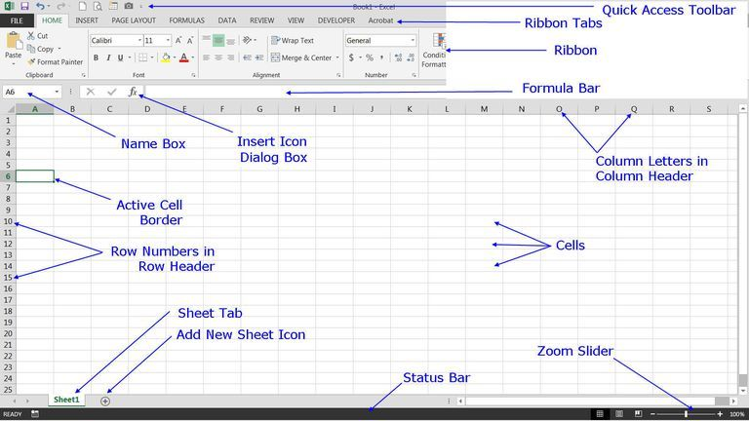
NOTICE: You should see something like the above (labelled image taken from https://computer2101.wordpress.com/2017/12/09/excel-screen-elements-and-parts-of-the-excel-screen/).
- In cell A1, type the following heading: miles.
- In cells A2 to A14, enter the following values (each value on a new row):
6500, 781, 371, 8900, 0, 124, 533, 222, 9013, 43, 2555, 0, 889
(these are results from survey of 13 students that asked “How many miles did you travel to go on your summer holiday?”).
NOTICE: It takes a long time, is prone to inaccuracy, and is quite boring.
- You should now see something that looks like this:
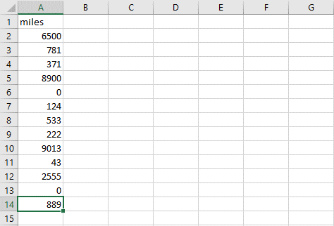

- Save your data file in the ‘Methods Practical 1’ folder you created on the desktop, using the ‘File tab’ and selecting ‘Save As’. Give the document the following title: Output_prac2_1ai.xlsx.
1b) JASP
JASP is a free, open-source statistics package that allows you to carry out almost all statistical test you see reported in psychology and neuroscience journals. It has an intuitive interface that is great for teaching stats. The large repertoire of statistical tests offered by JASP means that it can occasionally be difficult to select the options needed to run the test you are after. That’s what the practical component of this course is aimed at dealing with.
Alternatives: Almost all menu-driven statistical packages are commercial, expensive software – these include SPSS, Statistica, Stata, and SAS. There is another free alternative, PSPP http://www.gnu.org/software/pspp/, which is made to look and work just like SPSS. More advanced command-line stats programs like R (free) and Matlab (expensive) are more powerful but also more difficult to use. Up until 2019, this module taught stats using SPSS. We decided to change to JASP when SPSS’s deployment became so unreliable that most students could not install it on their own machines. The happy accident of the change was the realisation that JASP is, in many ways, far superior to SPSS!
How to access/install JASP: There are two ways of accessing JASP, depending on the type of machine you are using.
1) University Machine: The University of St Andrews has made JASP available on all its machines via the Apps Anywhere platform. Apps Anywhere can be accessed via the following web address: https://appstore.st-andrews.ac.uk/, or the Apps Anywhere icon on the taskbar or Windows menu.
2) Personal Laptop: JASP is free and open-source, meaning that anyone can install and use it on their machine. JASP can be downloaded from: https://jasp-stats.org/download/
1b) JASP i) Importing Data
JASP does not allow you to enter data via its own interface. Instead, it requires that you open an existing data file. The data files it will open are standard, open formats (e.g. comma-separated variable .csv, text .txt) and proprietary formats used by other statistical packages (e.g. SPSS .sav). We will generally be opening .csv files that have been saved using Excel, or the software’s own .jasp files.
- Start JASP.
- You will now be faced with the following Welcome Screen.


- Click the three blue horizontal lines in the top left:
NOTICE: There is no option to start a new file, only the option to Open an existing data file. We therefore need to switch back to Excel to save our data in a format that JASP will recognise.
- Keep JASP open, and switch back to Excel (or start it again if you closed it).
- In Excel, re-open the file you saved at the end of section 1a: Output_prac2_1ai.xlsx
- Instead of the Excel file .xlsx we need to save this file in a format that JASP can open. I mentioned previously that JASP will open .csv files. To save the file in this format, use the ‘File tab’ and select ‘Save As’. In the ‘Save as type:’ drop-down menu, select ‘CSV (Comma delimited) (*.csv)’. Give the document the following title: Output_prac2_1ai.csv and save.
- Switch back to JASP and click > ‘Open’ > Computer and Browse. Here you should see the Output_prac2_1ai.csv file you just saved in Excel.
- Open Output_prac1_1ai.csv.
NOTICE: JASP has auto-detected that the first cell is a variable heading. It has also auto-detected that the miles variable is a “Scale” variable. (Rather confusingly, JASP calls both interval and ratio data “Scale” data). Double-click on the ruler icon and you will see that the other options are Ordinal and Nominal.
- Save your data file in the same location you used for your.xlsx and .csv data. Click > ‘Save As’ > Computer. Give the document the following title: Output_prac2_1bi.
NOTICE: The file extension is .jasp. This is JASP’s own data file extension. At this stage, our .jasp file doesn’t contain any more information than was in the .csv or .xlsx files we created with Excel. This will change once we start computing statistics with JASP and saving them into the same file.
SECTION 2. Computing Descriptive Statistics
The following sections demonstrate how to use simple Excel and JASP commands to quickly compute descriptive statistics.
2a) Excel
- Use Excel to open the ‘practical 2.xls’ file.
- You will see a spreadsheet with two worksheets, ‘Raw Data’ and ‘Descriptives’. Examine ‘Raw Data’.
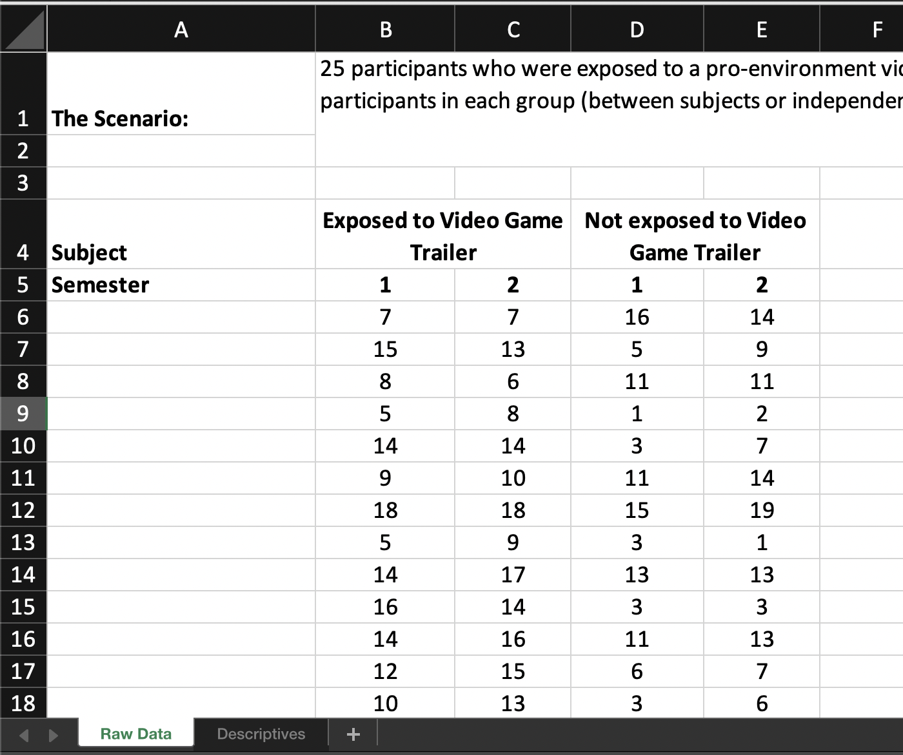
NOTICE: The data are from 25 participants who were exposed to a pro-environment video game trailer and 25 participants who were not, whose environmental behavioural intention scores were recorded at the end of each semester. Across semesters 1 and 2, the same participants were observed—semester is therefore a within-subjects (also referred to as a ‘repeated measures’ variable). However, those who were exposed to the video game trailer and those who were not are obviously different participants—exposure condition is therefore a between-subjects (also referred to as an ‘independent samples’ variable). Refamiliarizing yourself with these terms is important as these different types of data require different statistical procedures.
Data gathered from the same people = within-subjects. Comparisons made within the same people.
Data gathered from different people = between-subjects. Comparisons made between different people.

- Switch to the Descriptives worksheet by clicking the tab at the bottom-left of the screen
- You may need to scroll down to see that at the bottom of Section A, mean and standard deviation descriptive statistics have been computed for all between subjects groups (Exposed and Not exposed) and conditions (Semesters 1 and 2). Click on each of the cells within the black-bordered boxes to make sure you understand how each statistic has been calculated (the formula used will be displayed in the formula bar).
- 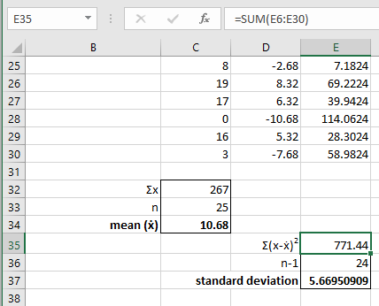

NOTICE: The mean is relatively straightforward to calculate. The standard deviation (SD) requires the creation of two additional columns in order to calculate squared differences. Here are the formulae for mean and SD to help jog your memory.

Mean ($\overline{x}$)
$$\overline{x}=\frac{\sum{x}}{n}$$

The sum of all the scores, divided by the number of scores
Standard Deviation (s)
$$s=\sqrt{\frac{\sum{{(x-\overline{x})}^{2}}}{n-1}}$$

The square root of the adjusted average squared deviation from the mean.

- Scroll down to Section B. You should see a series of grey boxes. We will use Excel formulae to compute descriptive statistics into these boxes.
- MEAN: In cell C43, work out the mean Exposed Semester 1 grade by typing exactly the following, then press return: =AVERAGE(C6:C30)
- Check that the value you get matches the long-form mean in cell C34.
- In cell G43, work out the mean Exposed Semester 2 grade by typing exactly the following: =AVERAGE(
Before pressing return, use the mouse to click and drag across all the cells you would like to find the mean of
Finish off the formula by closing the parentheses and press return.
- Check that the value you get matches the long-form mean in cell G34.
NOTICE: You can either type the cell references in manually, or select the cells with your mouse at the appropriate point as you are typing your formulae.
- Use the AVERAGE formula to calculate Not exposed students’ mean stats scores in cells K43 and O43.
- STANDARD DEVIATION: In cell C44, type exactly the following, then press return: =STDEV(C6:C30)
- Check that the value you get matches the long-form standard deviation in cell E37.
- Select Cell C44 and use the keyboard shortcut for copy—CTRL-C on a PC, ⌘-C on a Mac.
- Fill in the standard deviations for the other conditions by selecting the cells in which you would like to duplicate the formula and using the keyboard shortcut for paste—CTRL-V or ⌘-V.
NOTICE: Excel uses a relative reference whenever it pastes a formula into a new cell. As long as your descriptive are in the same relative position to the data they are summarising, copying and pasting will generally work as well as typing in each formula cell by cell.
- VARIANCE (s²)
$$s^{2}=\frac{\sum{{(x-\overline{x})}^{2}}}{n-1}$$

Variance is equal to the square of the standard deviation.

Use the standard deviation you have already calculated to compute the variance for each condition (fill in each grey box on row 45). You may find the POWER function useful (remembering that squaring a number is equivalent to raising it to the power of 2).
HINT1: Start off by typing : =POWER(
HINT2: Once you have indicated the cell reference for the value you would like to square, type a comma before indicating the power value and closing the parentheses. You should end up with something like =POWER(A1,2) <- but make sure you use the appropriate cell reference
ALTERNATIVE: You can also use the the ^ (caret) symbol, e.g. =A1^2
- STANDARD ERROR
$$SE= \frac{s}{\sqrt{n}}$$
Standard error is the standard deviation divided by the square root of the number of observations.

Use this to fill in each of the grey boxes on row 46. You may find the SQRT() function useful
HINT: Start off by typing = followed by the cell reference of the cell containing the standard deviation
NOTICE: The relative magnitudes of the standard deviation, variance and standard error values. Because they differ so much, it is very important that you are clear about which measure of dispersion you are reporting both in the text of your reports, and when you plot error bars on graphs.
- Save the spreadsheet once you have computed all descriptive statistics.

- Record the values you have computed to 1 decimal place in the following table:
 | EXPOSED SEM 1 | EXPOSED SEM 2 | NOT EXPOSED SEM 1 | NOT EXPOSED SEM 2
MEAN | [enter value] | [enter value] | [enter value] | [enter value]
SD | [enter value] | [enter value] | [enter value] | [enter value]
VARIANCE | [enter value] | [enter value] | [enter value] | [enter value]
SE | [enter value] | [enter value] | [enter value] | [enter value]

2b) JASP
- Use JASP to open the ‘Data_Prac2_2b.jasp’ file. The window that looks like an Excel worksheet is the Spreadsheet Panel.
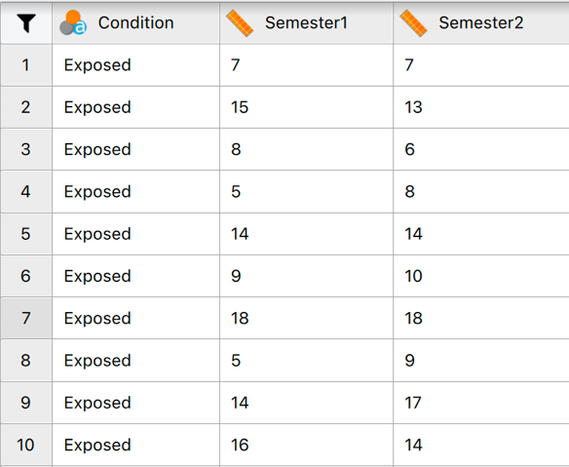
NOTICE: Instead of four columns, we have three. From the variable names, you will be able to see that the first column is something called a coding variable (you can see from clicking on the icon that this is set up as a nominal variable). JASP can only deal with within-subjects data (data gathered from the same participants) on neighbouring columns. Between-subjects data should be put on separate rows, and a coding variable used if necessary.
- Scroll down through the data to see that once all the data from Exposed students have been listed, the coding variable changes and Not exposed students’ data begin.
- Click on the Condition coding variable heading (). You should now see a section that indicates the labels that are assigned to the Condition nominal variable:
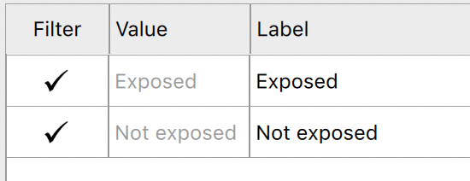

NOTICE: Each coding variable condition has a numerical value and a label. JASP uses text labels to help us see what each nominal condition represents.
- We will now calculate our descriptive statistics. In the menu, click Descriptives (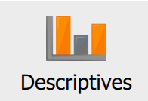).
- You’ll see that the view changes to the Results Panel. You can switch back and forth between the Data Panel and the Results Panel by clicking on the arrow adjoining each panel:
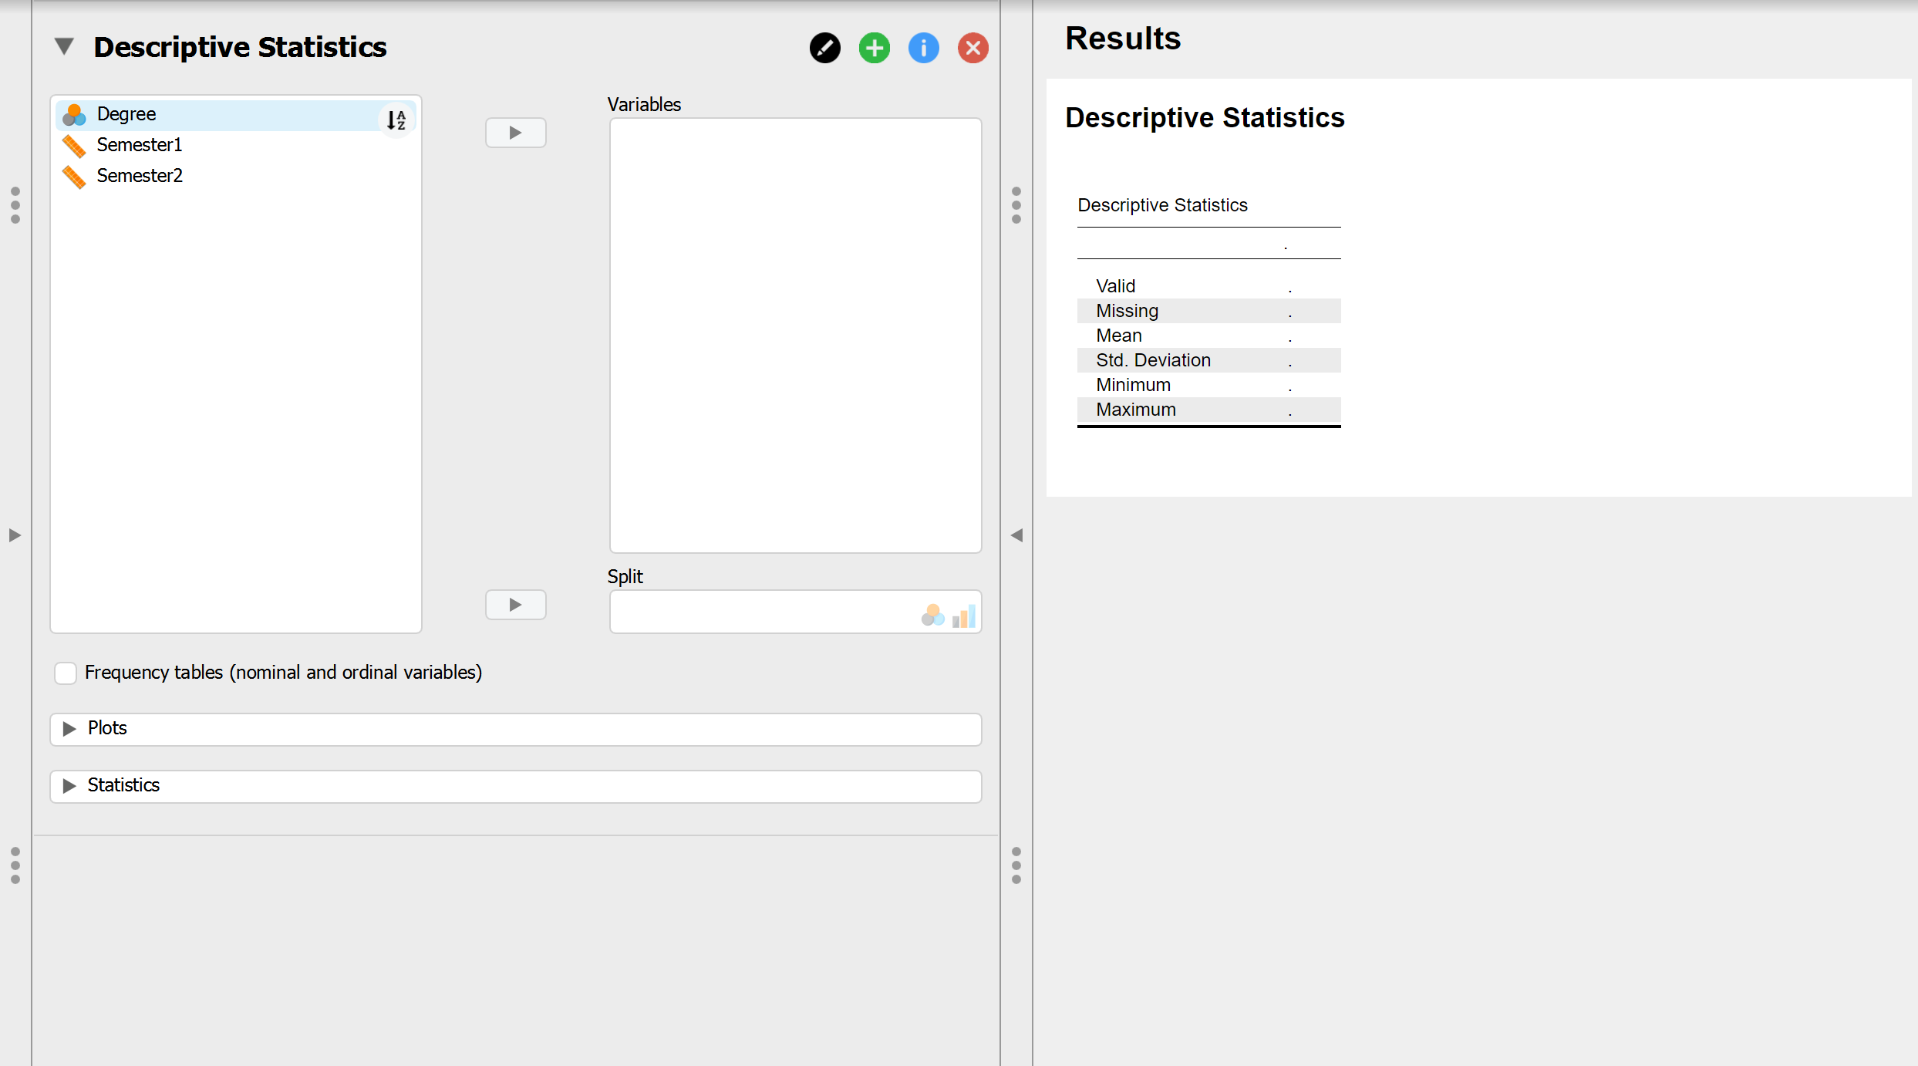

- In the Results Panel, under Descriptives Statistics, click on Semester1 and then the right arrow button () to transfer this into Variables. Now click on Semester2 and transfer this into Variables too. The Descriptive Statistics selection area should look like this:
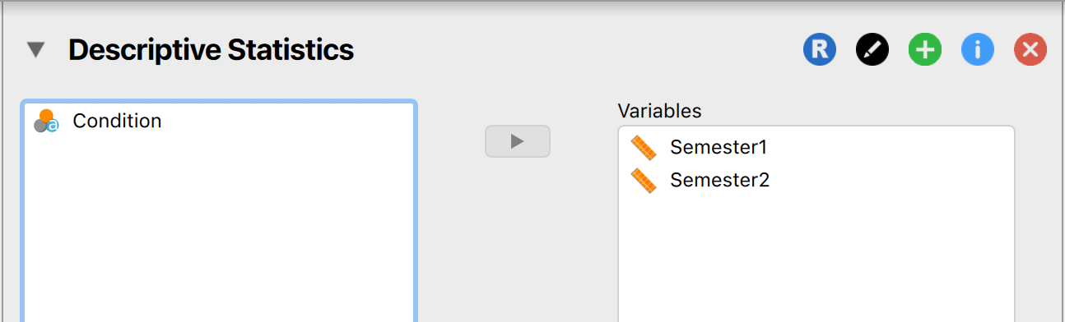

NOTE: here you can use the edit button () to rename the heading of your stats (e.g. here you may want to rename the section as ‘Descriptive Stats: Exposed and Not exposed Sem 1 and 2’). Throughout this session, you may find it helpful to rename the automatic headings in a similar way so that you can easily look for specific results.

- Click on the Statistics accordion menu (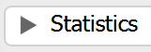) to open up the descriptive statistics options. In addition to the currently selected options (Mean, Std. Deviation, Minimum, Maximum), also make sure that S. E. Mean (Standard Error) and Variance are selected.
NOTICE: When you change the options in the Descriptive Statistics selection area, the Results shown to the right will change in real time.
- On the right-hand side of the Results panel, you should see the following descriptive statistics output:
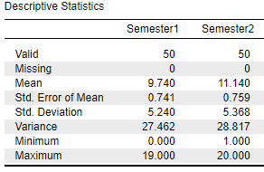
NOTICE: This is fine, but it doesn’t contain the data we need if we want to compare Exposed and Not exposed students. See that the Valid statistic (the number of valid data-points in each condition) is 50 for each semester. JASP has collapsed across the 25 Exposed and 25 Not exposed students and given us the descriptives as if they are all in the same condition. We need to do something about this!
- In the Descriptive Statistics selection area, click on Condition and transfer it into Split. This should split the output to the right according to the conditions of the Degree variable (Exposed and Not exposed).
- JASP has updated your output to split the descriptives by degree. You should see the following:
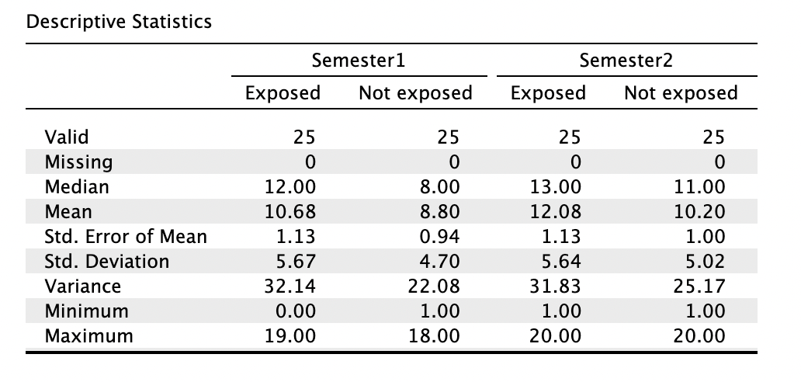
Check these values against those you calculated using Excel. If they don’t match up, have another go at the Excel calculations.
- In the Descriptive Statistics selection area, use the options in the Plots accordion to explore the different graphs that are available to summarise the data. We won’t do anything with these right now, but it is important for you to know that they are available to help you better understand your data.
- Save your data file. Click > ‘Save’.
NOTICE: There is no need to save the descriptive statistics output separately from the data file (this is different from packages like SPSS). This is because your data and the analyses are all saved in the same file. This makes it easy for you to update your analyses on any machine that you have access to the save file.
SECTION 3. Running, interpreting and reporting t-tests
3a) EXCEL
Excel is very limited in its capacity to run t-tests.
- It will only give you the option to run paired- and independent samples t-tests.
- It will not check your data to make sure they satisfy the assumptions of the t-test. It will therefore run t-tests even when it is inappropriate to do so and will not warn you about this.
- It will only give you the p value (significance) of the t-test, not the t-statistic or the degree of freedom. Therefore it does not give you an output that would allow you to report your statistics in a lab report or a journal article.
For these reasons, Excel should only be used to explore the data in the same way that you might look at descriptive statistics in Excel. Any statistical analysis carried out in Excel should always be confirmed in JASP and reported based on the JASP output.
- Use Excel to open the ‘Data_Prac2_2a.xls’ file.
- Navigate to the Descriptives worksheet and scroll down to Section C.
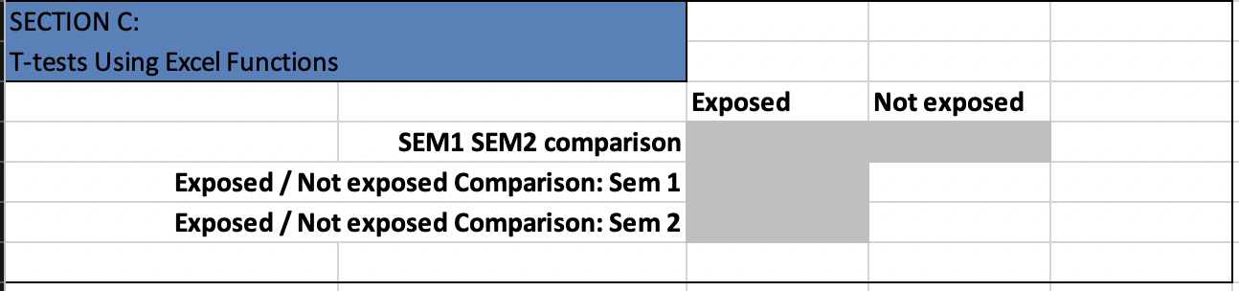

NOTICE: Row 52 has space for two paired-samples t-tests (one for each group providing the data)
- Exposed Semester 1 vs. Exposed Semester 2 (cell C52)
- Not exposed Semester 1 vs. Not exposed Semester 2 (cell D52)
Row 53 has space for one independent samples t-test (two groups each measured once)
- Exposed Semester 1 vs. Not exposed Semester 1 (cell C53)
Row 54 has space for one independent samples t-test
- Exposed Semester 2 vs. Not exposed Semester 2 (cell C54)
- The Excel t-test function is as follows:
=TTEST(array1,array2,tails,type)
array1 is the first dataset
array2 is the second dataset
tails specifies the number of distribution tails
(1 = one-tailed, 2 = two-tailed)
type is the kind of t-test to perform
(1 = paired, 2 = independent, equal variance-assumed, 3 = independent unequal variance-assumed)
- To run the appropriate t-test in C52, type: =TTEST(C6:C30,G6:G30,2,1)
NOTICE: We ran a two-tailed test because we didn’t have any hypotheses about the direction of the data. We also ran a paired-samples t-test because we are comparing the same people across two conditions.
- The test outputs a p value. This is a different output from that which you got when computing t values by hand last year. Excel hides the t value and instead gives you the exact significance, or p value. In this case, we have no need to compare this value to a table of critical values, we simply see whether the p value is greater than or less than .05. If it is less than .05, the test is significant, if it is greater than .05, it is not.
p value = [enter value]. Significant difference at the .05 alpha level? [click]
Fill in the formula that you would use in cell D52 (Not exposed Semester 1 vs. Not exposed Semester 2)
=TTEST([enter cell]:[enter cell],[enter cell]:[enter cell],[enter value],[enter value])
- Run this t-test and report the p value
p value = [enter value]. Significant difference at the .05 alpha level? [click]

- Fill in the formula that you would use in cell C53 (Exposed Semester 1 vs. Not exposed Semester 1) and report the p value.
=TTEST([enter cell]:[enter cell],[enter cell]:[enter cell],[enter value],[enter value])
p value = [enter value]. Significant difference at the .05 alpha level? [click]

HINT: Although we have not-tested the equality of variance, we should assume they are equal. We can test the equality of variances assumption later using JASP.
- Report the p value appropriate to C54 Exposed Semester 2 vs. Not exposed Semester 2.
p value = [enter value]. Significant difference at the .05 alpha level? [click]
- What can you conclude about the data from the four t-tests you have run so far? Write a sentence for each test below.
HINT: Don’t worry about formally reporting the statistics just yet. Just focus on the presence or absence of significant differences you have uncovered using Excel.
[type what you can conclude about the data here]
- Save the Excel file and close Excel.
3b) JASP
As you have already seen, dealing with between- and within-subjects data within the same JASP file can cause a few problems. These problems aren’t insurmountable, and they’re certainly much easier to deal with when using factorial statistical tests like mixed ANOVAs, but when learning how to use two-level inferential statistics like t-tests, it’s simply easier to create a data file for each type of test. For this reason, we’ll use one .jasp file for single- and paired-sample t-tests, and another for independent samples t-tests.
Single-sample t-test
- Use JASP to open the ‘Data_Prac2_3b_paired.jasp’ file.
NOTE: This is a different file to the one we previously opened in JASP. These are the same as the previous data we looked at, but only from Exposed students. Because we only have one group (those Exposed to the video game trailer), we don’t need a coding variable.
- You want to test the following hypothesis:
HYPOTHESIS: There will be a significant difference between participants exposed to the pro-environment video game trailer's environmental behavioural intention scores from Semester 1, and the mean score of all participants who attended the study the previous year, which was 10.
What is the null hypothesis?
[type the hull hypothesis here]
- For the eagle-eyed of you, you will notice we didn’t test if our data meet the t-test assumptions when we ran the t-test in Excel. The assumptions for single-sample t-test (also referred to as one-sample t-test) are:
- The data are interval / ratio (these data types are referred to as Scale in JASP)
- Data are normally distributed
Our data ARE coded as scale within JASP, so we meet the first assumption. To test the assumption of normality we will conduct a shapiro-wilk test.
In the menu, click Descriptives. Then move semester 1 to the variables section. You will see a sub-set of the descriptive statistics we calculated in the previous JASP section (i.e. only semester 1 Exposed students descriptives). In the statistics accordion menu, select Shapiro-Wilk test.
NOTICE: New rows are added to the table in the results section. One named ‘Shapiro-Wilk’ and one named ‘P-value of Shapiro-Wilk’. The table should look as follows:
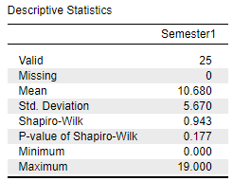
HINT: You might remember from the lecture that the Shapiro-Wilk test asks whether the data are significantly different to the normal distribution. The null hypothesis is that data are not significantly different to normal distribution. So:
- If Shapiro-Wilk p>.05, then data are not significantly different to normal (assumption of normality met).
- If Shapiro-Wilk p<.05, then data are significantly different to normal (assumption of normality not met).
Does the data meet the assumption of normality? Why/why not?
[Type your answer here]

- You should have found that the data did meet the assumption of normality because Shapiro-Wilk’s p was more than .05. Now we will run a single-sample t-test. Select a single-sample via T-tests > ‘One Sample T-Test’:
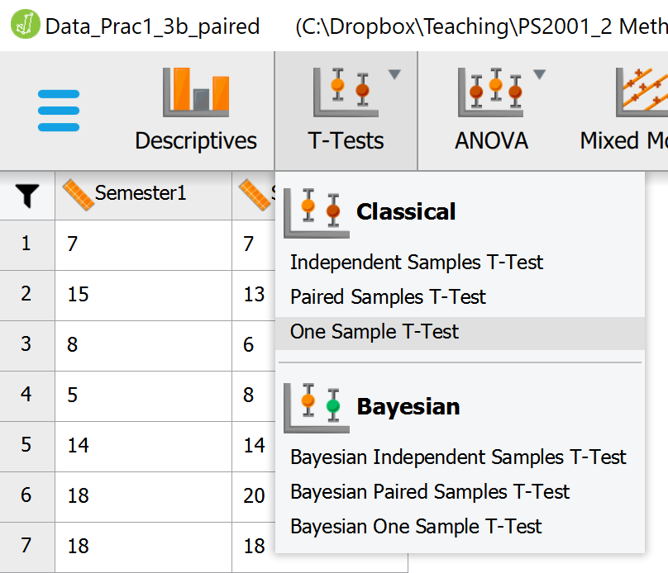

- NOTE: Remember you can use the edit button () to rename the heading of your stats (e.g. here you may want to rename the section as ‘One sample t-test: Exposed students semester 1’).

- In the One Sample T-Test selection area, transfer Semester1 to Variables, and enter the Test Value (the value against which we are testing these data; see the alternative hypothesis above if you’re not sure what this should be).
NOTICE: We are conducting a Student’s t-test, and based on our hypotheses, should be happy with the two-tailed alternative hypothesis indicated by .
- You should see a very simple output like this:
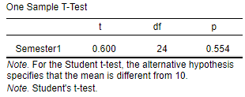
NOTICE: JASP gives us only the statistics we have asked for—those pertaining to the t-test. Within this output, we don’t have enough information to interpret this finding i.e. whether or not the Exposed students’ performance was higher or lower than the test statistic of 10.
- To see the descriptive statistics pertaining to this one sample t-test, in the One Sample T-Test selection, select Descriptives. Also select Descriptives plots and Effect size. You should now see an additional statistic output table (Descriptives), an additional figure (Descriptives plots), and an additional statistic (Cohen’s d) appear in the Results Panel.
- Your output should look this this:
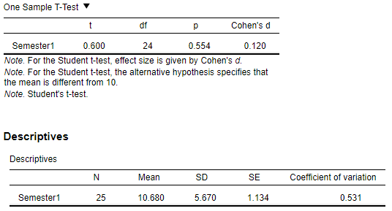
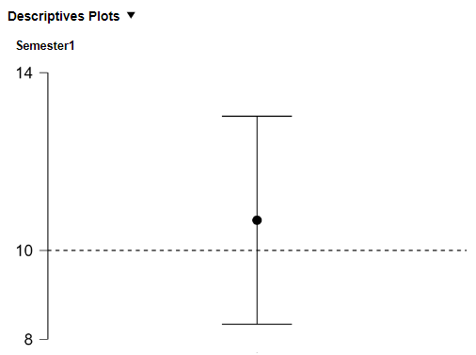
NOTICE1: The descriptives table and descriptive plot allow you to see how the central tendency (in this case, the mean) and dispersion (SD and SE in the table, 95% confidence interval in the plot) relate to the test value of 10. Because the 95% confidence interval overlaps with the test value, it is no surprise that this t-test returned a nonsignificant result.
NOTICE2: When running the one-sample t-test, there was an option to select ‘normality’ under ‘assumption checks’. If you select this you will be given a table like the one below:
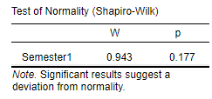
The numbers in this table should match those from the values in your descriptives table.
NOTICE3: It’s also good to know that you can also ask to see the Effect Size in the selection area. This is something you will learn more about next year. For now you should know that effect size is a measure of the magnitude of the statistical effect that takes into account the sample size contributing to your analysis. There are different effect size statistics for each statistical test—for t-tests, the Effect Size option in JASP will give you a statistic called Cohen’s d.

- Fill in the gaps below making sure to report all non-integer values to 2 decimal places except for the p value, which you should report to 3 decimal places:
A sample of 25 participants exposed to a pro-environment video game trailer received a mean environmental behavioral intention score of [enter value] (SD = [enter value]). The data were normally/not normally distributed (Shapiro-Wilk W = [enter value], p = [enter value]). Although the mean for participants exposed to the video game trailer in semester 1 was higher than the mean environmental behavioral intention score of all participants who took part in the study the previous year, [enter value], according to a single-sample t-test, this difference was not statistically significant, t([enter value]) = [enter value], p = [enter value].
HINT: Put the degrees of freedom (df) in parentheses after the t, and then report the t value, followed by its significance. Refer to the lecture slides if you are still unsure of what to do.

- Conduct another single-sample t-test on the semester 2 scores using the same hypothesis.
NOTE: Remember you can use the edit button to rename the heading of your stats (e.g. here you may want to rename the section as ‘One sample t-test: Exposed students semester 2’).
Report the results below:
[report the semester 2 score results here]
- Save your data file.
Paired-samples t-test
- Make sure the ‘Data_Prac2_3b_paired.jasp’ file is still open.
- You want to test the following hypothesis:
HYPOTHESIS: There will be a significant difference between Exposed students’ environmental behavioural intention scores from Semester 1, and Exposed students’ environmental behavioural intention scores from Semester 2.
What is the null hypothesis?
[type the hull hypothesis here]
- Select a paired-samples t-test via T-tests > ‘Paired Sample T-Test’.
NOTICE1: The Paired Samples selection area in the Results Panel gets stacked below the existing One sample t-test outputs. You can quickly switch between the two by clicking on the accordion menu arrows.
NOTICE2: We already know our data are normally distributed from testing it for our one-sample t-tests, so we do not need to check again.
- Select both Semester1 and Semester2 conditions, and transfer them over to Variable pairs. You should see something like this:
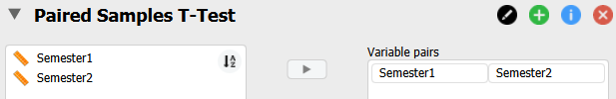

- Once again, select Descriptives, Descriptives plots, and Effect Size.
- You should now see an output like this:
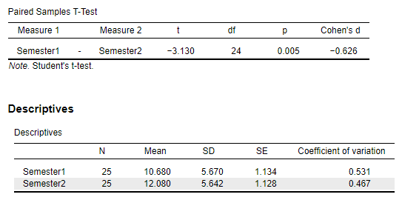
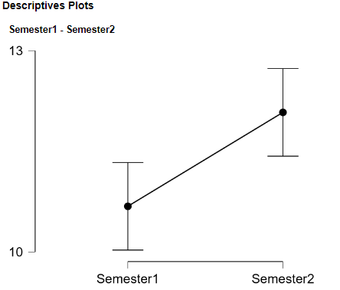
NOTICE1: This output is slightly more complicated than the output for a single-sample t-test, but the statistics you are interested in are largely identical. The major difference is that you have two sample means and two sets of dispersion statistics to report.
NOTICE2: The Descriptives plot figure allows you to see at a glance which of the two means is higher, and how different the two samples are. A key thing to look for when we examine paired-samples t-test descriptives plots is how close to overlapping the other means the error bars are. Because these error bars don’t overlap the means against which they are being compared, we know that we are likely to have a significant difference.
- Fill in the gaps paying attention to the decimal place advice given on page 14:
A sample of 25 participants exposed to a pro-environment video game trailer completed two environmental behavioural intention tests, one at the end of each semester. Their scores from semester 2 (M = [enter value], SD = [enter value]) were [click] higher than their scores from semester 1 (M = [enter value], SD = [enter value]), t([enter value]) = [enter value], p = [enter value].
NOTICE: It’s up to you whether you want to put the means in the main body of the text, or note them parenthetically. It’s also up to you whether you note statistical test results in the main body of the text (as I do) or parenthetically. As with most matters of writing style, the important thing is that you are consistent.
- Save your data file.

Independent samples t-test
- Use JASP to open the ‘Data_Prac2_2b.jasp’ file again.
- You should see a Results panel with the descriptive statistics output from earlier in the session. Switch back to the Data panel to check that you are analysing the dataset with Exposed and Not exposed students across Semesters 1 and 2.
- You want to test the following hypothesis:
HYPOTHESIS: There will be a significant difference in environmental behavioural intention scores between participants exposed to the pro-environment video game trailer in Semester 1 and participants not exposed to the pro-environment video game trailer in Semester 1.
- Select an independent samples t-test via T-tests > ‘Independent Samples T-Test’.
- Transfer Semester1 over as a Variable and Condition as a Grouping Variable. You should see something like this:
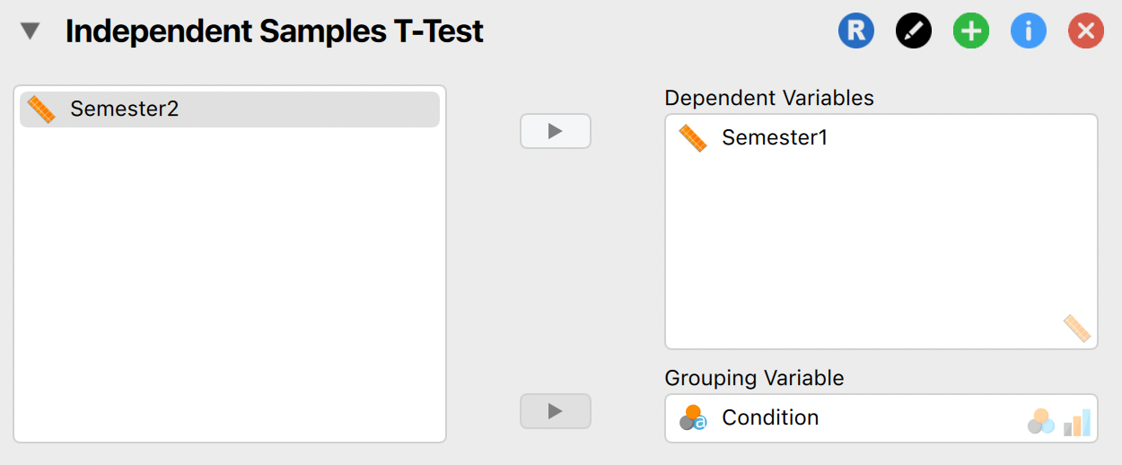

- Once again, select Descriptives, Descriptives plots, and Effect Size (keep Cohen’s d as the default measure). Under Assumption Checks select Normality and Equality of variances

NOTE: Equality of variances is an assumption specific to independent samples t-tests – selecting this option means JASP will run a Levene’s test.

As an option specific to independent samples t-tests, also click the Welch Test option.

- You should see an output like this:
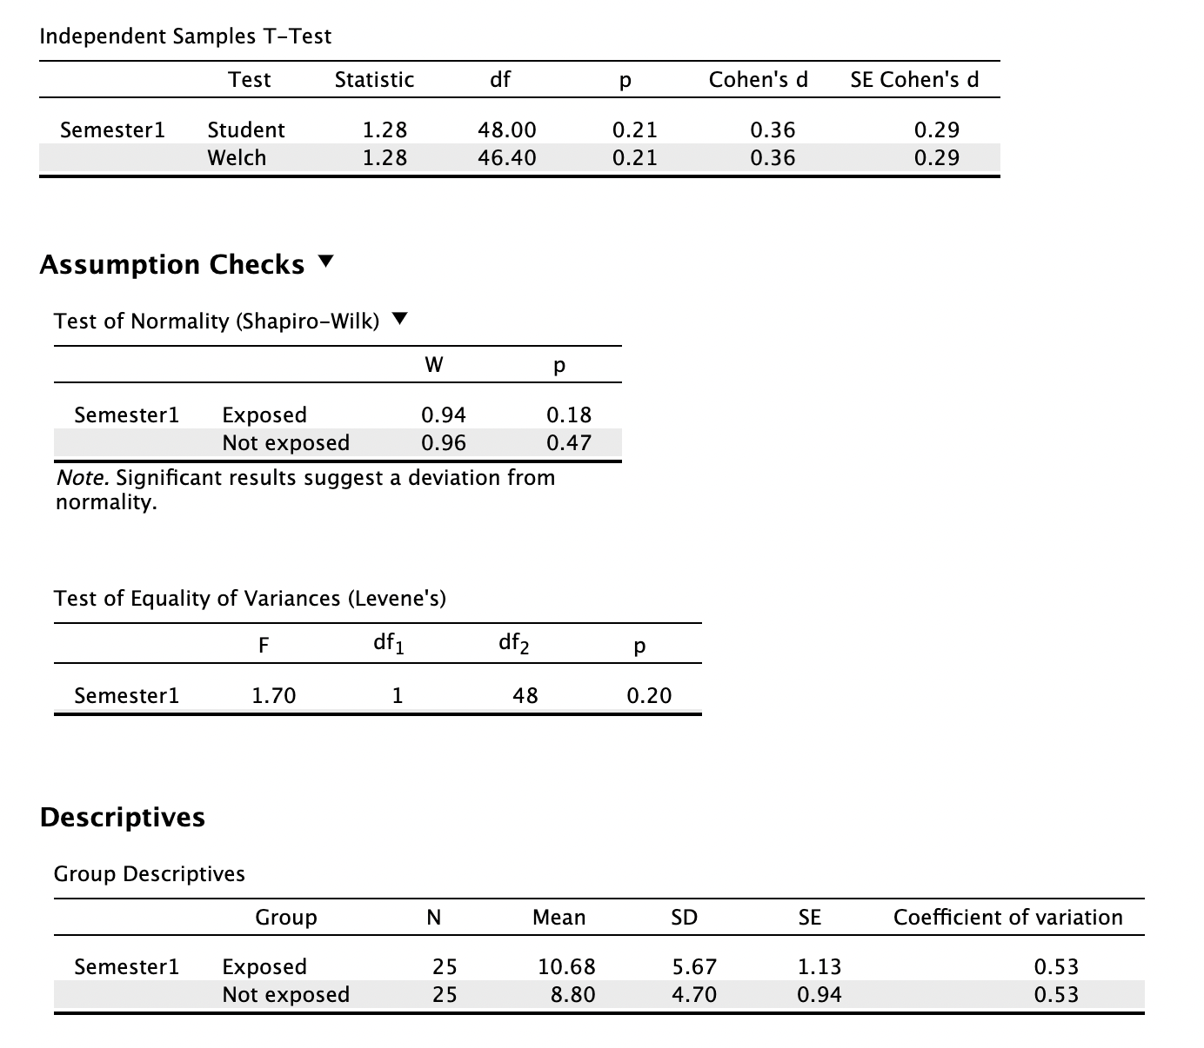

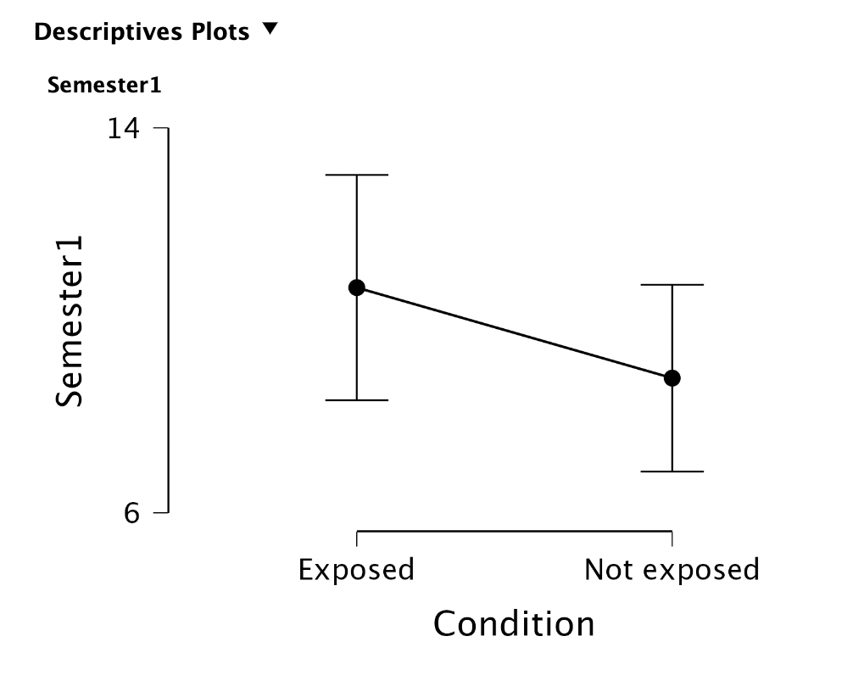
- The output is similar to what we have seen in previous t-tests, but we also have a new line labelled Welch in the t-test table, and a new table with the Levene’s test of equality of variances assumption check.
Levene’s Test for Equality of Variances: In the lecture it was mentioned that the independent samples t-test assumes that the variances of the two compared groups are equal. If they are not, we need to make some adjustment to the analyses we run. What this means in practical terms is:
If the p value of the Levene’s test is greater than .05:
- the independent samples have equal variances
- there is no need to report the Levene’s test result
- report the statistics from Student’s t-test (which assumes equal variances).
If the p value of the Levene’s test is less than .05:
- the independent samples have unequal variances
- report the Levene’s test result
- report the statistics from Welch’s t-test (which does not assume equal variances).
- Fill in the gaps taking care to use the appropriate number of decimal places for each non-integer value:
Although the pro-environment video game trailer group's scores (M = [enter value], SD = [enter value]) were numerically higher than the control group's scores (M = [enter value], SD = [enter value]), there was [click] difference in the two groups’ environmental behavioural intention scores, t([enter value]) = [enter value], p = [enter value].
- Conduct another independent samples t-test on the semester 2 scores using the same hypothesis. Report the results below:
[report the semester 2 score results here]
Notice: If you had to report an independent samples t-test on data which violated the equality of variances assumption check, you might report something like the following:
“Scores on the happiness subscale were numerically higher for older adults (M = 27.0, SD = 7.2) than young adults (M = 24.2, SD = 7.7). Levene’s test indicated that these data violated the assumption of equal variances, F = 3.56, p = 0.43, so Welch’s t-test was used, t(340.1) = 4.30, p < .001), finding the older adults’ scores to be significantly greater than the young adults’ scores.”
- Save your data file

NOTE: in all cases today we met assumptions of normality so t-tests were appropriate.
As covered in the lecture, equivalent non-parametric tests are shown in the table below:
Parametric | Non-parametric
One sample t-test | Wilcoxon signed-rank test
Paired sample t-test | Wilcoxon signed-rank test
Independent sample t-test | Mann-Whitney U test

You should see the options for the appropriate non-parametric equivalent in the menus for the parametric test under the tests heading. In a similar way to the Welch’s test appearing as an additional line in the table, the Wilcoxon and Mann-whitney tests would also appear as an extra line in the table. For example:
