FUNDAMENTALS OF PSYCHOLOGY

WORKBORK 1a

Covers:

Section 1: Research Methodology
Section 2: Descriptive Statistics
Section 3: Inferential Statistics & t-tests
Section 4: Glossary
Section 5: Formulae
Section 6: Significance Tables

SECTION 1: RESEARCH METHODOLOGY

Content covers:
- Science
- Laws
- Theories
- Hypotheses
- Variables
- Quasi-experiments
- True experiments
- Experimental design
- Population and samples

SECTION 1: RESEARCH METHODOLOGY

SCIENCE
Science is a self-correcting discipline. It is the process whereby new findings are presented in journals and are subject to what is called ‘peer review’. Peer review involves scientists’ peers, who have expertise of the field, scrutinizing and evaluating the methods and conclusions of the research.

The integrity of science rests on the willingness of scientists to expose new ideas and findings to the scrutiny of other scientists. Therefore, scientists expect their colleagues to reveal new findings to them before they reveal them to the public. An attempt to bypass peer review by taking a new result directly to the media (and the public) suggests that the work and its methods may not stand up to close examination by other scientists.

Knowing how scientific experiments are conducted will, amongst other things, help you recognize and separate science from pseudoscience. Pseudoscience is a set of ideas driven by ideological, cultural, or commercial goals, presented as scientific, although they are not.

Pseudo-scientists claim to base their theories on empirical evidence, and may even use some scientific methods, though often their understanding of a controlled experiment is inadequate. Many pseudo-scientists point out the consistency of their theories with known facts or with predicted consequences, but do not recognize that in science, such consistency is not proof of anything.

It is a necessary condition but not a sufficient condition that a good scientific theory be consistent with the facts. A theory that is contradicted by the facts is obviously not a very good scientific theory, but a theory, which is consistent with the facts, is not necessarily a good theory either.

As you will come to see, the most important discovery of science and modern medicine is not, as frequently claimed, vaccines or antibiotics. It is the randomized double-blind test, by means of which we know what works and what does not.

LAWS
A scientific law describes something that happens without exception and has been established by repeated testing. It specifies that under such-and-such conditions, such-and-such will occur (with a specified magnitude or frequency). It often describes a mathematical relationship between two or more measured variables.

Examples: The Law of Conservation of Energy in Sustainable Energy Systems (Robert, 1841)

THEORIES
A theory is a conceptual framework that explains existing observations (and the laws based on them) and predicts new ones.

Example: The Planetary Boundaries Theory (Rockström)

A scientific theory differs from what is typically meant by the word ‘theory’ in layman’s terms. In layman’s terms, the word "theory" means something that is unproven, an educated guess or assertion, which may or may not be true. A scientific theory however is supported by a substantial body of evidence, and has been proven beyond reasonable doubt by repeated testing of hypotheses (if not, it is simply a hypothesis). Theories are more like scientific laws than hypotheses. They are no less than scientific laws.

A theory is evaluated on the basis of:

- Principle of Parsimony (also known as Occam's Razor)
- Falsifiability (whether it generates hypotheses that are falsifiable) - Does it require any/a/many leap(s) of faith?
- Consistency with known data
- Internal consistency
- Utility in generating new hypotheses (new research)

Parsimony is the preference for the least complicated explanation for an observation. Given two equally predictive theories, choose the simpler: As in many situations in life, the simplest answer is often the correct answer.

Falsifiability regards whether it is possible to make an observation that would show that the theory is wrong (even if such an observation has not been made!). Is it clear what would justify rejection of the theory, and is it possible to actually test and challenge the basic premises of the theory?

Some pseudoscientific theories cannot be tested because they are so vague that anything relevant can be shoehorned to fit the theory, e.g., biodynamic farming, iridology and much New Age psychotherapy. All scientific theories however must be testable (at least in principle). It must be clear what criteria would lead to the rejection of the theory.

HYPOTHESES
A hypothesis is a working assumption, whose merit is to be evaluated. Ideally it should be based upon evidence, but sometimes it is an educated guess (or even simply a ‘hunch’). A scientific hypothesis is equivalent to a layman’s ‘theory’ (this is important to keep in mind).

A hypothesis identifies specific relationships between the variables and specifies the effect that we predict the independent variable (IV) will have on the dependent variable (DV). It is phrased as a statement, which may or may not be true. In psychology, you always have two hypotheses that are presented in opposing pairs:

- The null hypothesis (H_{O}) states that there is no relationship between two variables.
- The alternative hypothesis (H₁) states that a relationship between two variables exists.

If a given theory is true, then a specified pattern should be observed.
Likewise, if a given theory is untrue, then a specified pattern should not be observed.

The best hypotheses are those that specify a pattern of predicted results that would allow us to reject the theory.

People often conflate the words "theory" and "hypothesis". A theory generates hypotheses that can be tested. A theory that is unable to generate falsifiable hypotheses is not a scientific theory. Science is foremost about exploration, and a theory that cannot be explored has no currency in the scientific community.

The scientific method holds that all conclusions are tentative, and that nothing can ever be absolutely proven to a certainty. Every conclusion reached by any scientist must always include (even if it is only assumed) the unspoken preface that "This is true only to the best of our current knowledge". Science does not deal with absolute truths; it deals with hypotheses, theories and models.

One Tailed vs. Two-Tailed Hypotheses
When making predictions of the outcomes of research one can make either:

- a non-directional prediction, which only states that a relationship between two variables exists. This is called a two-tailed hypothesis, and you need a two-tailed test to test it.

OR

- a directional prediction, which specifies the nature of the relationship between the variables. These are called one-tailed tests, and you need a one-tailed test to test it (the critical values of significance differ for one and two tailed tests; more about this later).

You should only make a directional hypothesis if you can:
  - Base it on a well-researched theory.
  - Base it on previous research showing consistent trends in that direction.

If in doubt, make your hypothesis two-tailed.

Table 1: One- and Two-tailed hypotheses.
Two-tailed hypothesis | One-tailed hypothesis
Non-directional  Predicts a difference between the conditions but not the direction. The results could be in either direction (bigger/smaller, faster/slower). | Directional  Predicts a difference between the conditions and specifies the direction of the difference.
The difference will be:  Mean of group A ≠ Mean of group B | The difference will be:  Mean of group A > Mean of group B OR  Mean of group A < Mean of group B
H₁ = E.g. There is a relationship between green space access and psychological well-being. | H₁ = E.g. There is a positive relationship between access to green spaces and psychological well-being [i.e. greater access to green spaces leads to improved psychological well-being]

VARIABLES
A variable is anything that varies and can be measured. Examples include: height, weight, nationality, eye colour, diagnostic categories of Schizophrenia, results from an intelligence or personality test, environmental awareness, and recycling behavior.

It is important that the meaning and interpretation of each variable is the same for everyone. For example, people can vary widely on their understanding and definition of variables such as intelligence, stress and memory, or environmental awareness, sustainability, and ecological behavior. To counter this, researchers must provide an operational definition for the variables investigated in their study. An operational definition defines a variable in terms of the procedures used to produce or measure it.

Independent Variables (IV) and Dependent Variables (DV)
Experimenters manipulate (change) the independent variable(s) (exposure to green spaces, participation in environmental education programs, levels of environmental stress etc.) and measure changes in the dependent variable (mental well-being scores, pro-environmental behaviors, levels of eco-anxiety etc.).

Confounding Variables
These are one or more variables, which are not under the experimenter’s control, and which vary systematically with the IV, thereby decreasing the experimenter’s ability to isolate cause and effect (i.e. to say that it was the IV that caused the change in the DV, and not the confounding variable).

For example:

- An experimenter is interested in whether exposure to green spaces affects mental well-being. One group of participants (the experimental group) is given access to green spaces and is then tested on mental well-being at 8 AM. The other group (the control group) is tested on mental well-being, without access to green spaces, at 11 AM.
- Does the time of testing (8 AM vs 11 AM) influence one’s level of alertness and therefore mental well-being?
- Any difference between the groups at the completion of the study may be due to the exposure to green spaces or differences in alertness at the time of testing.

- An experimenter is interested in whether participation in environmental education programs affects pro-environmental behaviors. The experimental group of participants is tested in a room of 30°C, while participating in the program. The control group is tested in another room where no program is taking place and the room is at a temperature of 15°C.
- Does temperature have any influence on levels of pro-environmental behaviors?
- Any difference between the groups at the completion of the study may be due to the environmental education program or the temperature of the room.

What is to be done?
The experimenter needs to Counterbalance. If the experimenter suspects that there might be an effect of the time of day that one group is tested, s/he simply runs half of the participants in the experimental group and half of the participants in the control group in the morning; the other half of each of the groups in the afternoon. That way, any effect of the potentially confounding variable (e.g., time of day) is evenly distributed across the control and experimental conditions; if both groups are equally affected by the variable it cannot be responsible for any changes between the two groups performance on the test.

Random Variables (Nuisance/Extraneous Variables)
These are variables, other than the IV that can affect the DV. For example, person variables (including motivation levels, a participant’s amount of experience, or the participant having a bad day on the day of the experiment). It is simply impossible to control for everything.

What to is to be done?
The experimenter needs to use Random Assignment. Random assignment is a technique used to reduce the effect of extraneous variables. Using this technique, participants have an equal chance of being assigned to any of the groups in the experiment. This means that any pre-existing differences between participants are balanced across each condition and therefore concerns regarding variability in subjects are substantially reduced. Random assignment prevents random variables from consistently affecting one of the conditions because it spreads the effect of potential nuisance variables randomly across the different conditions.

Moderating Variables
A moderator is an additional variable which determines when the experimental variable does or does not have an effect. A moderating variable changes the relationship between the independent and dependent variables. It is important to consider moderating variables because they affect how far one can generalise from one’s results. For example, you might find that participants who are exposed to green spaces (IV) present with improved mental well-being (DV). However, on further examination, you discover that this is only true for participants who have high levels of environmental awareness. Here, environmental awareness is the moderator as it impacts when the exposure to green spaces is effective.

METHODS OF RESEARCH
There are two broad avenues of scientific study, quasi-experiments and true experiments.

QUASI-EXPERIMENTS
Quasi-experiments are characterized by their use of pre-existing groups of participants, which have not been manipulated by the experimenter. That is, the independent variable has been selected (e.g. gender or nationality) rather than manipulated. There are 4 types of quasi-experiments:

- Observational Studies
- Interviews and Questionnaires
- Case Studies
- Correlational Studies

- Observational Studies
Researchers observe the experimental units in their natural setting and simply record the variable(s) of interest. There is no attempt to manipulate/influence the variable(s) of interest. Preexisting groups of subjects are used.

Examples:

Advantages:

Disadvantages:
- Interviews & Questionnaires
Researchers gather information through interviews or questionnaires administered to a large number of people. Surveys and questionnaires generally ask questions about people’s attitudes, opinions and behaviours.

Examples:

Advantages:

Disadvantages:

- Case Studies
A case study is an in-depth analysis of an individual, group or event. Data are gathered through a number of techniques including observations, interviews, psychological tests, reports by others, physiological recordings, task performance and archival data.

Examples:

Advantages:

Disadvantages:

d. Correlational Studies
Correlational studies measure the association between naturally occurring events or variables. Three components make up a basic correlational study: 1) measure one variable (X); 2) measure a second variable (Y); 3) use statistics to determine if X and Y are related. As variables have not been manipulated in these types of studies, no causal inferences can be made.

Examples:

Advantages:

Disadvantages:

TRUE EXPERIMENTS
Quasi-experiments are extremely useful research techniques, but as you have seen the major drawback is that you cannot establish causal relationships between variables. How do you determine what factors are casual when there are so many possible independent variables that might be influential? True experiments are the key as they provide us with a powerful tool for examining cause-and-effect relationships. This technique requires researchers to control all aspects of a situation through manipulation. We control the What, When, Where and How of the experiment. As such, true experiments provide us with the only way in which scientists can unambiguously establish causality.

An experiment has three essential components:
- One variable is manipulated (IV).
- The researcher measures whether or not this manipulation results in changes in a second variable (DV).
- Extraneous variables are controlled for so that causal relationships can be established between the variables of interest.

In a basic experiment, participants are assigned to either a control group or an experimental group. The two groups are treated exactly alike in all ways, except one: the experimental group is given the treatment of interest while the control group is not. As such, the experimental group is manipulated by the researcher. As long as the experiment is performed properly, differences in the experimental and the control group must be due to that manipulation… and nothing else.

H₁ = Participants who engage in environmental education programs (independent variable) exhibit more pro-environmental behaviors (dependent variable).

Control group  Does not receive the treatment before observation (participants do not engage in the environmental education program) |  | Experimental group  Receives the treatment before observation (participants engage in the environmental education program)

Figure 1: Example of an experiment investigating the effect of environmental education programs on pro-environmental behaviors.

Examples:

Advantages:

Disadvantages:

EXPERIMENTAL DESIGN
Is the experiment going to use each participant only once or more than once? There are three designs:

a. Between Subjects Design
Experimental Condition | Control Condition
S1 | S5
S2 | S6
S3 | S7
S4 | S8
Each subject/participant is randomly Table 2: Between Subjects Design (S = subject). assigned to only one of the conditions (by tossing a coin, rolling a dice etc.). Each participant is used only once in the experiment.

Advantages:

Disadvantages:

b. Within Subjects Design Each participant is measured under both the experimental and control conditions. Thus, each participant is used more than once in the experiment. This design looks for differences from condition to condition within individuals. This means that one can ignore the participant variability. The participants effectively serve as their own control group.

Advantages:

Disadvantages:

c. Matched Design
Experimental Condition | Control Condition
S1 | S1
S2 | S2
S3 | S3
S4 | S4
Table 3: Within Subjects Design.

A matched design is sometimes used to exploit the advantages of both within and between subjects designs. It is a type of between-subjects design in which there are different participants in each condition, but each pair is matched on one or more relevant characteristics. This reduces between groups variability. Carrying out this type of design properly however requires considerable effort and resources.

POPULATIONS AND SAMPLES

Sample

Population

Population
A population is a complete set of individuals with some common characteristic. E.g. all New Zealanders, students, mice, males, females, cans of beer, households using solar energy.

Sample
A sample is a small number of scores selected from the whole set of scores (the population) of a given variable. E.g. the set of people included in a study selected from the population.

The art of sampling means taking a small Figure 2: A population and a sample. number of a population of items and testing them, and then drawing a conclusion about the population as a whole.

If you wanted to estimate how many hours people in a community spent engaging in eco-friendly behaviors on average, you would not ask everyone. Instead, you may ask a sample of 500 people and draw a conclusion (about the population) based on their responses. The larger the sample, the more representative the results.

Generalization from Sample to Population
Samples can sometimes only approximate the characteristics of the entire population; however they allow us to make informed guesses. Inferential statistics are tools allowing us to draw inferences about a population from a sample (more about this later).

How representative the sample is affects your ability to generalize the results. How representative the sample is depends on how it is selected.

SAMPLING TECHNIQUES
- Random Sampling
Every member of the population has an equal chance of being selected. This is the best option, but is rarely possible. Various methods can be employed to achieve this.

- Opportunity Sampling
A sample based on subjects who are available and willing to participate in the study.

Sample Size and drawing conclusions about the Population

a. Small sample size
If we take a number of small samples from a population and calculate their means and standard deviations (you will learn about means and standard deviations later in the course) we find that:
- These means vary considerably.
- It is common to find sample means around the population mean.
- The average of sample means is close to the population mean.
- The further away we go from the population mean, the fewer sample means we find.
- The standard deviation of the sample means (the standard error) may be large, which indicates that the average of the sample means is not too good an estimate of the population mean.

b. Large sample size
With larger sample sizes we find the same trends but:
- There is less spread of sample means.
- The sample means are more tightly clustered around the population mean.
- The average of sample means is closer to the population mean, therefore producing a better estimate of the mean of the real population.
- The standard error of larger sample sizes is smaller, which indicates that the average of the sample means is a relatively good estimate of the population mean.

In sum, larger sample sizes provide a better estimate of the real population mean.
Task 1a: University Students as Subjects
Many studies of ‘normal’ adults use university students as subjects. There may however be problems with using these participants.

Advantages:

Disadvantages:

These types of subjects have even been termed WEIRD!

W = ________________________
E = ________________________
I = ________________________
R = ________________________

D = ________________________

Task 1b: Hindsight versus the Scientific Process

SECTION 2: DESCRIPTIVE STATISTICS

Section covers:
- Types of Measurement
- Levels of Measurement
- Tables and Figures
- Measures of Central Tendency
- Measures of Variability
- Shapes of Distributions
SECTION 2: DESCRIPTIVE STATISTICS

Statistics is about making sense of the variability in the world that surrounds us. It is useful because it describes our data and allows us to assess how much we can rely on samples.

Different types of statistics are used for different purposes:
- Descriptive Statistics are used as a tool for summarising.
- Inferential Statistics make research easier by generalising from a sample to an entire population - Data exploration techniques are used to find trends in large amounts of information.

Descriptive statistics are visual and numerical techniques used to describe the major features about the data. They allow researchers to get an idea of the distribution of the data because they structure information to show the major trends seen in the raw data (i.e. unprocessed information).

TYPES OF MEASUREMENT
The main types of measurement in statistics are:

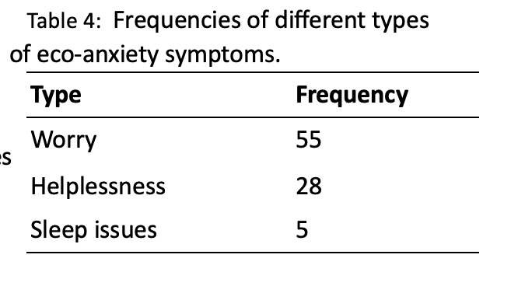
a. Qualitative (Nominal / Category)

Measurement is a qualitative measure where one must decide what category of a variable a given case belongs to.

Each category is named and groups various cases within it. The numbers of items under each category are the frequencies
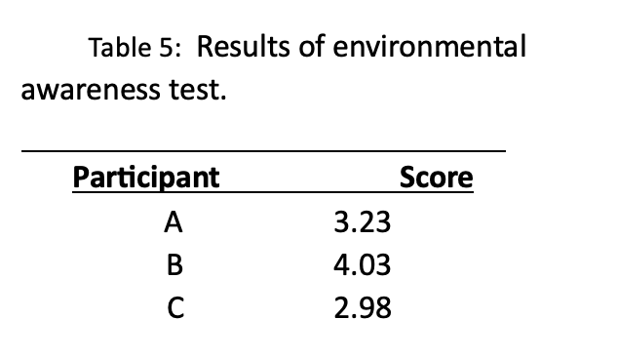

b. Quantitative Data (Score / Numerical)

Measurement in which numerical values are assigned to a measurement, such as weight (e.g. 5 kg). Each numerical value indicates the individual’s score on the variable, so that the numbers quantify the variable.

LEVELS OF MEASUREMENT

- Nominal Categorisation
The Nominal Scale represents qualitative data (see above).

Examples:

- Ordinal (or Rank) Measurement
Scores are ordered from the smallest to the largest, and a rank is assigned (1st, 2nd, 3rd etc.). Numbers indicate the relative position of something on a list. They indicate if something has more or less of a certain property, but not HOW much more.

Examples:

- Interval Measurement
Data that is on an interval scale of measurement tells you how much more of a certain property something has. This is because the intervals between numbers on a scale are equal and each increase in a unit value is therefore exactly 1 more than the previous value. Data on an interval scale however, have no absolute zero (note: the word ‘data’ is plural of the word ‘data-point’). Data on an interval scale are not very common in psychology.

Examples:

- Ratio Measurement
A ratio scale is a special form of interval scale that has a true zero (zero = none). For example, 20° C does not represent a temperature which has twice the heat of 10° C because the zero on the Celsius scale is arbitrary, and does not represent an absence of heat. However, when we consider the metric system for temperature (i.e. ‘degrees Kelvin’), then there is a true zero (called ‘absolute zero’) which is equivalent to – 273°C and represents the absence of heat. Therefore, a measure of 20K (i.e. 20 degrees Kelvin) is twice as hot as 10K.

Examples:

N.O.I.R.
You can think of the scales of measurement as ranked in order of increasing complexity, with data on the nominal scale being the simplest, and ratio data being the most sophisticated. To remember the order, think of the word NOIR (Nominal, Ordinal, Interval, Ratio).

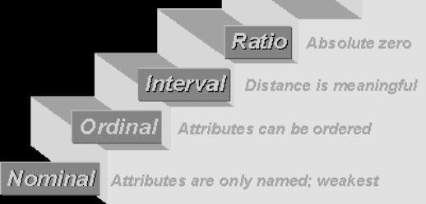  Figure 3: Scales of Measurement
  For the statistics that we will be learning we will be treating these two high levels of data in the same manner.

TABLES AND FIGURES
Variables can be expressed through the use of figures (e.g. pictures, diagrams, and graphs) and tables. Their aim is to quickly and clearly communicate the important trends in the data. Tables and figures must be able to ‘stand alone’. That is, a reader should be able to interpret their meaning without having to read a full report. Keep this in mind when presenting data in your own lab reports.

When drawing figures and tables remember to:
- give a clear, detailed title. Titles go above tables and are labelled “Table 1: ……”. Titles go below figures and are labelled “Figure 1: ……”.
- label everything in the figure or table clearly (e.g. axis, column).
- refer to them in the text (e.g. Participants who exercised more, slept longer (Figure 1).)

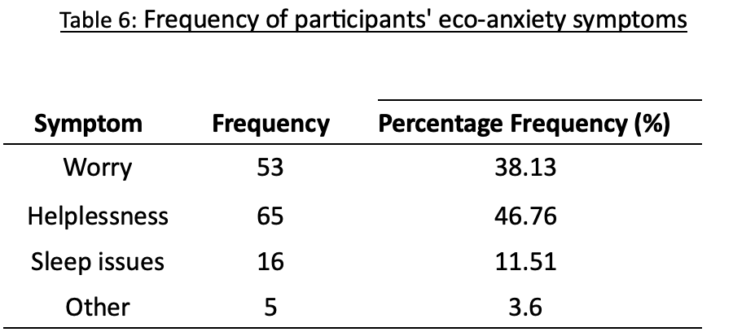
i) Frequency Table for Nominal Data

Nominal data can be clearly presented using frequency tables. Frequencies may be expressed in the form of simple frequencies or percentage frequencies.

These are calculated:

​​STEP 1: Find the category frequency: Category Frequency _{[Worry]} = 53

STEP 2: Sum the total frequencies: Worry + Helplessness + Sleep issues + other = 53+65+16+5= 139

STEP 3: Convert into percentage applying the formula:

Percentage Frequency _{[Worry]} = $\frac{53×100}{139}$ = 38.13 %

ii) Bar Chart

The main trends of the data are indicated by the heights of the bars. These represent the frequencies in each case. A bar chart is used for displaying a discretely measured variable, a categorical variable. One such variable is types of eco-anxiety symptoms (Figure 4).
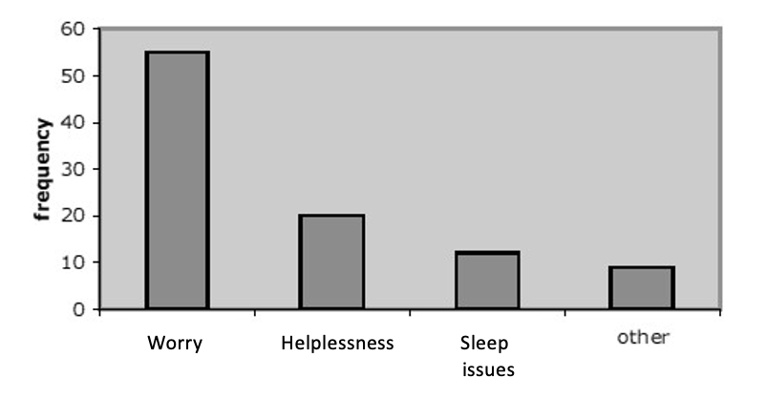

Figure 4: Bar chart showing the frequency with which different eco-anxiety symptoms are experienced.

Features:
- Bars are separate.
- Can be useful for nominal and ordinal data.
- Only the height of the bar is relevant, not the width.
- Can present frequencies, percentages & means.

Remember to:
- Keep your chart simple in appearance (e.g., colour and 3D are not necessary for most charts).
- Avoid too many bars.
- Label each bar with the category it represents and give an overall title to the horizontal axis.
- Combine the small categories into an “other” category, unless they are important categories.
- Make the bars of equal width and separate them equally.
- Avoid using a legend/key unless the data are complicated and a key will aid your understanding.

iii) Box Plot (aka Box & Whisker Plot)

This plot provides a visual representation of the median, interquartile range and range (See Figure 5). It is particularly useful for presenting ordinal data. It is also useful when comparing two or more sets of data in terms of what the typical values are in the data sets and how the remainder of data are spread around the central values. The median and interquartile range provide the ‘box’ and the range provides the ‘whiskers’.

Maximum

Minimum

75
th

percentile

25
th

percentile

Median

Range

Interquartile
Range

Figure 5: Box Plot (Box & WhiskerPlot)

iv) Frequency Table for Numerical / Score Data

For certain tests it is common for psychologists to pre-specify the responses. An example of this would be a questionnaire where one must circle a given statement that relates to another statement:

Always | Most of the time | Sometimes | Very rarely | Never
E.g. I have trouble sleeping because of environmental concerns.

This is a Likert-type response where each alternative corresponds to a value. It is summarised in a frequency table (or a histogram).

Table 7: Students’ self-reported trouble sleeping due to environmental concerns

Response Category Value Frequency
Always | 1 | 23
Most of the time | 2 | 14
Sometimes | 3 | 53
Very rarely | 4 | 8
Never | 5 | 4

v) Histogram

Histograms are often mistaken with bar-charts. The fundamental distinction between the two is: 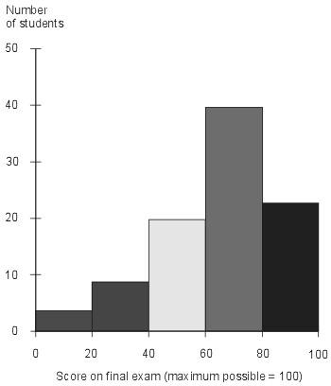
Figure 6: Histogram showing student scores on a final exam about sustainability topics.

- Bar charts show counts for a categorical variable - the only thing that can be quantified in a bar chart is the bar height.

- With histograms the area of the boxes is proportional to the density approximation; i.e. they show an approximation of the density function of a continuous variable.
The boxes do not represent distinct unrelated categories, but different points on a continuously measured numerical variable.
- The bars must touch.
- The bars can be of different width. This is where the confusion typically derives. If all bars have
the same width in a histogram (such as in Figure 6) the two plots can get mixed up. The area of each bar represents the number of observations.

MEASURES OF CENTRAL TENDENCY
Numerical indices (such as the mean) take less space than tables and diagrams and describe large amounts of data very effectively. The Measures of Central Tendency are the most ‘typical’ and ‘likely’ scores of the distribution. They include:

1) The Mode
The mode is the most frequently occurring score or category of scores. A distribution can be bimodal when two scores share the highest occurrence. Both scores are labelled as modes. Use the mode for Nominal data and for Bimodal distributions.

Advantages:

Disadvantages:

Task 2a:  Table 8: Points scored by students on a sustainability awareness exercise.  Score Frequency |  | Task 2b:  What is the mode for the following set of data?  5, 7, 3, 3, 5, 8, 9, 8, 8, 3, 6, 6, 2, 6, 2, 6  The mode of this data set = ________
  0 | 5
  3 | 7
  9 | 12
  12 | 4
  The mode of this data set =
  ____________
  since it is more frequent than any other score.

2) The Median
The median is the middle score of a set, organised from the smallest to the largest score. In a set of 15 ranked scores the median will be the 8th score. The median is good for “bad” distributions (skewed distributions and/or data with extreme values). Use the median for Ordinal data.

For larger datasets one can use the following formula: M = (n + 1)
2

Advantages:

Disadvantages:

Task 3:

The set of: 3, 5, 2, 7, 8, 1, 9 would be ranked in this order: _______________________.
The median, being the 4th score = ________.

When there is an even number of scores, the median will be the average of the two scores closest to the middle. The set of 8, 5, 3, 7, 2, 1 would be ranked: _______________________. Since there is no middle score, we take the average of the two middle scores (here, the 3rd and 4th scores) (3 + 5 / 2) and obtain ________ as our median.

3) The Mean
The everyday concept of average, calculated by adding all the scores together and dividing by the total number of scores.

Where: x = the arithmetic mean

x  = symbol for summation x =

n x = a score
n = the number of scores

The mean is based on all the data in the distribution and is generally the preferred measure of central tendency, except for “bad” distributions (non-normal distributions). Use the mean for Interval and Ratio data.

Advantages:

Disadvantages:

Task 4:
Calculate the mean for the following data set: 7, 5, 4, 7, 7, 5: ________________________.

MEASURES OF VARIABILITY (Dispersion) - The Spread of Scores
Two samples can have the same mean (see the normally distributed frequency distributions in Figure 7, both with a mean score of 53), but a very different spread of the scores. The distribution of the second graph is wider and flatter; there is more variability around the mean in the second graph.

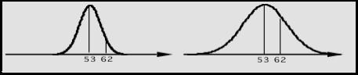
Figure 7: Normal distribution showing data sets with the same mean but with different variability.

Various measures can be used to determine the amount of variability in a distribution. These measures fall into two categories:

- Distance Based Measures
- Centre Based Measures
a. Distance Based Measures:

i) The Range
This is the interval between the largest score and the smallest score and is expressed as a single number (i.e. maximum score – minimum score = range).

Advantages:

Disadvantages:

Task 5:
Of the following set: 2, 3, 5, 9, 13, 14, 17, and 32 the range is__________________________.

ii) The Interquartile Range (IQR)
The interquartile range represents the range covered by the middle 50% of the distribution. First order your scores from smallest to largest. Circle the median value and now look at the data in two parts – those data points that fall below the median and those data points falling above the median. For each half of the data calculate the median value. Finally, subtract the median from the lower half of the data from the median of the top half of the data. The result is the IQR. For example, imagine you have the following data set: 2, 3, 5, 9, 13, 14, 17

IQR = ( 2 3 5 ) 9 ( 13 14 17 ) IQR = 14 – 3 = 11

Median for lower Median for Median for upper
half of data set full data set half of data set

Advantages:

Disadvantages:

Task 6:
Of the following set: 2, 3, 5, 9, 13, 14, 17, 32…the interquartile range is ______________ .
Of the following set: 2, 3, 5, 9, 13, 14, 17…the interquartile range is __________________ .

Note: Typically we would present the median, range and IQR together to best describe data at the ordinal level, as these measures are all based on position. A template for presenting these descriptive statistics in a lab report is as follows: the median score was XX (range = xx, IQR = xx).
b. Centre Based Measures:

In contrast to the range, the centre based measures combine all the values (all the data points) in a dataset to produce a measure of spread. They are used to calculate the dispersion from the mean and thus give an idea of how closely concentrated round the mean a random data point is likely to be.
Small variance: data points tend to be close to the mean.
Large variance: data points tend to be further from the mean.

i) The Variance
The variance is the average squared distance from the mean.
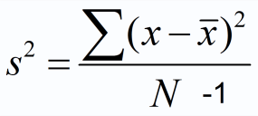 | (X- x )² = | The mean is subtracted from each of the scores; the difference is squared; then (and only then) all the squared differences are summed.
 | N = | Total number of scores/sample size (can be presented as either ‘N’ or ‘n’).
 |  = | Summation sign

Example:
Table 9: Worked example of the Variance calculation
Score (X) | (X - x ) | (X- x )²
6 | 6 – 8.2 = -2.2 | 4.84
13 | 4.8 | 23.04
5 | -3.2 | 10.24
5 | -3.2 | 10.24
12 | 3.8 | 14.44
x = 41 / 5 = 8.2 N = 5 |  | (X- x )² = 62.8

Using the data in Table 9 above, we put the values into the formula:
S

² =  (x - _{x} )² / N -1 = 62.8 / (5-1) = 15.70

Advantages:

Disadvantages:

Task 7a: Calculate the variance.

  Score (X) | (X - x ) | (X- x )²
  5
  12
  4
  12
  x =  N = |  | (X- x )² =
  Note: Don’t round any values until you get to your final
  answer and then
  round your answer to 2 decimal places.

S
2

=

Task 7b: Calculate the variance.

  Score (X) | (X - x ) | (X- x )²
  13
  2
  6
  17
  5
  5
  x =  N = |  | (X- x )² =
  Remember: Don’t round any values until
  you get to your final answer and then
  round your answer to 2 decimal places.

S
2

=

ii) The Standard Deviation
There is one problem with using variance to represent the amount of spread in the data. Variance is not on the same scale as the scores and the mean of the scores. It is not given in units of X (pears, people, pounds etc.) but in units of X². Thus, if we were measuring height, variance would be in units of height² (area), which can be pretty hard to interpret (!). The way to deal with this is to take the square root of the variance, which gives us the standard deviation.

The standard deviation is the standard unit of measurement in statistics (it is the one you should state every time you state the mean).

It is useful because its size indicates the amount of variability in a set of scores. The bigger the standard deviation, the more spread-out the scores. The standard deviation represents the average amount that scores vary from the mean of the set of scores. In other words, it tells you how far away from the mean, any random data-point in your data-set is. A large standard deviation therefore means that a data-point that you might choose at random from your data-set is relatively far from the mean (if this is the case, the mean may be misleading as a representation of your ‘average’ score). But, like the variance, it is highly affected by outliers. Thus, it is best for normally distributed data.

As with the variance, the complication comes when we want to make statements about the population (on which our sample is based) rather than merely our sample. We typically want to say something about how people in general might respond to X, rather than just the 40 people in the sample that we study.

However, our sample is only an estimate of the population, and samples tend to under-estimate the variance in the actual population (partly because the sample tends to be much smaller than the population).

Therefore, there are two formulas to calculate the standard deviation:

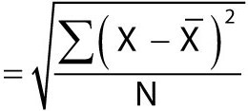
The population standard deviation

Use this formula when you have tested every subject in the population and wish to calculate the standard deviation for that population.

The sample standard deviation
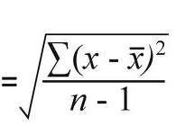
Use this when you have a sample, but want to describe the population from which the sample was drawn (this is the formula we will use in SD our labs).

You will see that the two formulae are very similar. The only difference being that the formula for the sample SD allows the variability in our data to be larger, since we expect our sample to underestimate the population variance. It does so by dividing the numerator of the equation by N-1 rather than by N. By dividing with a smaller number (N-1 rather than N) we get a larger standard deviation.

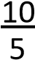
E.g.: 10 = 1.67 vs = 2
6
When we report the sample SD, we therefore allow for more variability in the data.
a) Steps for Calculating the Sample Standard Deviation:
- Calculate the mean
- Subtract the mean from each raw score
- Square each deviation score
- Sum all squared scores
- Divide the sum by the number of scores minus 1
- Take the square root

Example:
Table 10: Worked example of the Standard Deviation calculation
Score (X) | (X - x ) | (X- x )²
6 | 6 – 8.2 = -2.2 | 4.84
13 | 4.8 | 23.04
5 | -3.2 | 10.24
5 | -3.2 | 10.24
12 | 3.8 | 14.44
x = 41 / 5 = 8.2 N = 5 |  | (X- x )² = 62.8

Using the data in Table 10 above, we put the values into the formula:
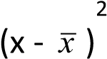

Step 1:  / N -1 = 62.8/ (5-1) = 15.70

15.70 is the Variance. We need to square root this value to get the Standard Deviation
2

Step 2: S.D. = √  (x - x ) / N -1 = √15.7 = 3.96 (2 decimal places, dp)

Advantages:

Disadvantages:

Task 8:
Score (X) | (X - x ) | (X- x )²
6
13
3
15
x =  N = |  | (X- x )² =
Remember: Don’t round any values until your final
answer (which you round to 2dp).
Calculate the standard deviation (S.D.).

S.D.

S² =

S.D. =
27

Task 9:
Chang, C., Lin, B. B., Feng, X., Andersson, E., Gardner, J., & Astell-Burt, T. (2024). A lower connection to nature is related to lower mental health benefits from nature contact. Scientific Reports, 14(1). https://doi.org/10.1038/s41598-024-56968-5

The aim of the study is to determine if there is any difference in the mental health benefits from nature contact between individuals with higher and lower connection to nature. The hypothesis is that a lower connection to nature is related to lower mental health benefits from nature contact. Participants are divided into two groups according to their reported connection to nature (High Connection and Low Connection). They are surveyed about their frequency of visits to public greenspaces and their levels of stress and anxiety, following the procedure established by Chang et al. (2024). The reactions of the participants are recorded through self-reported measures, including an open-ended question about their reasons for visiting greenspaces. All participants engage in nature contact activities for 25 sessions. Results are reported as the percentage of sessions in which participants with higher and lower connections to nature report reduced stress and anxiety levels.

Table 11a: Mental health benefits from nature contact characterized by the percentage of sessions where participants reported reduced stress and anxiety levels.

Data Set A: LOW CONNECTION TO NATURE | Data Set B: HIGH CONNECTION TO NATURE
76 | 82
40 | 76
56 | 96
88 | 92
44 | 86

Table 11b: Calculate the mean and standard deviation for Data Set A
Score (X) | (X - x ) | (X- x )²
x =  N = |  | (X- x )² =

SD =

Table 11c: Calculate the mean and standard deviation for Data Set B
Score (X) | (X - x ) | (X- x )²
x =  N = |  | (X- x )² =

SD =

Task 9 continued:
Describe and compare the two data sets on the previous page by looking at the means and standard deviations.

b) The Standard Deviation and the Normal Curve:
Knowing the SD allows us to determine the location of a score in the distribution.

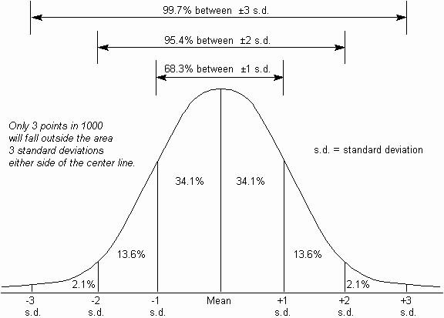

Figure 8: The normal distribution with the standard deviations and the percent of scores that fall within each section of the graph. (Note that only 3 points in 1000 will fall beyond the area three standard deviations either side of the mean.) (Adapted from http://syque.com)

iii) Z-Scores: Measuring the Number of Standard Deviations
The z-distribution allows us to determine where a given score is, relative to the rest of the scores. The z-score tells us how many standard deviations away from the mean any given score is. In order to calculate the z-score value, one must know the mean and standard deviation.
z-score = X - x

SD

Z-scores are very useful because they allow us to compare and combine variables that use different units of measurement.

Example:

Claire is pleased that they scored 60 on an Environmental Awareness test. Jamie, however, is disappointed to have scored 60 on an Eco-Anxiety questionnaire. They have the same scores, why the different reactions?
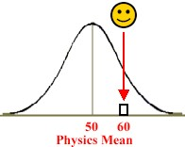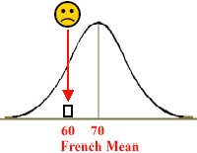

T
he Environmental Awareness Test

Mean score = 50

S.D. = 10

Claire scored 60

Z = (60
-

/ 10 =
50)

+1

With a z score of +1 Claire scored better

than most in her class.

Eco-Anxiety questionnaire

Mean score = 70

S.D. = 5

Jamie scored 60

Z = (60
-

70)
/ 5 =
-
2

With a z score of
-
2

Jamie

scored
below

most in
his

class.

Figure 9: Comparing the mean and spread of the Environmental Test and the Eco-anxiety Test
.

Mean
Mean

Using what we know about the standard deviation and the normal distribution (see Figure 8), we can compute that:

84% (2.1 + 13.6 + 34.1 + 34.1) of the students in Claire’s class scored lower than she did.

97.5% (13.6 + 34.1 + 34.1 + 13.6 + 2.1) of students in Jamie’s class scored higher than he did.

Task 10:
Members of Emma’s community participate in sustainability activities on average two times per week with a standard deviation of 2.3. Emma participates in sustainability activities six times per week. Calculate Emma’s z-score to see how her engagement compares to the average of her community members. What can you conclude?

Z =
Conclusion:

SHAPES OF DISTRIBUTIONS
When carrying out statistical analyses we must take into account the shape of the score distribution. The normal curve (the normal distribution) is a symmetrical, bell-shaped curve, which is useful in statistics, primarily because many distributions are of approximately this shape.



It is a frequency distribution, in which most scores cluster around the mean.

-3
-2
-1
0
.+1
.+2
.+3
In Figure 10 the x-axis represents test scores, and the Y-axis represents the frequency with which they occur.
Progressively less likely scores occur further away from the mean.
The normal distribution is extremely common. Figure 10: The normal distribution.

Intelligence, height, shoe sizes, the life of a light bulb etc. are all normally distributed.
95.4% of the scores in a normal distribution lie within approximately two standard deviations of either side of the mean.

The normal distribution is important because:
- analysis of data that is normally distributed in a population is far more straightforward than for any other type of distribution.
- it is necessary for parametric tests (if data is not normally distributed, you have to use nonparametric tests (introduced in Semester Two)).

In a perfectly symmetrical normal curve the mean, mode and median are identical. If their values differ, the curve is asymmetrical; in other words, non-normal. Frequency distribution curves can be distorted depending on their skew:

Skew is the extent to which a curve is lopsided rather than symmetrical. Remember that the normal distribution is a frequency distribution; the X-axis represents the scores; the Y-axis represents the
frequency of the scores.

Positive skew

More scores are found to the right of the mode. The median and mean are bigger than the mode.
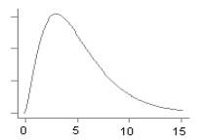
Figure 11: Positive skew.

Negative skew

More scores are found to the left of the mode. The median and mean are smaller than the mode.
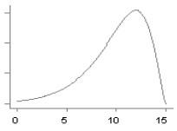
Figure 12: Negative skew.

SECTION 3: INFERENTIAL STATISTICS & T-TESTS

Section covers:
      - Descriptive Statistics
      - Inferential Statistics
      - Hypothesis Testing
      - One- and Two-Tailed Tests
      - Type I and Type II Errors
      - Standard Error
      - The t-test
      - Paired-Samples t-test
      - Independent-Samples t-test

SECTION 3: INFERENTIAL STATISTICS & T-TESTS

DESCRIPTIVE STATISTICS | Describes a sample and the population from which it is drawn by using statistics to summarise the central tendency and variability of the data (e.g., mean, median, and standard deviation).
INFERENTIAL STATISTICS | Enables you to draw inferences such as:
Does one variable predict another variable?
Are two group means really different from each other? That is, are they more different than would be expected by chance?

Sample data can be used to assess the relative plausibility of competing hypotheses, as they apply to the population. But, because we tend to study only a subset of a population (a sample), actual PROOF is not possible (we would need to test the entire population to obtain 100% certainty).

There will always be a degree of uncertainty in our decisions. The cause of this is variability (in the population and the sample). But, while we cannot prove absolutely, we can prove beyond reasonable doubt (this is an important distinction to keep in mind).

Inferential Statistics measures the variability in our data, and by doing so, tells us how confident we can be that what we found reflects how the rest of the population behaves.

Inferential Statistics therefore allows us to assess effects of the independent variable against the background of random variation. In other words, Inferential Statistics give the probability that a certain result occurred because of chance factors, i.e. with no influence from the independent variable. If there is a very small chance of this (usually 5% is used as the ‘drop-off point’), we can conclude that the effect that we see is caused by the independent variable.

There are many different kinds of statistical tests, and the one you choose depends on the design of the research. They each involve different calculations. At the end of a calculation you end up with a single score, which you use to look up (in a statistical table) the probability that the differences between the groups could have occurred by chance.

HYPOTHESIS TESTING
When we want to make comparative statements, such as saying that one treatment is better than another, we have to go through hypothesis testing. Science works in a ‘round-about’ way. Instead of proving hypotheses, it works by disproving hypotheses (more specifically, by disproving the Null hypothesis, H_{O} - the hypothesis of no effect).

Hypothesis testing is based on the same principle as the legal concept of being “innocent until proven guilty beyond reasonable doubt”. When we test hypotheses (guilty or not guilty, the drug has an effect or does not have an effect etc.), the H_{O} is assumed to be true until evidence clearly calls it into question.

Therefore, hypothesis testing aims to disprove the H_{O} (akin to disproving that a defendant is innocent). You begin with the assumption that there is no effect in the population (as in a court of law: the defendant is innocent; or in science: the drug has no effect). Then you see if the value you get for the effect in your sample (the number returned in the statistical test) is the kind of value you would expect if there really were no effect in the population. If that value is unlikely in a population in which there is no effect, you can conclude that there is an effect (this is the ‘round-about’ but very important bit!).
When we test a hypothesis, we want to determine if a particular value of a sample comes from a known population (from the drugs with no effect on a given disease, those innocent of a crime that just by chance happen to be at the crime-scene when the crime is committed, or individuals with no change in eco-anxiety after participating in a nature-based mindfulness program, etc.).

For example, before implementing a new urban green space initiative, a city planner will want to know if the residents’ levels of eco-anxiety will be different from the levels of those who do not have access to the new green spaces.

The test will be whether the sample residents, who have access to the new urban green space initiative, come from the population that we already know about (residents without access to the green spaces), or from a different population (residents who may have benefited from the green spaces). If the statistics indicate that the residents ‘come from two different populations’ (and the experiment is well designed), we can conclude that the difference is due to the green space initiative.

Populations defined by the H_{O} will be those where the correlation between the two variables considered (e.g. access to green spaces [access/no access] and eco-anxiety levels) is zero.

We can determine if it is likely that the sample comes from the population defined by the H_{O} (i.e. from a population, in which there is no effect). If that is unlikely, then you can reject the H_{O} (which has then been disproved) and accept the H₁.

This means that there is a statistically significant difference between the control and experimental groups (an effect of varying the independent variable [for example, providing or not providing access to green spaces]), implying that there is a relationship between the variables.

If the relationship is statistically significant we can generalise from our sample to the population.

Hypotheses, Significance and Inferential Tests
In deciding the significance level (the p-value), we must be aware of the pitfalls associated with both setting the significance level either too low or too high. In psychology the accepted significance level is 5% (p < 0.05), which gives an acceptable balance between Type I and Type II errors (more below).

The ‘p’ in p-value is short for probability (a p-value is also called an alpha level). A p-value of 0.05 means that if the null hypothesis was true (i.e. there is no relationship between variables) there is a 5% chance of finding the obtained result on the statistical test.

Sometimes researchers want to be very sure before they decide if a value is different (e.g. in medical research). Thus, we can use a p-value of 0.01 as well.

If the p-value is 0.01, then there is only a 1% chance of finding the given results if there were no true relationships between the variables. As the probability of finding your results is so unlikely (when there isn’t a real relationship) we can be more confident that there is a true relationship between our variables.

Accepting or Rejecting the H_{O}
To determine if a value is from a known population, we start by converting the value into a z-score and then find out how likely that score is for the known population (hypothesis testing follows the logic of Figure 8).

- If the value is likely for the known population, then it is likely that the value comes from that known population (in other words, that the treatment had no effect). Thus, if the sample’s test value (e.g. t-value) is within the 95% interval, we accept the H_{O} that there is no relationship between the variables.
- If the value is unlikely for the known population, then it probably does not come from the population we know about, but instead comes from some other population (in other words, the treatment had an effect). A value is considered unlikely if it is less than 5% likely for the known population. Any value that occurs 5% or more of the time for the known population is considered likely and part of the known population. Thus, if the sample’s test value is within the extreme 5%, we conclude that there is less than a 5% chance that it happened by chance, and accept the alternative hypothesis (H₁) that there is a relationship between the two variables we are looking at.

Critical values
Tables can be used to find the minimum size of the value, which cuts the 95% from the extreme 5%. The cut-off points provided by the tables are called critical values (Figure 13). Critical Values are a way to save time with hypothesis testing.
We do not have to look up the probability of getting a particular value in order to verify if it is less than 5% likely. The reason is that there is only one z-score that is 5% likely. Any z-score beyond that point is less than 5% likely. Thus, we only have to verify that the computed z-score is more extreme than the one that is 5% likely.

The critical value is affected by:
- The alpha level (i.e. the p-value that we have set. If the p-value is 0.01 [1%] the critical value will be different from that for a p-value of 0.05).
- The degrees of freedom (which is usually N-1).
- Whether we are performing a one- or a two-tailed test (see below for details).

ONE- AND TWO-TAILED TESTS
When comparing the two sets of scores, we want to know, whether they are sufficiently different from each other, in order to “fall” in the extreme 5% of the distribution.

Two-Tailed Tests:
When making a non-directional prediction (a two-tailed hypothesis) we test for unlikely events on both sides of the mean (above and below) at the same time. (E.g. “H₁​ = Access to green spaces affects stress levels”, meaning that access to green spaces may either increase or decrease stress levels). Thus, we split the ‘unlikely block’ of 5% into two parts, each half together totaling 5% of the area. Hence, the two 2.5% extremes of the distribution are the area of statistical significance (see shaded sections of Figure 13).

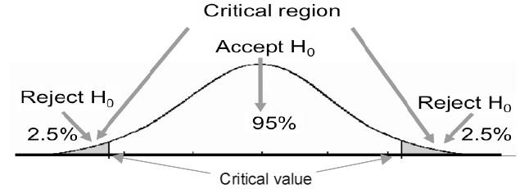
Figure 13: Accepting / rejecting the null hypothesis in a two-tailed test.

One-Tailed Tests:
In a one-tailed test we are looking at only one tail of the distribution at a time (either on the positive side above the mean or the negative side below the mean).

For example:
H₁ = Access to green spaces has a negative effect on stress levels (first graph in Figure 14)

OR
H₁ = Access to green spaces has a positive effect on stress levels (second graph in Figure 14)

Thus, when making a directional prediction, the 5% extreme of the distribution should be used as the area of statistical significance. This means that all of the 5% cases, which we define as significant, should be in one extreme of the sampling distribution (it is not split into 2 x 2.5% as in a two-tailed test) (Figure 14).

Directional hypotheses are therefore more likely to produce a significant result than non-directional hypotheses for the same data (make sure you understand why). This means that with less strong trends, you can achieve the same level of significance if your hypothesis and test are one-tailed. This makes it tempting for researchers to test one-tailed rather than two-tailed hypotheses. But remember: one-tailed hypotheses (and by consequence, one-tailed tests) are only allowed if they are based on theories and/or previous research showing consistent trends in that direction.

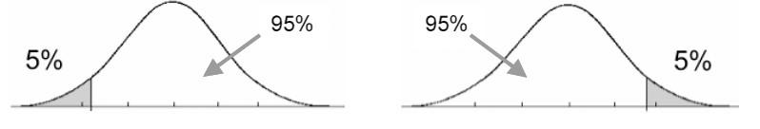
Figure 14: One-tailed significance shown at either end of the normal distribution.

Important: If a negative relationship arises instead of the positive one predicted (or vice versa) it should be ignored (it then supports the H_{O} that there is no positive relationship between the two variables). One should never change the direction of the hypothesis after collecting the data (that would amount to cheating!).

TYPE I AND TYPE II ERRORS
There is always a chance of incorrectly rejecting the null hypothesis.

Type I Error: is when you decide that a null hypothesis is false when it is in reality true.

Type II Error: is when you decide that a null hypothesis is true when it is in reality false.

The purpose of statistical tests is to determine which of the two hypotheses (H_{O} or H₁) is true, while juggling Type 1 and Type 2 errors.

The probability of making a Type I Error is the same as the p-value in the statistical test (typically 0.05, i.e. 5% or 0.01, i.e. 1%).

We cannot however simply be more conservative in our choice of significance level in order to avoid Type I errors, as this will increase the chance of a Type II Error. Statistical tests in which there is less chance of making a Type II error are said to be more powerful.

Table 12: Type I and Type II errors.
 | The truth: H is true / the  O  accused is not guilty | The truth: H is false / the  O  accused is guilty
Reject H  O | Type I Error  An innocent is convicted | Correct decision /  Justice is served
Fail to reject H  O | Correct decision /  An innocent person is free | Type II Error  A guilty person is freed

STANDARD ERROR

Standard Error (SE) = Standard Deviation (SD)
N

The s.e. can be used as a rough test of significance (often calculated before carrying out an inferential test). Figure 15 shows that there is, in this sample, a difference between the boys' and girls' scores (the mean scores are 500 and 600, respectively).

But can we, on the basis of this data, conclude that this is also the case for the population? (Remember that the sample is only a subset of the population and therefore tends to underestimate the variability that there is in the population).

Here the s.e. is helpful. The top of the error bar is the mean + s.e. The bottom of the error bar is the mean - s.e. In between the top and bottom error bar is a fuzzy area in which the population

0
200
400
600
800
Boys
Girls

mean

lies (Figure 16
).

0
200
400
600
800
Boys
Girls
0
200
400
600
800
Boys
Girls

Figure 15: Scores on a linguistic test of Figure 16: Scores on a linguistic test of 10- Figure 17: Scores on a linguistic test 10-year-old children. year-old children (showing overlap of error of 5-year-old children (showing no
bars) overlap of error bars).

Although in Figure 15 and Figure 16 there is a difference in the sample means (500 vs. 600), the standard error bars overlap, which suggests that there is in fact no significant difference between the means in the actual population. If the standard error bars do not overlap, as in Figure 17, the means of the actual populations (and not just the sample means) are likely to be significantly different from each other.

THE T-TEST
The t-test is an inferential test that assesses whether the means of two groups are statistically different from each other.

Examples:

- Do men and women perform differently on a test of spatial ability (are the group scores different)?
- Does drug A treat headache pain more effectively than drug B?
- Does participating in a sustainability education program improve environmental awareness more effectively than not participating?

The problem is that if you calculate two sample means and they are physically different, there are two possible reasons for the difference:

- Each group comes from a different population and the sample means represent two different populations. If this is the case you reject the Null Hypothesis.
- The groups come from the same population, and the means vary by chance. The groups are not different. You just happened to pick two groups with means that are far apart. If this is the case, you fail to reject the Null Hypothesis.

We can decide which of the explanations above is correct by completing the t-test. We compare the two means and get an estimate of the probability that the means are different simply by chance. I.e. if they differ more than they would if there were in reality no difference in the population.

The t-test is based on the underlying assumptions of the H_{O} that there is no relationship between the two variables (the IV and DV), and therefore there is no difference between the means of the two groups.

If we accept the H_{O} (that there is no difference between the two groups due to the independent variable) then we can assume that both samples come from the same population of scores. Therefore, differences between the samples are due to chance factors and not a relationship between the independent variable and dependent variable.

The t-distribution is a theoretical statistical distribution, which like the z-distribution’s z-score, has a t-score. It is based on the same logic, the difference being that the t-score uses the standard error instead of the standard deviation like the Z-score does.

Like a z-score, the t-score tells you if the difference is far away from the centre of a distribution.

If you have the standard error of a set of sample means, the t-distribution allows you to calculate how your sample mean differs from the average sample mean (which essentially is the population mean).

By calculating the standard error of the differences between the two groups of scores, we can tell by how much the difference between the two sample means is likely to deviate from the population mean difference (which, according to the H_{O}, is 0).

Remember how the z-score was calculated?

Z = particular score – sample mean of scores standard deviation of scores

To calculate a t-score:

t = particular sample mean – average of sample means standard error of the sample means

t = particular sample mean – population mean standard error of the sample means

The top part of the formula is easy to compute -- just find the difference between the means. The bottom part is called the standard error of the difference. To compute it, we take the variance for each group and divide it by the number of people in that group. We add these two values and then take their square root.

The t-statistic is therefore a ratio that measures the actual difference between the groups in terms of the amount of difference that would be expected due to chance (i.e. the standard error). Therefore, the larger the value of t, the larger the difference between the group means, and the lower the probability that the result occurred through chance factors.
When comparing the two sets of scores we want to know whether they are sufficiently different from each other to “fall” in the extreme 5% of the distribution.
If the H_{O} is true, 95% of all the differences lie within roughly 2 s.e. on either side of the centre.
Once you have computed the t-value, you have to look up the critical value in a table of significance. The significance table for the t-distribution reports the value of the score necessary to put a sample mean in the extreme 5% of the sample means, which are statistically significant or improbable.

Therefore, if the t-value is big enough (bigger than the critical value that you look up in a significance table), you can reject the null hypothesis. You then conclude that it is unlikely that the samples are different simply by chance. Since the only difference between the samples should be the level of the IV, the difference must be caused by the IV.

Note: The t-value will be positive if the first mean is larger than the second, and negative if it is smaller. Whether the t-value that you have calculated is positive or negative is irrelevant when you look up the critical value (ignore the +/- sign).

Two types of t-tests exist; the paired-samples (within subjects, related) t-test and the independent samples (between subjects, unrelated) t-test. Which one you should use depends on your experimental design (within or between subjects).

Both t-tests are parametric tests, which means the data has to meet certain criteria:
- The scores (the DV) must be at an interval or ratio scale.
- The data must be normally distributed.
- The groups must have homogeneity of variance (similar variances).

PAIRED-SAMPLES T-TEST
The main feature of paired-samples t-tests is that the same participants’ performance is measured twice on one variable under different conditions (we are looking for differences within subjects).

Example: An experimenter aims to find out whether participating in a community garden affects people's stress levels. Participants' levels of stress are recorded before and after a 3-month period of participation in the community garden.
In this experiment, the independent variable is the different points in time (before and after participation) at which stress levels are measured, and the dependent variable is the stress scores of participants.
The H_{O}​ states that there is no difference in the participants’ stress levels before and after participating in the community garden. This implies that the two samples come from the same population.

Table 13: Participants' stress levels measured before and after participation in a community garden.

Participant | Before (X₁) | after (X₂)
1 | 4.2 | 5.6
2 | 5.3 | 7.2
3 | 6.6 | 2
4 | 8.4 | 6.1
5 | 5.6 | 7.4
6 | 3.3 | 3.1
7 | 8.8 | 8.5
8 | 4.7 | 5.4
9 | 9.3 | 7.8
10 | 6.8 | 8.4

We calculate the t-score for this example as follows:

STEP 1:
In order to compare both samples, we subtract one set of scores from another to convert them into a single sample. A set of scores (d), which results from the difference between the scores, is obtained.

STEP 2:
According to the H_{O} the mean of d should be 0.
However, in this example we see that the difference score is 1.5 which means there is a mean difference score of 0.15 (∑d/10 = 1.5/10 = 0.15). We need to know whether 0.15 is sufficiently different from 0 in order for the two sets of data to be considered significantly different from each other.

We calculate the t-score for this example as follows:

Table 14: Calculations for a Paired-Samples t-test for data in Table 13.

Participant | Before (X₁) | After (X₂) | Difference d = X₁ – X₂ | d²
1 | 4.2 | 5.6 | -1.4 | 1.96
2 | 5.3 | 7.2 | -1.9 | 3.61
3 | 6.6 | 2.0 | 4.6 | 21.16
4 | 8.4 | 6.1 | 2.3 | 5.29
5 | 5.6 | 7.4 | -1.8 | 3.24
6 | 3.3 | 3.1 | 0.2 | 0.04
7 | 8.8 | 8.5 | 0.3 | 0.09
8 | 4.7 | 5.4 | -0.7 | 0.49
9 | 9.3 | 7.8 | 1.5 | 2.25
10 | 6.8 | 8.4 | -1.6 | 2.56
 | Total = 63  Mean = 6.3 | Total = 61.5  Mean = 6.15 | ∑d = 1.5 | ∑d² = 40.69

To find out we use the paired-samples t-test formula: t =

d
n
d
d
n
−
−



²
²
1
(
)

=

1.5

=
1.5 = 0.22 (2dp
)

t = 1.5 = 1.5

(10 x 40.69) – (1.5)² (406.9 – 2.25) 44.9611111 6.705304699

(10 - 1) 9

If the value we obtain is equal to or greater than the critical value in the appropriate significance table for the corresponding degrees of freedom (df = N-1; in this example df= 9), we can accept the H₁ because our value is in the extreme 5% of the population sample means.

However, since our 0.22 is not larger than the critical value (2.262, 2 tailed test, 5% level) we must accept the H_{O} that there is no difference in the stress levels of our participants before and after participation in the community garden. The mean values of stress for the two points in time are different (Before mean = 6.3; After mean = 6.15) but the t-test has shown that they are only different due to chance and random factors and that there is no real difference between the two sets of stress recordings.

NB: it is a two tailed test because our initial hypothesis was non-directional.

An example of how the results would be presented in a lab report:

A paired-samples t-test revealed no significant difference between the two conditions
(t ₍₉₎ = 0.22, n.s.). Participants showed a similar level of stress before and after participation in the community garden.

(Please note: n.s. = non significant; if you were to find a significant result you would report your findings as follows: t_{(df)} = X, p<0.05)

Task 11: Class exercise
Participant | Condition A Blur | Condition B No Blur | Difference (d) |  | d²
1
2
3
4
5
6
 | Total =  Mean = | Total =  Mean = | ∑d = | ∑d² =

Calculate your t value using data from the above table: t =

d
n
d
d
n
−
−



²
²
1
(
)

t =

df = n – 1 = _______________________
Based on our original hypothesis, this will be a: 1 tailed-test OR 2 tailed-test (circle correct one)
Critical Value = _____________________ (see page 63)
Explain your findings in words (using the template at the bottom of page 39):

Task 12:
Concerned about the initial low levels of environmental awareness among her students, Paula enrols each of her students in an intensive sustainability education program. Paula expects the program to be effective and for environmental awareness to improve significantly after the course. Has the sustainability education program helped?

Participant | Environmental Awareness Score Before (A) | Environmental Awareness Score After (B) | d = (A – B) |  | d²
1 | 10 | 2
2 | 5 | 1
3 | 6 | 7
4 | 3 | 4
5 | 9 | 4
6 | 8 | 5
7 | 7 | 2
8 | 5 | 5
9 | 6 | 3
10 | 5 | 4
 | Total =  Mean = | Total =  Mean = | ∑d = | ∑d² =

Calculate your t value using data from the above table:
t =

Explain your findings in words:

INDEPENDENT-SAMPLES T-TEST
In the independent-samples t-test two groups of scores from two different groups of participants are compared to see whether their means differ significantly.

Like the paired-samples t-test, the independent-samples t-test is based on the underlying assumptions of the H_{O} that there is no relation between the two variables, i.e. that there is no difference between the means of the two groups.

t = Differences between two sample means
Difference expected by chance

t = Differences between two sample means
Standard error

t
x
x
x
x
n
x
x
n
n
n
n
n
=
−
−
⬆

⬇
⬇

✗


+
−
⬆

⬇
⬇

✗


−
+
−
+
⬆

⬇

✗





1
2
1
2
1
2
1
2
2
2
2
2
1
2
1
2
1
1
1
1
(
)
(
)
(
)
(
)

Example:
Does the type of residential area (urban versus rural) impact the level of eco-friendly behaviors among residents? (see Table 15)

STEP 1: Fill in the following table:
Table 15: Eco-friendly behaviors among urban vs. rural residents
Subject | Urban Area X₁ | X₁2 | Subject | Rural Area X₂ | X₂2
1 | 8 | 64 | 1 | 29 | 841
2 | 2 | 4 | 2 | 1 | 1
3 | 42 | 1764 | 3 | 17 | 289
4 | 31 | 961 | 4 | 22 | 484
5 | 5 | 25 | 5 | 12 | 144
6 | 12 | 144 | 6 | 3 | 9
7 | 79 | 6241 | 7 | 45 | 2025
8 | 63 | 3969 | 8 | 30 | 900
9 | 4 | 16
N₁ = 9 | X₁= 246  Mean = 27.3333 | X₁² = 13188 | N₂ = 8 |  X₂ = 159  Mean = 19.875 | X₂² = 4693

STEP 2: Using the values calculated in STEP 1 complete the t-test formula.

Remember: Don’t round until the final value and be sure to note the different sample sizes.

t = 27.333333 – 19.875

[13188 – (246)²] + [4693 – (159)²] x 1 + 1

9 8 9 8
(9 – 1) + (8 – 1)

t = 7.4583333

[13188 – 6724] + [4693 – 3160.125] x 0.236111111

15

t = 7.4583333

[6464] + [1532.875] x 0.236111111

15

t = 7.4583333

125.8767355

t = 7.4583333
11.21948018
t = 0.66 (2dp)

If the value of t is equal to or exceeds the critical value in the significance table for the corresponding degrees of freedom (df = N1 + N2 – 2 OR df = (N1 – 1) + (N2 – 1); in this example df = 9+8-2 = 15), the result is statistically significant. In this case, t (0.66) is less than the critical value (2.131, 2 tailed test, 5% level) and therefore the results are not statistically significant.

An example of how the results would be presented in a lab report:

An independent samples t-test showed no significant difference in the level of eco-friendly behaviors between urban and rural residents (t ₍₁₅₎ = 0.66, n.s.).

(NB: If you were to find a significant result you would report your findings as follows: t_{(df)} = X, p<0.05)

Task 13: Class exercise
 | Group A (Burglar) |  |  |  | Group B (Buyer)
N | Scores (X₁) | Scores² (X₁²) |  | N | Scores (X₂) | Scores² (X₂²)
1 |  |  |  | 1
2 |  |  |  | 2
3 |  |  |  | 3
4 |  |  |  | 4
5 |  |  |  | 5
6 |  |  |  | 6
N₁ = | X₁=  Mean = | X12 = | N₂ = |  |  X₂ =  Mean = | X₂² =

t
x
x
x
x
n
x
x
n
n
n
n
n
=
−
−
⬆

⬇
⬇

✗


+
−
⬆

⬇
⬇

✗


−
+
−
+
⬆

⬇

✗





1
2
1
2
1
2
1
2
2
2
2
2
1
2
1
2
1
1
1
1
(
)
(
)
(
)
(
)

Calculate your t value using data from the above table:
t =

Explain your findings in words:

Task 14:
A researcher wishes to investigate the impact of nature sounds on task performance. She has two groups of students and asks them to complete a task. Group A complete the task with forest sounds playing in the background, while in a separate room Group B have urban city sounds playing. Analyze the data below to better understand the impact that the type of background sound has on task performance.

 | Group A |  |  | Group B
N | Scores (X₁) | Scores² (X₁²) | N | Scores (X₂) | Scores² (X₂²)
1 | 10 |  | 1 | 2
2 | 5 |  | 2 | 1
3 | 6 |  | 3 | 7
4 | 3 |  | 4 | 4
5 | 9 |  | 5 | 4
6 | 8 |  | 6 | 5
7 | 7 |  | 7 | 2
8 | 5 |  | 8 | 5
9 | 6 |  | 9 | 3
10 | 5 |  | 10 | 4
N₁ = | X₁=  Mean = | X12 = | N₂ = |  X₂ =  Mean = | X₂² =

Calculate your t value using data from the above table:
t =

Explain your findings in words:

Task 15: t-test practice question 1

Promoting the adoption and maintenance of household water-saving behaviours is an important component of responding to water scarcity. While much research identifies what influences the adoption of new behaviours, factors that support the maintenance of these behaviours have rarely been examined. To address this, you will conduct a controlled study to explore how different types of encouragement affect the maintenance of water-saving behaviours, based off of Dean et al. (2021).
The study takes place in a controlled environment where participants have full control over their water usage. You recruit 14 environmentally conscious individuals and randomly divided them into two groups. People in the first group receive regular reminders and educational material about water-saving (Group A), while people in the second group receive no additional encouragement (Group B). They are each asked to maintain water-saving behaviours over a week and are told that the five people who save the most water will win a meaningful prize (in order to motivate them to reduce water consumption as much as possible). Overall, those in the 'reminder and education' condition are faster at adopting water-saving behaviours than those in the 'no encouragement' condition. You conclude that regular reminders and educational material help maintain water-saving behaviours. But are your conclusions statistically valid? The water used by each individual in the two groups is given below (in litres). What is the appropriate analysis to perform and what is the outcome of that analysis?

Total water used (litres) for the reminder and education group | Total water used (litres) for the no encouragement group
21 | 25
30 | 25
27 | 36
18 | 42
16 | 39
23 | 38
21 | 20

Dean, A. J., Kneebone, S., Tull, F., Lauren, N., & Smith, L. D. G. (2021). “Stickiness” of water-saving behaviours: What factors influence whether behaviours are maintained or given up?. Resources, Conservation and Recycling, 169, 105531. https://doi.org/10.1016/j.resconrec.2021.105531

Task 16: t-test practice question 2
Every environmentally conscious individual will tell you that their own sustainability efforts are more effective than those of others. This is a simple example of a basic social psychological phenomenon: ingroup bias. That is, we tend to evaluate what our group does more positively than we evaluate what other groups do. The same effort will be evaluated more positively when it is attributed to our group than when it is attributed to another group. When our community recycles a large amount of waste, it is seen as highly effective. When another community recycles the same amount, it is seen as less significant.
So, when people claim that their community's sustainability efforts are superior, don't believe it. It is they who are the biased ones!
Or are they? To support your claim, you take a clip of a community participating in a recycling program. You then show this to a group of environmentally conscious individuals and ask each of them to rate – on a scale of 1 to 10 – how effective they believe the recycling efforts are (the higher the score, the more effective they believe it is). But, using the miracles of modern technology, you had manipulated the videos so that, half the time the community was their own, and half the time it was another community.
Below you will find the scores for the 'own community' and the 'other community' conditions. Do they support the idea that people could possibly be biased about their own community's sustainability efforts?

Participant | Average rating score for own community | Average rating score for other community
1 | 8 | 4
2 | 7 | 5
3 | 9 | 3
4 | 9 | 6
5 | 6 | 2
6 | 7 | 1

SECTION 4: GLOSSARY

This glossary is not exhaustive and other concepts will be presented during the course. Note: different textbooks occasionally use a different nomenclature for some concepts.

Alternative Hypothesis: The hypothesis that is accepted if the null hypothesis is rejected, usually represented by the symbol H₁. Also known as the experimental or research hypothesis. The alternative hypothesis usually states that the independent variable has had an effect on the dependent variable that cannot be explained by chance alone. (N.B. You never prove that the alternative hypothesis is correct, even if the null hypothesis is rejected, there is always a chance that you have wrongly rejected it.)

Between Subjects Design: An experimental design in which each subject is randomly assigned to only one of the treatment conditions.

Case Study: A research method involving the detailed study of a single individual, used mainly in clinical psychology and neuropsychology.

Classification Variable: An independent variable created by the selection of subjects on the basis of a factor such as age or gender. It is a characteristic which is observed and classified rather than imposed by the experimenter.

Confounding Variables: One or more variables not under the control of the experimenter that vary systematically with the independent variable, decreasing the experimenter’s ability to isolate cause and effect.

Control Group: A group of subjects which does not receive the experimental treatment but in all other respects is treated in the same way as the experimental group, (so as to tease out the effects of the treatment itself). In medical studies involving the administration of drugs the control group is known as the placebo group. A neutral substance (placebo) is administered to this group without the subjects knowing if it is an active drug or not.

Control Variable: A variable that remains constant throughout the experiment while the researcher measures the impact of the independent variable. The control variable may influence the dependent variable if it is not controlled for.

Correlation: A statistical relationship between two variables such that high scores on one factor tend to go with high scores on the other factor (positive correlation) or that high scores on one factor go with low scores on the other factor (negative correlation).

Correlational Design: A type of research design in which patterns of correlations are analysed.

Counterbalancing: An arrangement of treatment conditions to neutralise practice effects and / or the effects of fatigue, e.g. where group A completes Task 1 followed by Task 2, and group B completes Task 2 followed by Task 1.

Cross- Sectional Design: A technique used for studying developmental factors e.g. by studying a number of groups of children of differing ages (and thus at different stages of development) at the same point in time.

Degrees of Freedom: The number of independent pieces of information that remain after estimating one or more parameters.

Demand Characteristics: Features of the experimental situation which can affect the subjects’ behaviour, in particular when the subject has expectations about what he/she is required to do, or has worked out what the experimenter “wants” to happen.

Dependent Variable: The selected behaviour which is measured to try to gauge the effect of the independent variable in an experimental design.

Descriptive Statistics: Data summarised in numerical form, such as mean, median, mode. This forms the first stage of data analysis. Means, standard deviations and standard errors are presented in the form of a table or figure.

Double-Blind Study: In order to control for experimenter effects and demand characteristics, neither the subjects nor the experimenter knows which group of subjects has received which experimental treatment until after the data has been collected. This type of design is of particular use in pharmacology research when new drugs are being tested.

Empirical: From the Greek en (in), peira (trial), meaning derived from careful observations or experiments rather than from speculation or theory.

Environmental Variable: An independent variable in which some aspect of the subject’s physical surroundings are manipulated.

Experiment: A method of research which permits the inference of cause and effect. At least two groups of subjects are treated exactly alike in all ways except one, the independent variable. Differences in the behaviour of the Experimental and Control group which cannot be accounted for by experimental error are then attributed to the effect of the experimental treatment.

Experimental Design: The plan of the experiment which specifies the treatment conditions (independent variables), what is to be measured (dependent variables) and methods of assigning subjects to groups.

Experimental Error: Uncontrolled sources of variability in the results which occur randomly during the experiment. Much of this error is due to individual differences among subjects.

Experimental Hypothesis: See Alternative Hypothesis.

Explanatory Research: Where the experimenter attempts to identify cause and effect.

Exploratory Research: Research designed to investigate an area on which little information exists. This includes the use of pilot studies, which are trial runs of an experiment. The aim is to gain more information before doing more thorough research.

External Validity: The degree to which results of a study with a sample of subjects can be generalised to make statements about a much larger population of subjects.

Generalisation: An inference made from a sample to a population. The researcher attempts to extend the results of his/her study to a much larger group of people.

Ho: See Null Hypothesis.

H₁: See Alternative Hypothesis.

Hypothesis Testing: The formal process by which a decision is made concerning the rejection or acceptance of the null hypothesis.

Independent Variable: The variable manipulated by the experimenter. It is a feature of a task given to subjects, or a manipulation of the external or internal environment. Internal environment refers to attitudes, beliefs, etc.

Inferential Statistics: Procedures and measures used to make inferences about population characteristics from samples drawn from that population. The process of hypothesis testing is part of inferential statistics.

Internal Validity: The extent to which a study evaluates the hypothesis it was designed to test. That is, the IV produces the effect in the experiment and not a confounding variable.

Interval Scale: Measurements on a continuous numerical scale with equal intervals between points but where the zero point is arbitrary, as in, for example, measures of temperature in Celsius or Fahrenheit.

Linear Trend: A linear relationship between the independent and the dependent variable, a relationship which can be represented by a straight line.

Longitudinal Study: A form of research often used to study developmental issues where the group of subjects is studied over an extended period of time. Measurements are taken several times at regular intervals to look at the effect of time on the dependent variable.

Matched-Subjects Designs: A class of between-subjects design in which the subjects are matched on one or more relevant characteristics. This design is used to reduce between groups variability.

Mean: A measure of central tendency, giving an average of a set of scores (i.e. the sum of all the scores divided by the number of scores in the set).

Median: A measure of central tendency, giving the value of the middlemost score (above or below which half of all the scores lie). If there are an even number of scores the median is the average of the two middle scores.

Naturalistic Observation: A form of observational research in which the observer records information about naturally occurring behaviour while attempting not to intervene or affect the behaviour in any way. This research is also described as unobtrusive.

Nominal Scale: Data is allocated into different (often named or numbered) categories. For example, the allocation of books in a library catalogue to different topics. Data on this scale cannot be meaningfully added and subtracted.

Non-Experimental Research: Research which lacks a true independent variable which is manipulated by the experimenter. Useful in situations where it is not possible or not ethical to manipulate the variable of interest.

Non-Parametric Statistics: Used when data is ordinal or nominal in scale, so that operations like addition and subtraction cannot be meaningfully applied. These tests are less sensitive than parametric tests to trends in the data (e.g. differences between conditions) but can be used with a wider range of measures.

Normal Distribution: A theoretical data distribution which appears bell shaped, is symmetrical about the mean and has the most probable scores concentrated around the mean. Progressively less likely scores occur further away from the mean. 68.3% of the scores lie within one standard deviation either side of the mean, 95.4% of the scores lie within two standard deviations either side of the mean and 99.7% fall within three standard deviations.

Null Hypothesis: This is usually a statement of “no effect”, that is to say that the independent variable will not have any effect on the dependent variable and that any differences between the experimental and control groups are attributable to chance. The null hypothesis is usually represented by the symbol H0, and is stated in order that it can be rejected as an explanation for the results of the experiment.

Observational Research: The systematic study of behaviour as it occurs in the natural environment.

Operational Definition: Defines a variable in terms of the procedures used to produce or measure it.

Opportunity Sampling: A sample based on subjects who are available and willing to participate in the study. Many experiments in psychology use undergraduates as subjects as they are cheap and easy to find.

Ordinal Scale: A scale of measurement where data are put in order, but where there is no fixed amount of difference between the points on the scale. For example, the rank order of premier league football teams, or World ranking of tennis players.

Paradigms: Logical systems made up of theories and research techniques which reflect a predominant way of thinking about a particular topic.

Parametric Statistics: Can be carried out on data which is interval or ratio scale, and thus is suitable for arithmetic operations such as addition and subtraction. This enables parameters such as mean and standard deviation to be defined.

Participant Observation: A form of observational research in which the observer’s presence is known to the subject.

Placebo: An inactive substance or dummy treatment administered to a control group to compare its’ effects with a real substance, drug or treatment.

Placebo Effect: A positive or therapeutic benefit resulting from the administration of a placebo to someone who believes the treatment is real.

Population: The total number of all possible subjects or elements which could be included in a study. If the data are valid, the results of research on a sample of subjects drawn from a much larger population can then be generalised to the population.

Power: The probability of correctly rejecting the null hypothesis, i.e. rejecting the null hypothesis when it is false; defined as 1 minus the probability of a type II error (See type I and type II errors).

Practice Effects: The systematic change (increase or decrease) in the subjects’ performance over a series of treatment conditions in a repeated measures (within-subjects) design. A potential source of error usually neutralised by using a counterbalancing design.

Predictive Research: Research designed to find out if the score on a particular measure or a test result corresponds with some other behaviour of interest. E.g. do the results of an IQ test predict how well a person will perform in final exams?

Psychology: From the Greek psyche (mind), logos (study), the study of the nature and functions of the mind and of human behaviour.

Psychometric Testing: From the Greek psyche (mind), metron (measure), testing of mental ability such as IQ, also includes the use of tests to measure interests, attitudes and personality.

Random Assignment of Subjects: Procedure by which each subject has an equal probability of being assigned to each different treatment condition in an experiment. Also called Randomisation. Introduced by R. A. Fisher in 1926 so that inferential statistics could be carried out to analyse differences between groups of subjects.

Random Sample: A group of subjects randomly chosen from a defined population.

Random Sampling: A procedure in which each member of the population has an equal chance of being included in the sample.

Reliability: The consistency with which a measuring instrument (such as a psychometric test) performs its’ function, gauged, for example, by comparing test scores from the same subjects at different times.

Sample: A subgroup selected from a larger group of potential subjects (population).

Sample Size: The number of subjects assigned to a treatment condition in an experiment or study.

Sampling: The process of selecting subjects for research. See random sampling, opportunity sampling.

Sampling Distribution: The frequency distribution of a statistic obtained from an extremely large number of random samples drawn from a specified population.

Significance (Statistical): Is achieved when there is a low probability that the results of an experiment occurred by chance alone. In psychology it is conventional that results are said to be significant if the probability of their occurrence by chance is equal to or less than 5 per cent, usually written as p < 0.05.

Significance Level: The probability with which the experimenter is willing to reject the null hypothesis (in favour of the alternative hypothesis) when the null hypothesis is in fact correct. Also known as the probability of a type I error.

Standard Deviation: A measure of dispersion within a set of data, calculated from the square root of the variance, to give a value in the same range as raw scores. The standard deviation is the spread of scores around the mean of the sample.

Standard Error: The standard deviation of the sampling distribution of the mean. A statistical estimate of the population standard deviation based on the mean and standard deviation of one sample. Calculated by dividing the standard deviation of the sample by the square root of the number of subjects in the sample.

Subject Mortality: The loss of subjects during a research study, (hopefully not due to death). Subjects may drop out of a study for a variety of reasons. It becomes a problem when subject loss is not random and occurs unequally across groups.

Survey Research: Research using questionnaires or interviews to poll or obtain information.

t-test: A parametric statistical test of the difference between the means of two samples.

Task Variable: An independent variable in which some aspect of a task is manipulated by the experimenter.

Theory: A set of propositions which summarise, organise, and explain a variety of known facts, e.g. Darwin’s theory of evolution. Theories are intended to logically summarise information and to give a framework for the generation of new tests and ideas on the topic.

Type I Error: An error of statistical inference when the null hypothesis is rejected when it is true. This is an error of “seeing too much in the data”.

Type II Error: An error of statistical inference when the null hypothesis is retained when it is false. This is an error of “not seeing enough in the data”.

Validity: From the Latin validus (strong), the degree to which a measuring instrument measures what it is supposed to measure.

Variability: The degree to which differences exist among a set of scores. The standard deviation is usually used to describe the variability of scores in a sample.

Variable: A property that can take different values. In research designs variables are classed as independent and dependent.

Within-Groups Variability: A measure of variability based on the variation of subjects treated alike in an experiment, (i.e. the subjects are in the same group). The amount of within-groups variability gives a measure of experimental error.

Within-Subjects Design: An experimental design where all subjects receive all treatment conditions. Also called a repeated measures design.

- -Variable: The variable which is plotted on the X-axis of a graph (i.e. the horizontal axis). In an experiment the variable plotted on the X-axis is the independent variable.

- -Variable: The variable plotted on the Y-axis of a graph (vertical axis). In an experiment the Y-variable is the dependent variable.

Z-score: A score expressed in units of standard deviations from the mean. Also known as a standard score.

SECTION 5: FORMULAE

 x
Mean: x =

n

(x−x)² Standard Deviation: SD = n−1

Standard Error: SE = SD /  n Independent-Samples t-test: t =

x
x
x
x
n
x
x
n
n
n
n
n
−
−
⬆

⬇
⬇

✗


+
−
⬆

⬇
⬇

✗


−
+
−
+
⬆

⬇

✗





1
2
1
2
1
2
1
2
2
2
2
2
1
2
1
2
1
1
1
1
(
)
(
)
(
)
(
)

d
Paired-Samples t-test: t =
nd² −(d)²

n −1

SECTION 6: SIGNIFICANCE TABLES

T-TEST TABLE OF SIGNIFICANCE (Wilson & MacLean, 2011)

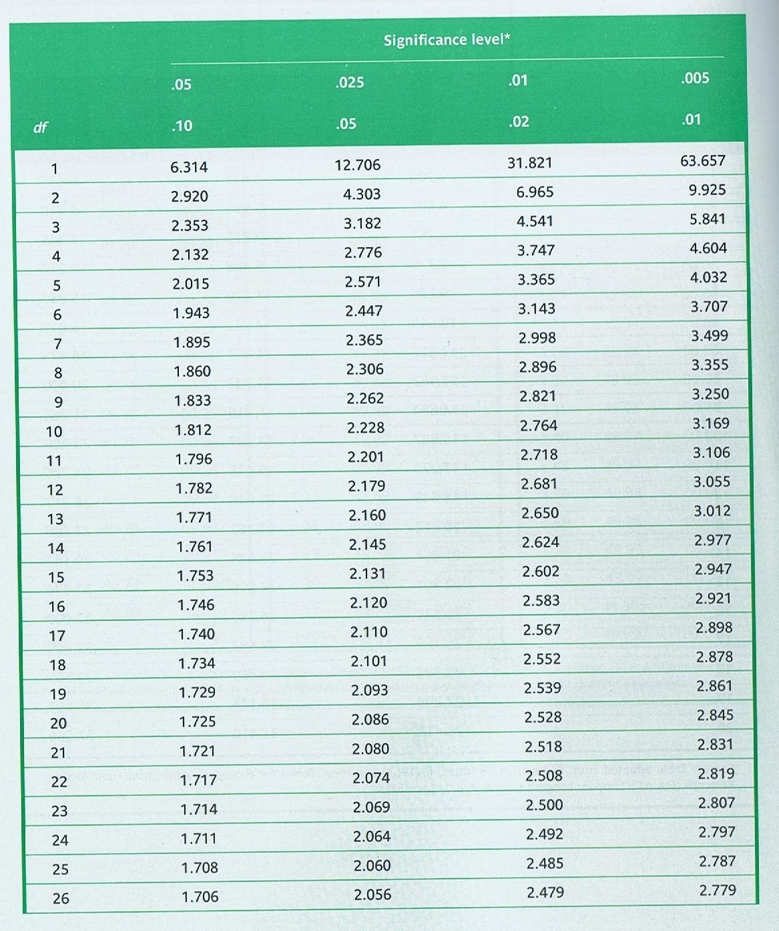

1
tailed

2
tailed

Use this column for 1
tailed test at 5% level

Use this column for
2

tailed test at 5% level

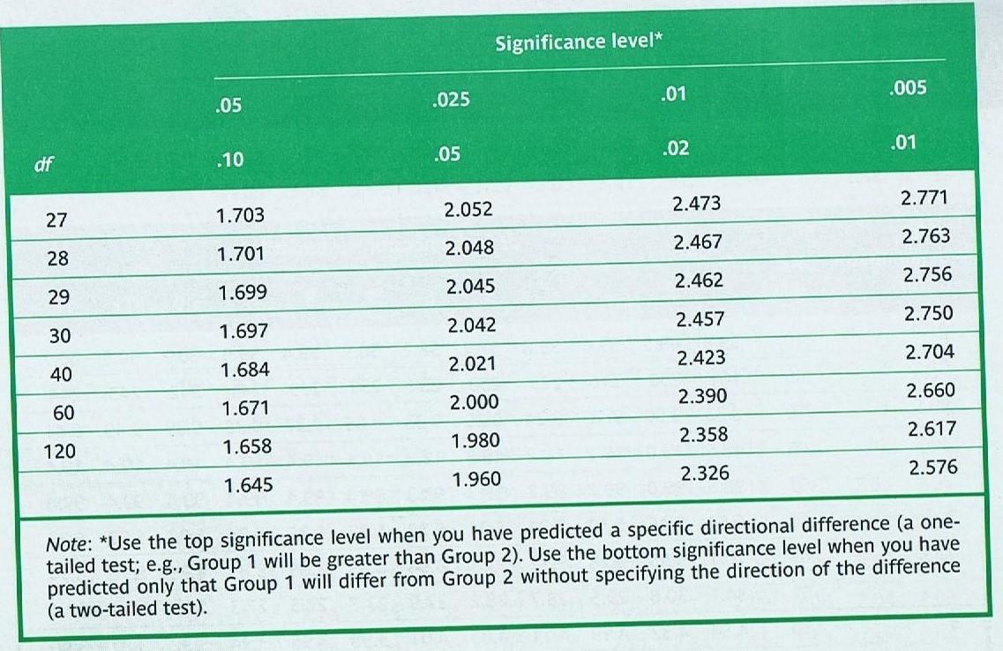

NOTES:

NOTES:

