Practical 4 worksheet
Factorial ANOVA and Revision
Outline of Practical Session:
- Between-subjects factorial ANOVA:
  - See how you would conduct one in Excel
  - Conduct the same analysis in JASP
- Within-subjects factorial ANOVA:
  - See how you would conduct one in Excel
  - Conduct the same analysis in JASP
- Revise conducting and interpreting:
  - t tests in JASP
  - one-way ANOVA in JASP
For factorial ANOVAs today, you will not have to conduct the analyses in Excel because they are complicated and introduce lots of potential for human error.
However, I have provided worked examples in Excel. You will see how the factorial ANOVAs can be conducted in Excel, and we will then validate these analyses by running JASP analyses on the same data.
You will still need to understand the calculations that underpin factorial ANOVA, and you should pay special attention to the degrees of freedom and the differences in how you calculate each of the main effects and the interaction.
Adapted using:
Gaillac, R., & Marbach, S. (2021). The carbon footprint of meat and dairy proteins: A practical perspective to guide low carbon footprint dietary choices. Journal of Cleaner Production, 321, 128766. https://doi.org/10.1016/j.jclepro.2021.128766
Sharif, A. (2021). Role of solar energy in reducing ecological footprints: An empirical analysis. Journal of Cleaner Production, 292, 126028. https://doi.org/10.1016/j.jclepro.2021.126028

Before you start, create a directory called ‘Methods Practical 4’ on your computer, and download the ‘Practical 4a data.xlsx’ and ‘Practical 4b data.xlsx’ files.

SECTION 1. Conducting between-subjects factorial ANOVA
The formulae for between-subjects factorial ANOVA are*:
Degrees of Freedom ${df}_{A}=n_{cA}-1$
${df}_{total}=N-1$
${df}_{A×B}={df}_{A}×{df}_{B}$
${df}_{error}={df}_{total}-{df}_{A}-{df}_{B}-$ ${df}_{A×B}$
Sums of Squares ${SS}_{A}=\sum{n_{k}{\overline{x}}_{k}^{2}-\frac{{(\sum{x)}}^{2}}{N}}$
${SS}_{cells}=\sum{n_{k}{\overline{x}}_{k}^{2}-\frac{{(\sum{x)}}^{2}}{N}}$
${SS}_{total}=\sum{x^{2}-\frac{{(\sum{x)}}^{2}}{N}}$
${SS}_{A×B}={SS}_{cells}-{SS}_{A}-{SS}_{B}$
${SS}_{error}={SS}_{total}-{SS}_{cells}$
Mean Squares ${MS}_{A}=\frac{{SS}_{A}}{{df}_{A}}$
${MS}_{A×B}=\frac{{SS}_{A×B}}{{df}_{A×B}}$
${MS}_{error}=\frac{{SS}_{error}}{{df}_{error}}$
F Values $F_{A}=\frac{{MS}_{A}}{{MS}_{error}}$
$F_{A×B}=\frac{{MS}_{A×B}}{{MS}_{error}}$
* The formulae for factor B are identical to the formulae for factor A, and are not listed.
1a) EXCEL
This section shows you how Excel can be used to conduct the between-subjects factorial ANOVA example from the lecture.
- Use Excel to open the ‘Practical 4a data.xlsx’ file. On the formulae worksheet, you’ll find all the formulae needed to calculate between- and within-subjects factorial ANOVA. Now click on the ‘Between 1-footprint tab to display the relevant sheet.
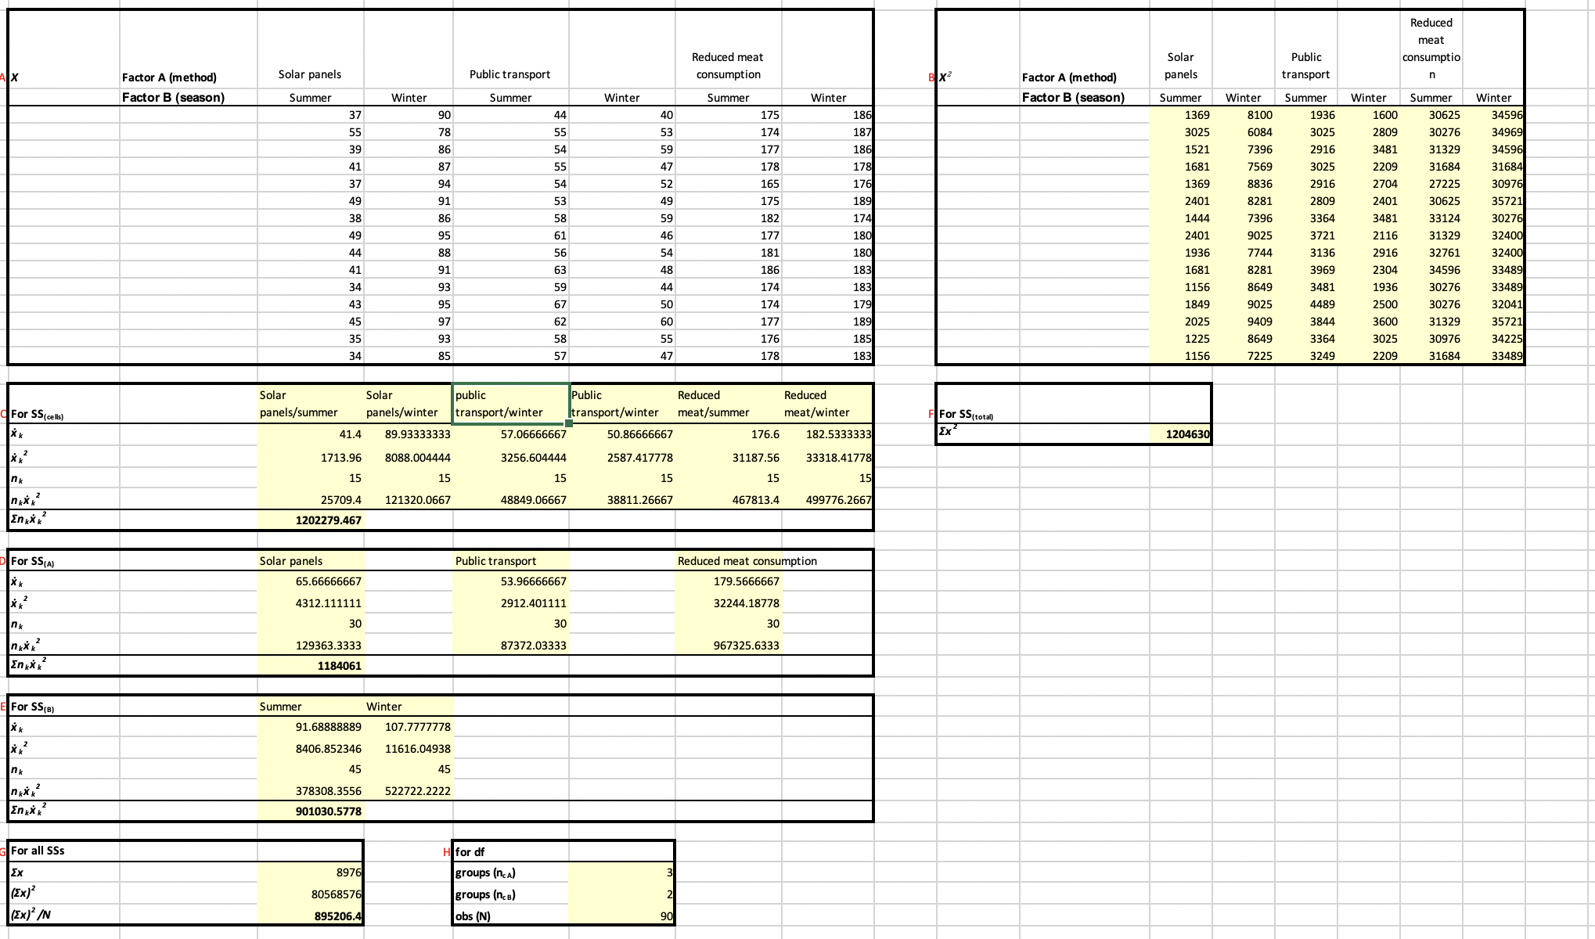NOTICE: Which is the most effective method for different groups of people to reduce their carbon footprint? The reason we are conducting a between-subjects factorial ANOVA on these data is that there are two independent variables (hence a factorial ANOVA and not a one-way ANOVA) and we have different groups per condition, rather than different treatment conditions using the same subjects (hence between-subjects and not within-subjects). The reason we are conducting a between-subjects factorial ANOVA on these data is that there are two independent variables (hence a factorial ANOVA and not a one-way ANOVA) and we have different groups per condition, rather than different treatment conditions using the same subjects (hence between-subjects and not within-subjects). The two factors we are investigating are the method of carbon footprint reduction (Factor A) and the season of implementation (Factor B). We’re going to take a moment to look through each of the labelled boxes to make sure we know which part of the equation each will be used for. As you are looking through the data, click on the numerical values in the shaded cells. If you click on the cell values in the formula bar, you’ll see the corresponding cells in the worksheet highlighted.
Box A. These are the raw data (x).
formula bar
Box B. These are the squared values of X (x²). These are summed to compute the $\sum{x^{2}}$ portion of the SS_{total} equation in Box F.
Box C. This is used to calculate the $\sum{n_{k}{\overline{x}}_{k}^{2}}$ portion of the SS_{cells} equation. What makes Box C different from boxes D and E is that it deals with the means of every possible permutation of between-subjects conditions that can be made from each of the independent variables (called a cell; see the cell headings to see which combination of conditions each cell represents). We therefore have 6 different cells, which we get from 3 conditions of factor A and 2 conditions of factor B. The first row shows the cell means (${\overline{x}}_{k}$) which are squared in the next row (${\overline{x}}_{k}^{2}$). The number of participants/observations in the cell (n_{k}) is on the third row. The squared cell means are multiplied by the number of participants/observations in the cell ($n_{k}{\overline{x}}_{k}^{2}$) in row four, and finally summed in row five ($\sum{n_{k}{\overline{x}}_{k}^{2}}$).
Box D. This is used to calculate the $\sum{n_{k}{\overline{x}}_{k}^{2}}$ portion of the SS_{A} equation. Notice that we collapse across cells that belong to the same condition of factor A. For example, the CAR column summarises both the Solar panels/summer and Solar panels/winter cells. We therefore have only 3 sets means (${\overline{x}}_{k}$), one for each level of factor A. These are squared in the next row (${\overline{x}}_{k}^{2}$). The number of participants/observations in the condition (n_{k}) is on the third row. See that each of these is 30, double that of each cell in Box C. The squared cell means are multiplied by the number of participants/observations in the cell ($n_{k}{\overline{x}}_{k}^{2}$) in row four, and finally summed in row five ($\sum{n_{k}{\overline{x}}_{k}^{2}}$).
Box E. This is used to calculate the $\sum{n_{k}{\overline{x}}_{k}^{2}}$ portion of the SS_{B} equation. This time we collapse across cells that belong to the same condition of factor B. For example, the 11 column summarises footprint reduction methods by all means (solar panels, public transport, reduced meat consumption) as long as it took place during summer. We therefore have only 2 sets means (${\overline{x}}_{k}$) but 45 participants/observations per mean (n_{k}) contributing to the final summary in row five ($\sum{n_{k}{\overline{x}}_{k}^{2}}$).
Box G. This is used to calculate $\frac{{(\sum{x)}}^{2}}{N}$ common to all SS equations. First, all the observations are summed ($\sum{x}$). On the next row, these values are squared (${(\sum{x)}}^{2}$), before this squared total is divided by the total number of observations ($\frac{{(\sum{x)}}^{2}}{N}$).
Box H. This lists the number of conditions/levels within group A (n_{cA}), the number of conditions/levels within group B (n_{cB}) and the total number of observation (N), which are used in degrees of freedom calculations.
Box I. This uses the between-subjects formulae listed above to work through the degrees of freedom, the sums of squares, the mean squares and eventually the F statistics.
Box J. Here we calculate the critical values against which we can compare our F statistics calculated in Box I.
NOTICE1: We have three different critical values because we have three different combinations of degrees of freedom.
NOTICE2: All three of our F statistics are far greater than the critical F values. We therefore have a significant main effect of footprint reduction method (Factor A), a significant main effect of season (Factor B) and a significant footprint reduction method x season interaction (Factor A x Factor B). Unlike JASP, Excel does not give us the exact p values.
A note on F and p values.
When we calculate a critical value, we use the degrees of freedom to find the distribution of all the possible F values we could get if we ran millions of imagined analyses on data drawn from the same population (i.e. where we should expect no significant differences). For a certain proportion of our imagined studies, we would get some extreme F values that would give the impression of significant differences in our data. By setting an alpha value of .05, our critical value identifies the point on the distribution below which .95 (95%) of our imagined studies lie, and therefore, above which only .05 (5%) of them lie. We set this as the criterion on the basis that, if the F statistic is so extreme that the theoretical probability (p) of getting a statistic as high or higher is only 5%, then we may as well assume that our data are actually drawn from different populations (i.e. are truly, significantly different).
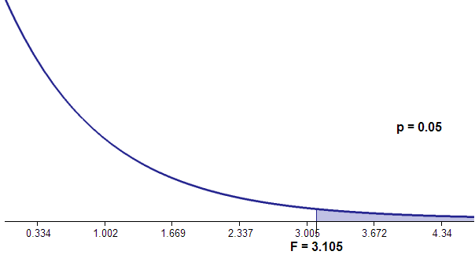  f | To explain exactly what we are doing when we compare our test statistics against a critical F value, consider the F distribution for the main effect of footprint reauction methods (Factor A).  The F(2,84) distribution (indicated by the curve in the graph on the left) has a critical value for the alpha value of .05 at 3.105. Test statistic F values above 3.105 indicate significant effects (they lie in the 5% zone), those below indicate nonsignificant effects (they lie in the 95% zone).
When we calculate an F test statistic, we want to see what amount of the distribution lies above that statistic. Only a tiny proportion of this F distribution would be above the value of the test statistic we calculated (5161; miles off the right-hand-side of the scale in the picture above), so we can definitely say that there is a less than 5% probability we would have obtained this finding by chance if there were no true differences between samples. In other words, this finding would occur far fewer than 1 in 20 times if the samples were drawn from the same population.
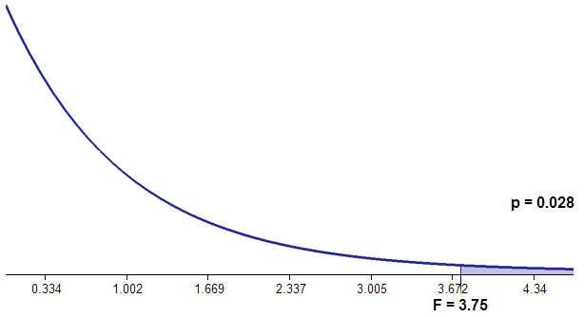  d | Even if we had obtained the smaller test statistic F value of 3.75, we can see from the figure to the left that only .028 (2.8%) of the distribution lies above this value (p = .028).  In other words, this finding would still occur fewer than 1 in 20 times if the samples were drawn from the same population. Because the acceptable alpha level is .05 (5%), this a statistically significant result.
Any test statistic F value smaller than the critical value would have more than .05 (5%) of the distribution above it, and would therefore be indicative of a nonsignificant effect.

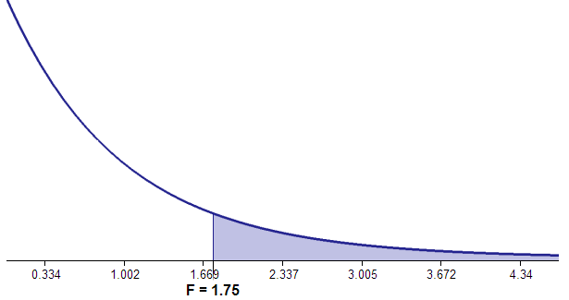  fgh | An F value of 1.75 has .18 (18%) of the distribution above it (p = .18). In other words, this finding would occur more than 1 in 20 times if the samples were drawn from the same population (closer to 1 in 5 times). Because the acceptable alpha level is .05 (5%), we call this a nonsignificant result. Using this logic, it is easy to see why we compare test statistics to critical values when we don’t have access to precise p values pertaining to test statistics.
It is always the case that as you go from left to right along the x axis of the F distribution graph above, the amount of distribution to the right of your finger decreases. Therefore, as F values increase, p values decrease.
p = 0.18
p = .18
NOTE: Remember that the shape of the distribution for the F statistic is impacted by the degrees of freedom – so the specific shape of the curve in the above examples is specific to the degrees of freedom of that specific example. Because the shape changes with degrees of freedom, this is why F-values for some cases are significant for some cases but not others (because depending on the shape/spread of the curve, the ‘5%’ cut off will be at a different value). i.e. F-values are not comparable across examples with different degrees of freedom.
Therefore, to say we have a significant main effect or interaction in an ANOVA (or any other parametric inferential statistic, including t tests), we can look for one of two things:
- A test statistic above the critical value (what we look for in Excel or whenever we use a table of critical values)
- A p value below the alpha level of .05 (what we look for in JASP).

1b) JASP
Remember from the last two practicals, that JASP is quite particular about between-subjects (or independent samples) data – it likes each new participant to have their own row. This means that we needed to use a coding variable when we are planning between-subjects analyses. For between-subjects factorial ANOVA, since we have more than one between subject variable, we need to use more than one coding variable – one for each independent variable. In the data we have just looked at in Excel, we would need two coding variables because we have two independent variables.
- Open a new worksheet in Excel.
- Create three column headings: Footprint reduction method, Season, and Reduction in CO2.
Footprint reduction method and Season will be our coding variables representing our independent variables. Reduction in CO2 will be our dependent variable.
- We now need to assign numeric values to our categorical conditions. Fill in the condition names for the following three numeric values of the Footprint reduction method independent variable.
Value: 1 Value: 2 Value: 3
Label1: [enter label name] Label2: [enter label name] Label3: [enter label name]

- Do the same for the Season independent variable, this time giving it two condition names.
Value: 1 Value: 2
Label1: [enter label name] Label2: [enter label name]

- Copy the Solar panels/Summer data from the ‘Between 1- Footprint worksheet (from Box A.) into the first fifteen rows of the Reduction in CO2 column, then fill in the two columns of numeric coding variables as appropriate.
- Now do the same for data from all the other cells. When you have finished, you should have 3 columns comprising 90 rows each. The first few rows should look like this:
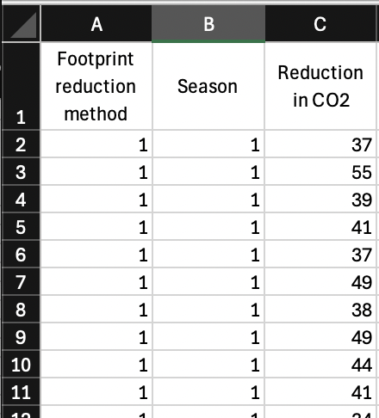
- Save your data as a .csv file with the title: Data_prac4_4b.
- Close Excel and open the .csv file you have just created in JASP.
- In JASP, double-click the Footprint reduction method heading and assign the labels you defined in step 3 above to the values 1, 2 and 3.
NOTE: if clicking the heading does not give you an option to label your values, you will need to make sure the variable is defined as ‘nominal’ or ‘ordinal’ – in this case transport should be ‘nominal’ because here is no logical order to the footprint reduction methods. To change the way the variable is defined, click on the small picture next to the heading name and select the data type you would like.
- Double-click the Season heading and assign the labels you defined in step 4 above to the values 1 and 2.
- Now our data are ready to run the analyses. Select a between-subjects ANOVA via ANOVA > ANOVA
NOTICE: The way we request a between-subjects factorial ANOVA is exactly the same as for a between-subjects one-way ANOVA.
- Our dependent variable is Reduction in CO2, so transfer this over into the Dependent Variable box.
- Transfer the two coding variables into the Fixed Factors box. You should end up with something like this:
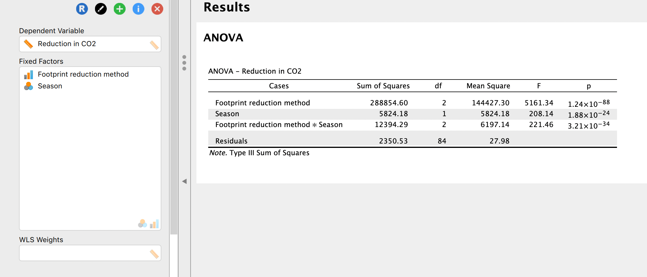
- If we chose to interpret this table alone, we wouldn’t have any information to help us understand the result. We must now ask for more information from our analyses to make interpreting the results easier.
- Specify that you want Descriptive Statistics and partial η² Estimates of effect size (by ‘ticking’ the appropriate boxes).
- Click on the Assumption Checks accordion menu and select Homogeneity tests.
NOTICE: See what happens when you specify that you want a Welch Homogeneity correction. The error message tells you that there is no way of correcting for a violation of homogeneity of variance within a between-subjects factorial ANOVA—this is only possible with a between-subjects one-way ANOVA.
- Click on the Post Hoc Tests accordion menu, transfer Footprint reduction method, Season, and Footprint reduction method * Season to the right, and make sure that you have both Tukey and Bonferroni Corrections specified.
- Click on the Descriptives Plots accordion menu. You can now specify a plot that will help you interpret an interaction. Transfer Footprint reduction method to Horizontal Axis and Season to Separate Lines, and select to Display error bars (keeping the 95% Confidence interval default).
- Finally, click on the Marginal Means accordion menu, and transfer Footprint reduction method and Season to the right.
NOTICE: Specifying which factors and interactions to display marginal means for instructs JASP to break down means according to conditions within each factor, collapsing across the other factors (e.g. looking at Footprint reduction methods while collapsing seasons). This provides you with the means according to each condition of your factors, much as you saw at the top of boxes C, D and E in your Excel sheet, and allows you to more easily interpret the ANOVA outputs. We haven’t asked for the interaction marginal means, because the Descriptive Statistics we requested give us these.
- Your output should now consist of eight tables and one graph.
- As with one-way ANOVA, let’s start our interpretation with Descriptives and Descriptive plots.
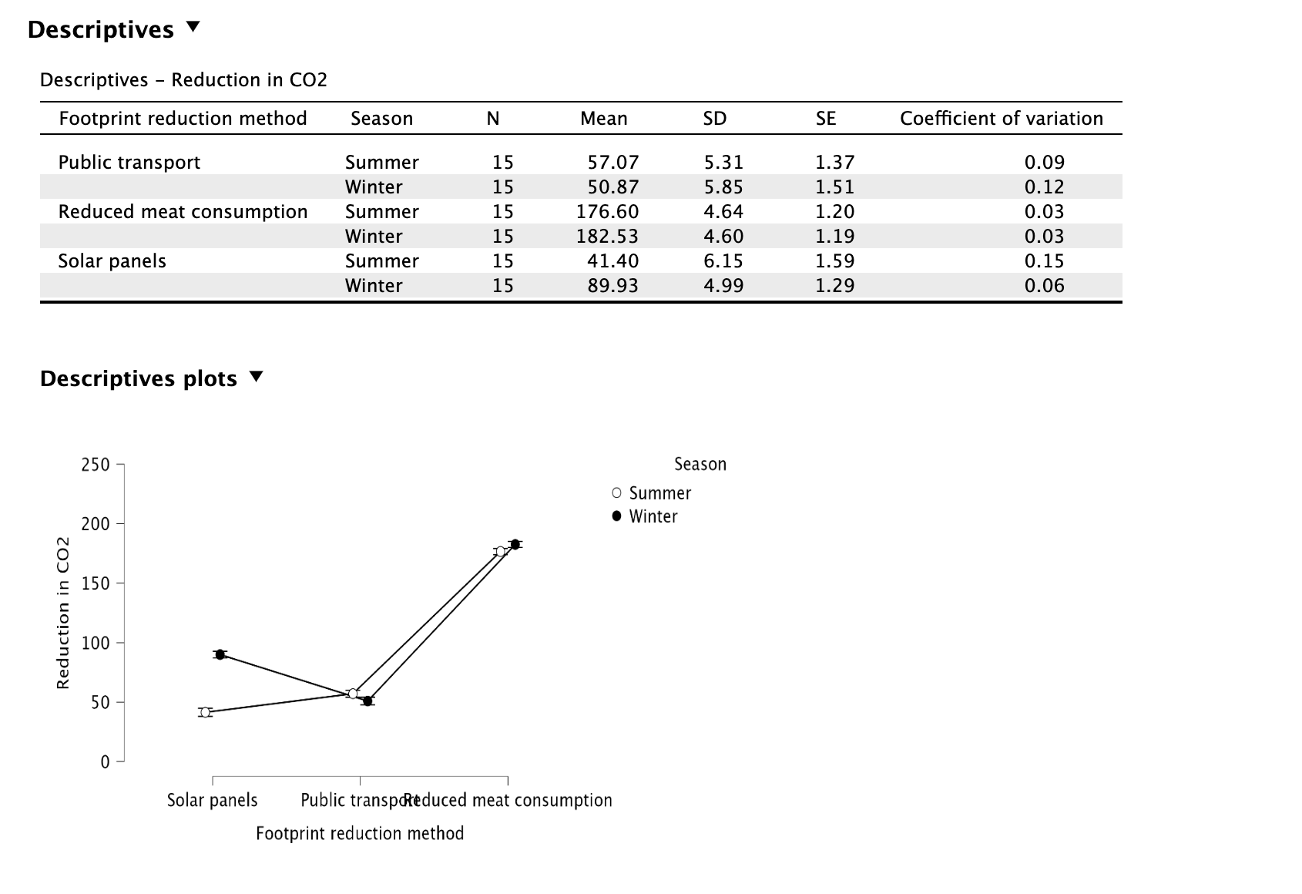NOTICE: From looking at the graph, reduced meat consumption seems to reduce CO2 far less than the other methods of footprint reduction, regardless of season. Whilst season doesn’t make much difference to public transport or reduced meat consumption, it does for solar panels. Let’s delve further into the results to examine these potential effects more formally.
- The next box down (under heading ‘Assumption Checks’) shows us the results of Levene’s test of homogeneity of variance. This tests the null hypothesis that our data possess homogeneity of variance. As there is no correction for factorial ANOVA (unlike Welch’s one-way test for one-way ANOVA) and non-parametric equivalent, we need to hope that Levene’s test result indicates that we should proceed.
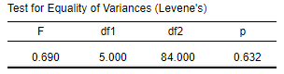

Levene’s test of homogeneity of variance is [click] as its p value is [click] the alpha level of .05. It is therefore [click] to proceed with the between-subjects factorial ANOVA.

- Assuming we can proceed, we can now look at the most important output table: the ANOVA output (you may need to scroll back to the top of your output to find this table). Compare the contents of this table to the Excel results. Take care to see which Excel ‘sums of squares’ and ‘mean squares’ correspond to the equivalent JASP values.
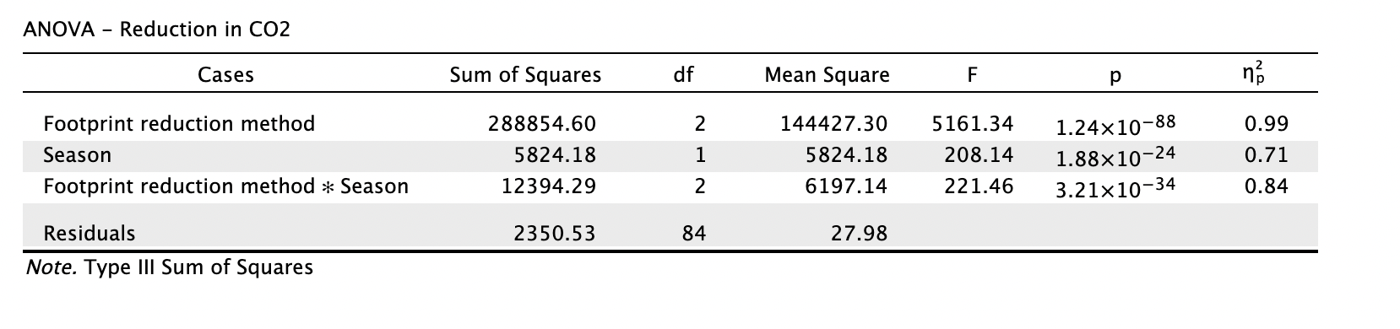

- Fill in the gaps:
HINT: Although we would normally be very precise when reporting significance values provided by JASP (e.g. p = .034, p = .722, p = .004), sometimes they are so small that JASP displays them as < .001. In this situation, you should report the significance as p < .001.
Main effect of footprint reduction method: F([enter value], [enter value]) = [enter value], p < [enter value]
Main effect of season: F([enter value], [enter value]) = [enter value], p < [enter value]
Transport x departure interaction: F([enter value], [enter value]) = [enter value], p < [enter value]
- The next outputs that we will look a to us are the results of the pairwise comparisons for each factor. If you scroll down, you should find two tables that compare each of the conditions in each factor (under the heading Post Hoc Tests):
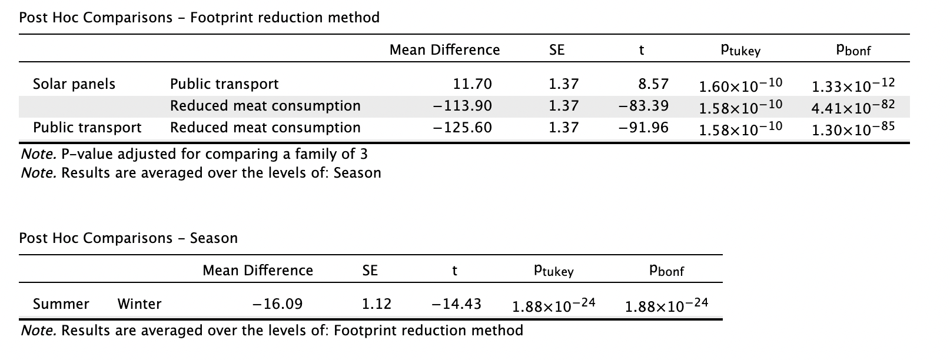
NOTICE1: It’s no surprise that we have significant main effects as all of our Bonferroni-corrected pairwise comparisons show significant differences. However, even with this pattern of results from pairwise comparisons, it is not inevitable that the interaction should reach significance.
NOTICE2: The pairwise comparison outputs show you the mean differences between the factor conditions, but not the condition means (or marginal means). You can find those in the Marginal Means section at the bottom of the output.
- Let’s report the main effects as we would in a paper. Use the ANOVA, post hoc comparison, and marginal means outputs to fill in the gaps:
In a 2 x 3 ([enter factor name] x [enter factor name]) between-subjects factorial ANOVA , there were [click] main effects of [enter factor name], F([enter value], [enter value]) = [enter value], p [enter sign and value] and [enter factor name], F([enter value], [enter value]) = [enter value], p [enter sign and value]. Regardless of the method of footprint reduction employed, CO2 was significantly less reduced during [enter time] (M = [enter value]) than during [enter time] (M = [enter value]). Method of footprint reduction also affected CO2 reduction independent of season—in post-hoc tests, solar panels (M = [enter value]), public transport (M = [enter value]) and reduced meat consumption (M = [enter value]) all showed significant pairwise differences (Bonferroni-corrected), all ps [enter sign and value].
NOTICE: There’s no need to report the pairwise comparison statistic for any independent variables with only two conditions, such as season above. In these circumstances, the ANOVA F value statistic, along with the means and standard deviations of the two conditions tell the reader all they need to know.
- To complete the analysis, you should ideally try to explain the interaction by examining the descriptives plot and the interaction post-hoc comparisons.
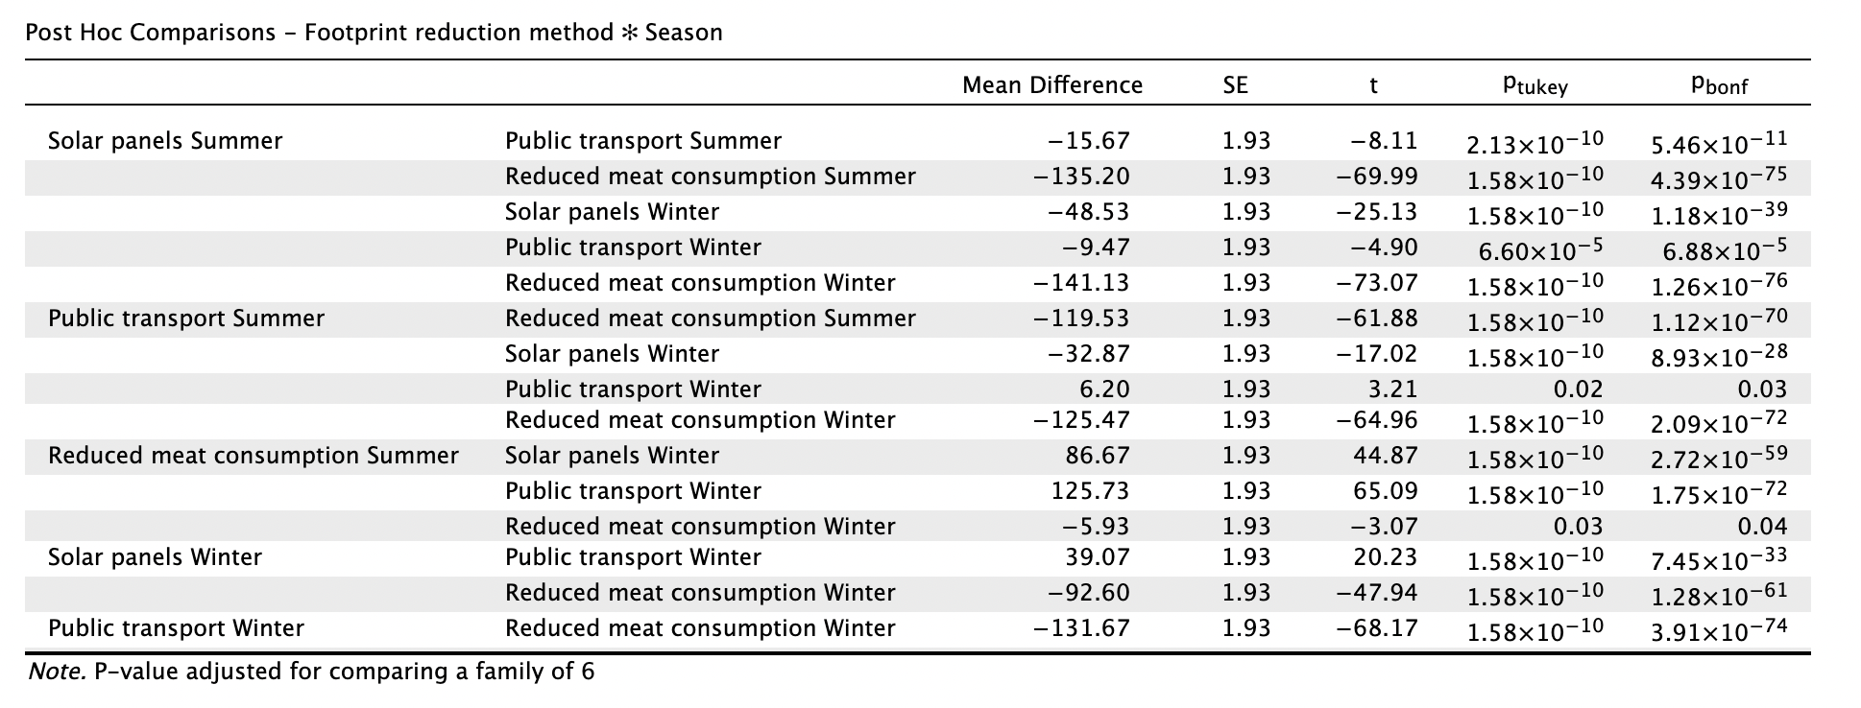
NOTICE: When we looked at the descriptive plots, we noticed that solar panels showed most variation according to season than public transport or reduced meat consumption. Indeed, if we read these rows we can see that solar panels has a Bonferroni-adjusted p value of < .001, whereas the p values for public transport, .028 and reduced meat consumption, .043, are still significant, but not quite so drastically.
- Use the ANOVA, descriptives, and post hoc comparison outputs to report the interaction and follow-up tests:
There was a [click] interaction between [enter factor name] and [enter factor name], F([enter value], [enter value]) = [enter value], p [enter sign and value]. Bonferroni-corrected pairwise comparisons (thresholded at a revised alpha level of [enter value] to control for the family of [enter value] tests) were conducted to explore this interaction. When employing solar panels, CO2 was significantly [click] during summer (M = [enter value], SD = [enter value]) compared to winter (M = [enter value], SD = [enter value]), p [enter sign and value]. A significant though less dramatic CO2 reduction held for reduced meat consumption (summer M = [enter value], SD = [enter value]; winter M = [enter value], SD = [enter value]), p [enter sign and value], but the opposite difference was observed for public transport (summer M = [enter value], SD = [enter value]; winter M = [enter value], SD = [enter value]), p [enter sign and value].
- Save your data file as Data_Prac4_4b.jasp.

SECTION 2. Conducting within-subjects factorial ANOVA
The formulae for within-subjects factorial ANOVA are*:
Degrees of Freedom ${df}_{A}=n_{cA}-1$
${df}_{error A}=\left(n_{p}-1\right)×{df}_{A}$
${df}_{A×B}={df}_{A}×{df}_{B}$
${df}_{error A×B}=\left(n_{p}-1\right)×{df}_{A×B}$
Sums of Squares ${SS}_{A}=\sum{n_{k}{\overline{x}}_{k}^{2}-\frac{{(\sum{x)}}^{2}}{N}}$
${SS}_{cells A}=\sum{n_{k}{\overline{x}}_{k}^{2}-\frac{{(\sum{x)}}^{2}}{N}}$
${SS}_{cells A×B}=\sum{n_{k}{\overline{x}}_{k}^{2}-\frac{{(\sum{x)}}^{2}}{N}}$
${SS}_{between subj}=\sum{n_{c}{\overline{x}}_{p}^{2}-\frac{{(\sum{x)}}^{2}}{N}}$
${SS}_{total}=\sum{x^{2}-\frac{{(\sum{x)}}^{2}}{N}}$
${SS}_{A×B}={SS}_{cells A×B}- {SS}_{A}- {SS}_{B}$
${SS}_{error A}={SS}_{cells A}- {SS}_{A}- {SS}_{between subj}$
${SS}_{error A×B}={SS}_{total}-{SS}_{between subj}-{SS}_{A}-{SS}_{error A}-{SS}_{B}-{SS}_{error B}-{SS}_{A×B}$
Mean Squares ${MS}_{A}=\frac{{SS}_{A}}{{df}_{A}}$
${MS}_{error A}=\frac{{SS}_{error A}}{{df}_{error A}}$
${MS}_{A×B}=\frac{{SS}_{A×B}}{{df}_{A×B}}$
${MS}_{error A×B}=\frac{{SS}_{error A×B}}{{df}_{error A×B}}$
F Value $F_{A}=\frac{{MS}_{A}}{{MS}_{error A}}$
$F_{A×B}=\frac{{MS}_{A×B}}{{MS}_{error A×B}}$
* The formulae for factors B, C etc. are identical to the formulae for condition A, and are not listed.
2a) EXCEL
This section shows you how you can use Excel to conduct a within-subjects factorial ANOVA. This is even more complicated than a between-subjects ANOVA as it requires the calculation of a number of separate error terms.
Use Excel to open the ‘Practical 4a data.xlsx’ file (if it isn’t already open). Navigate to the ‘Within 1-eco-behaviour sheet.
20 environmental psychology students are asked to complete a battery of eco-behavioural assessments at four points during their project work shift. The study investigates whether the time into their shift (Factor A: 4 levels) and whether it is the first or last assessment taken in each battery (Factor B: 2 levels) affect eco-behavioural scores. The reason we are conducting a factorial within-subjects ANOVA on these data is that there are two independent variables (hence a factorial ANOVA and not a one-way ANOVA) and we have different treatments carried out on the same participants, rather than different groups per condition (hence within-subjects and not between-subjects).
There’s a lot to look at here, which should give you some idea of the complexity of within-subjects factorial ANOVA.
Box A. These are the raw data (x).
Box B. These are the squared values of x (x²) which are summed to compute the $\sum{x^{2}}$ portion of the SS_{total} equation in Box I.
Box C. These are the participant means across all treatment conditions (${\overline{x}}_{p}$) which are squared (${\overline{x}}_{p}^{2}$) and then multiplied by the total number of treatment conditions (n_{c}) to compute the $\sum{n_{c}{\overline{x}}_{p}^{2}}$. This is used as part of the calculation of SS_{between subj.}
NOTICE: The formula for SS_{between subj.} in factorial ANOVA is different to the formula in one-way ANOVA. Do not use the wrong formula by mistake, as it will lead to a different, incorrect value of SS_{between subj.}
Box D. This is used to calculate the $\sum{n_{k}{\overline{x}}_{k}^{2}}$ portion of the SS_{cells A} equation. Notice that we collapse across all conditions of factor B that belong to the same condition of factor A. For example, the 9am column summarises both the 9am/1st and 9am/10th data for each participant. We therefore have 4 sets of means (${\overline{x}}_{k}$) for each participant, one for each level of factor A. These are squared in the next set of columns (${\overline{x}}_{k}^{2}$). The number of observations per condition (n_{k}) is on the third set of columns - see that this is 2 because each mean summarises 2 data points. Each squared mean is multiplied by the number of observations per condition ($n_{k}{\overline{x}}_{k}^{2}$) in the next set of columns, and finally summed at the foot of the box ($\sum{n_{k}{\overline{x}}_{k}^{2}}$).
Box E. This is used to calculate the $\sum{n_{k}{\overline{x}}_{k}^{2}}$ portion of the SS_{B} equation. This time we collapse across all conditions of factor A that belong to the same condition of factor B. For example, the 1st column summarises the first test scores taken at 9am, 3pm, 9pm and 3am. We therefore have 2 sets means (${\overline{x}}_{k}$) and observations (n_{k}) contributing to the summed statistic ($\sum{n_{k}{\overline{x}}_{k}^{2}}$).
Boxes F, G and H. These are identical in principle to Boxes C, D and E in the between-subjects factorial worksheet. They deal with the group means across cells (Box F) and each condition of factor A (Box G) and factor B (Box H).
Box J. This is used to calculate the $\frac{{(\sum{x)}}^{2}}{N}$ portion common to all SS equations.
Box K. This lists the number of conditions/levels of each treatment group (n_{cA} and n_{cB}), the number of participants (n_{p}) and the number of observations (N), which are used in degrees of freedom calculations.
Box L. This uses the within-subjects formulae listed above to work through calculating the degrees of freedom, the sums of squares, the mean squares and eventually the F statistics.
Box M. Here we calculate the critical values against which we can compare our F statistics calculated in Box L.
2b) JASP
The data file required to run a within-subjects factorial ANOVA is more straightforward than that required for a between-subjects factorial ANOVA. No coding variables are required because all of the treatment conditions are measured in the same participants. Therefore, JASP is happy to have as many columns of data per row as are required.
- Open a new worksheet in Excel.
- Create eight column headings that correspond to the eight combinations of our independent variables below (so that there is one row with this information rather than the information spread across two rows)
You might end up with something like this:

- Copy and paste the data from the ‘Within 1-eco-behaviour worksheet under your newly-created headings.
- Save your data as a .csv file with the title: Data_prac4_4b.
- Close Excel and open the .csv file you have just created in JASP.
NOTICE: Look at what JASP has done to your variable names. It has prefixed headings that start with a number with the letter ‘V’. This is a common theme in statistics software—they prefer that you start your variables with a letter rather than a number. Let’s leave the variables names as they are.
- Select a within-subjects (repeated measures) ANOVA via ANOVA > Repeated Measures ANOVA
NOTICE: This is different to the menu path we took to specify a between-subjects factorial ANOVA, which was ANOVA > ANOVA
- In the Repeated Measures ANOVA specification, we are asked to define the factors of our within-subjects factorial ANOVA. Because we have two independent variables, we need to specify two factors. Specify your first factor, time. Below the factor name, list the four time conditions
Note: You can do this by clicking on ‘RM factor 1’ in the ‘Repeated Measures Factors’ box, and type ‘Time’. You can then click on the text ‘Level 1’ and replace with the name your first Time level (9am). Repeat this until you have all your time levels entered.
Below your Time factor and levels, specify your second factor, repetition, then list the two repetition conditions.
NOTICE: As you do this, JASP will population the Repeated Measures Cells with descriptions of the combinations of your factors (‘9am,1st’, ‘9am,10th’ etc.) This makes it really easy for you to copy the appropriate variables into the Repeated Measures Cells.
- Transfer your variables from the left-hand side, into the corresponding Repeated Measures Cells on the right. This is more complicated than for one-way ANOVA because you have to think about the various combinations of your factors. You should end up with something that looks like this:
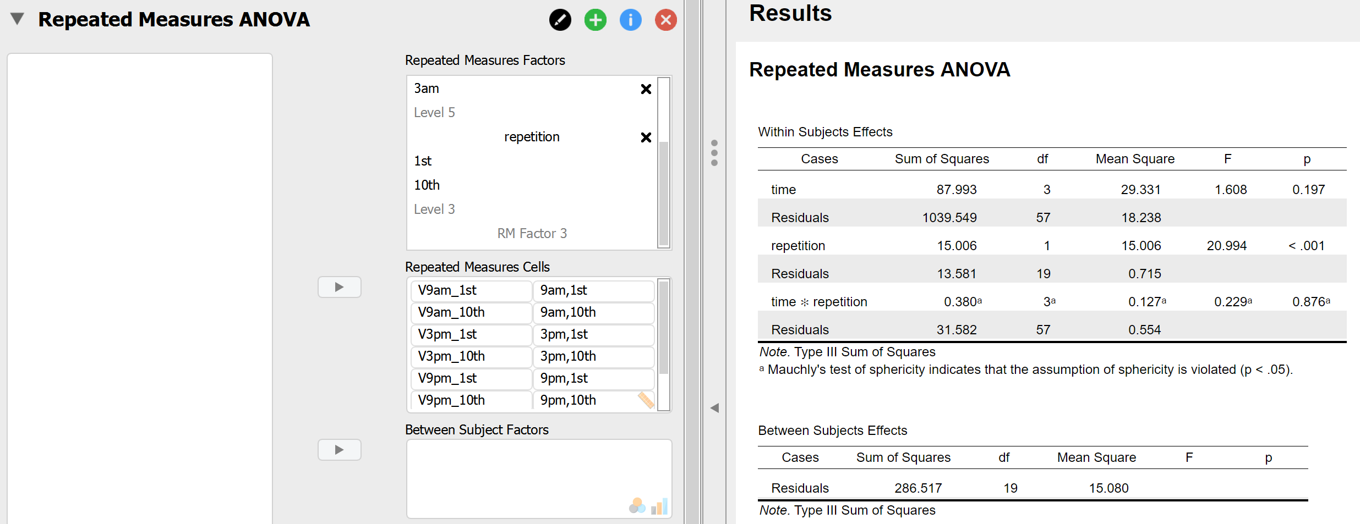

- Specify that you want Descriptive Statistics and partial η² Estimates of effect size.
- Click on the Assumption Checks accordion menu and select Sphericity tests and ask for Greenhouse-Geisser sphericity corrections.
NOTICE: There is an option to ask for homogeneity tests, but this is only useful if we have between-subjects factors as well as within-subjects factors. This will become important to us in Semester 2 when we learn about mixed factorial ANOVA.
- Click on the Post Hoc Tests accordion menu, transfer time, repetition, and time * repetition to the right, and make sure that you have both Tukey and Bonferroni Corrections specified.
- Click on the Descriptives Plots accordion menu. You can now specify a plot that will help you interpret an interaction. Transfer time to Horizontal Axis and Departure to Separate Lines, and select Display error bars (keeping the 95% Confidence interval default).
- Finally, click on the Marginal Means accordion menu, and transfer time and repetition to the right.
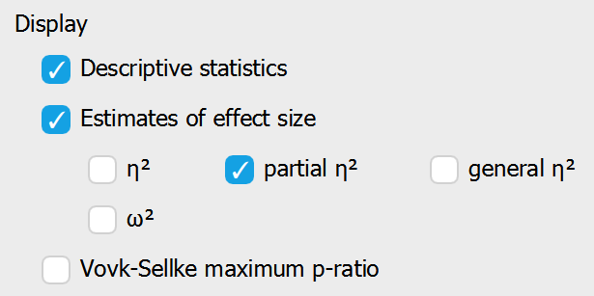 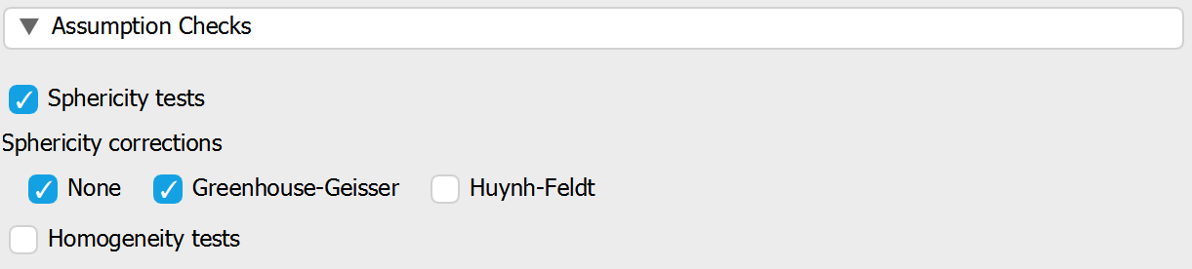
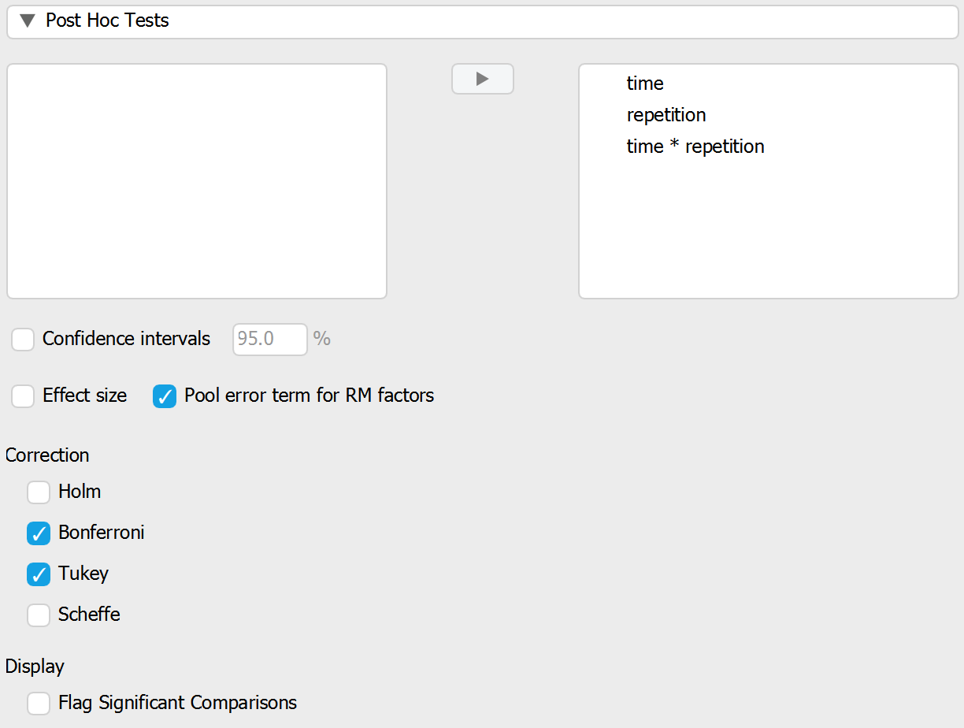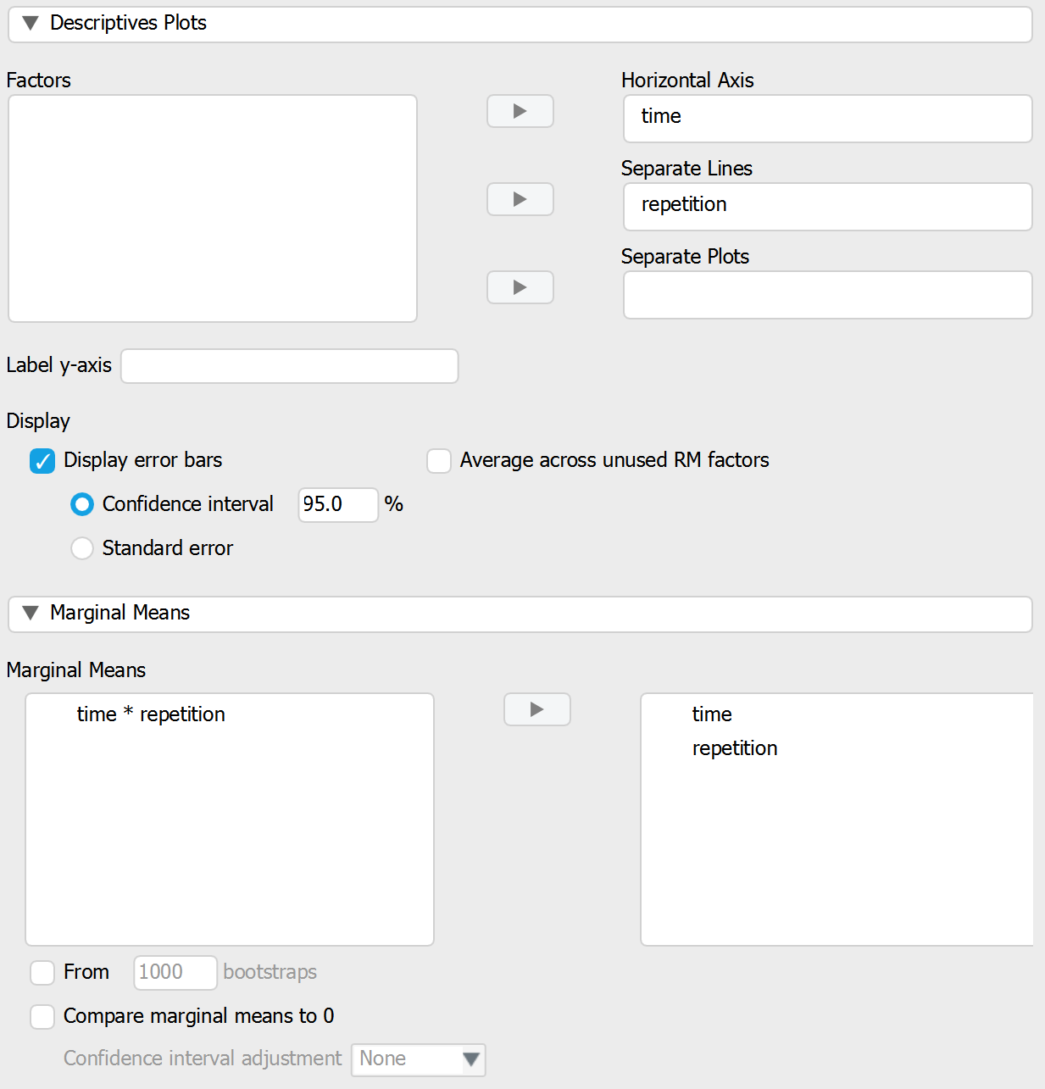
- Your output should now consist of nine tables and one graph.
- Once again, we start with Descriptives and Descriptives plots.
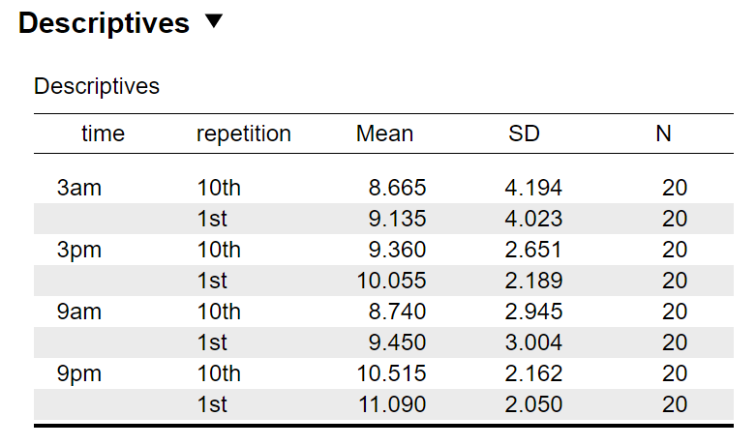 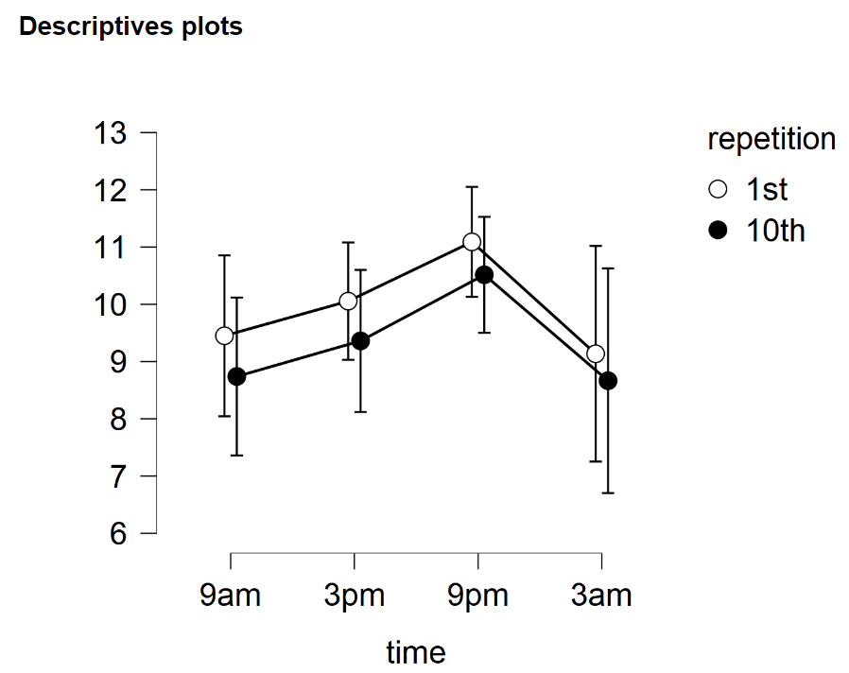
NOTICE: Trends in factorial designs are difficult to interpret from the descriptives alone. For this reason, it is useful to examine the plot, and to present a version of it as part of your lab report or journal manuscript. Looking at the plot, we may have a significant effect of repetition because, across all conditions of time, the 10th repetition of the eco-behaviour tests was performed on more poorly than the 1st. That said, the error bars are pretty large and overlap the means of the other repetition conditions, so we need to examine the formal statistics.
- The next table down (under the heading ‘Assumption Checks’) shows us the results of the Mauchly’s Tests of Sphericity. We are testing the null hypothesis that our does not violate the assumption of sphericity—that it can be analysed by ANOVA without applying any corrections to the degrees of freedom. But what does sphericity mean? Because we are dealing with repeated-measures data from the same people, responses across the various treatment conditions will all be correlated more than if we were dealing with between-subjects data. The within-subjects ANOVA calculation therefore considers this correlation in its formulae. But, it can only do so reliably if all of the pairs of conditions are approximately equally correlated. The assumption of sphericity is the assumption that the correlations between pairs of treatment conditions are not different. In order to proceed with an uncorrected ANOVA we would ideally like the correlations between conditions to be roughly equal, and therefore we want each Mauchly’s test to be nonsignificant.
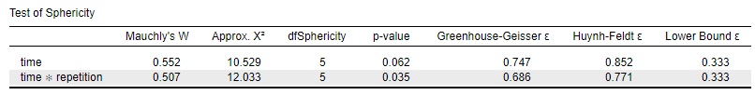
NOTICE1: The test of sphericity for the main effect of time is nonsignificant. We therefore look at the Sphericity Correction ‘None’ ANOVA result for this main effect.
NOTICE2: We don’t have a test result for the main effect of repetition. This is because the repetition independent variable only has two conditions. Because the Mauchly’s test compares correlations between pairs of conditions and we only have one pair of repetition conditions, there is nothing against which to compare that pair. For this reason, there is no need to look at the Mauchly’s test for repetition and JASP won’t show us a result for it. We therefore also look at the Sphericity Correction ‘None’ ANOVA result for this main effect.
NOTICE3: The test of sphericity for the time x repetition interaction is significant. This means that in order to proceed we need to look at ANOVA statistics where the degrees of freedom have been adjusted to control for this violation of sphericity. For the time x repetition interaction, we look at the Sphericity Correction ‘Greenhouse-Geisser’ ANOVA result.
- We can now look at the most important output table: the ANOVA output (you may need to scroll back up).
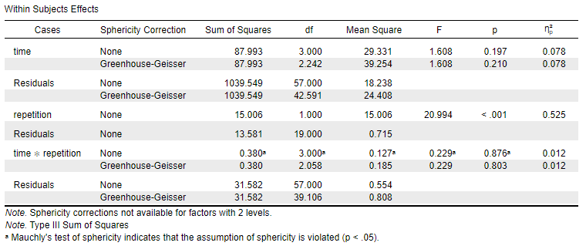
NOTICE1: Although it seems complicated, we can break it up into three sections: the time condition and its corresponding residuals (error); the repetition condition and its corresponding residuals; and the time x repetition interaction and its corresponding residuals. Note that time and time x repetition both have Greenhouse-Geisser sphericity correction rows because they have more than two conditions and sphericity might therefore be an issue. Repetition doesn’t, because it has only two conditions (see NOTICE2 above).
NOTICE2: JASP tells us that our sphericity test has flagged a violation of assumptions for the time x repetition condition (see the asterisk next to the 0.229 in the Sphericity Correction ‘None’ row). If we had forgotten to ask for Greenhouse-Geisser corrected results, this would remind us that we need to go back to the Repeated Measures ANOVA specification screen and ask for them.
- Take a moment to compare the Sphericity Correction ‘None’ rows above to the output from the Excel sheet. Take care to see which Excel sums of squares and mean squares correspond to the equivalent JASP values.
- Fill in the gaps:
NOTICE: Our ANOVA only produced one significant result. This occurred in a factor for which there were only two conditions. It is therefore not necessary to report the results of pairwise comparisons as the ANOVA itself tells us exactly which pair of conditions drove the significant difference.
Main effect of time: F([enter value], [enter value]) = [enter value], p [enter sign and value]
Main effect of repetition: F([enter value], [enter value]) = [enter value], p [enter sign and value]
Time x repetition interaction (Greenhouse-Geisser corrected):
F([enter value], [enter value]) = [enter value], p [enter sign and value]
- Fill in the gaps:
HINT: The χ², df and p values for Mauchly’s test and the ε correction parameter are in the Test of Sphericity table.
In a 4 x 2 ([enter factor name] x [enter factor name]) within-subjects factorial ANOVA , there was no significant main effect of time on eco-behaviour scores, F([enter value], [enter value]) = [enter value], p [enter sign and value]. In other words, time of day [click] affect performance. There was a [click] main effect of repetition—performance on the first repetition of the eco-behvaiour assessment was [click] than performance on the tenth repetition, F([enter value], [enter value]) = [enter value], p [enter sign and value]. For the time x repetition interaction, Mauchly’s test indicated that the assumption of sphericity had been violated, χ²([enter value]) = [enter value], p [enter sign and value]. Therefore degrees of freedom were corrected using Greenhouse-Geisser estimates of sphericity, ε = [enter value]. [click] significant interaction was found, F([enter value], [enter value]) = [enter value], p [enter sign and value].
- Save your data file as Data_Prac4_4b.jasp.
SECTION 3. Revision of JASP analyses from Practicals 1 and 2
Use JASP to analyse the four datasets contained within the ‘Practical 4b data.xlsx’ file. Remember that some analyses require reformatting with coding variables and that others do not.
Fill in the gaps below.
3a) t tests
Independent Samples t test
Mindfulness trainees descriptives: M = [enter value], SD = [enter value]
Control descriptives: M = [enter value], SD = [enter value]
Levene’s test: F = [enter value], p [enter sign and value]
Based on Levene’s test, it is [click] to proceed with an analysis using an independent-samples t-test.
Independent samples t test: t([enter value]) = [enter value], p [enter sign and value]
Is there a significant difference between the two groups? [click]
Paired Samples t test
Before workshop descriptives: M = [enter value], SD = [enter value]
After workshop descriptives: M = [enter value], SD = [enter value]
Paired samples t test result: t([enter value]) = [enter value], p [enter sign and value]
Does the workshop significantly alter scores? [click]
3b) One-way ANOVA
One-Way Between-Subjects ANOVA
Environmental activists descriptives: M = [enter value], SD = [enter value]
Trainee environmentalists descriptives: M = [enter value], SD = [enter value]
Control descriptives: M = [enter value], SD = [enter value]
Levene’s test: F([enter value], [enter value]) = [enter value], p [enter sign and value]
Based on Levene’s test, it is [click] to proceed with an analysis using a between-subjects ANOVA.
ANOVA result: F([enter value], [enter value]) = [enter value], p [enter sign and value]
Is the ANOVA significant? [click]
From the pairwise contrasts, which variable pairs are driving the ANOVA results?
☐ Expert – Novice ☐ Expert – Control ☐ Novice – Control
One-Way Within-Subjects ANOVA
Initial awareness descriptives: M = [enter value], SD = [enter value]
Active participation descriptives: M = [enter value], SD = [enter value]
Leadership role descriptives: M = [enter value], SD = [enter value]
Advocacy and mentorship descriptive: M = [enter value], SD = [enter value]
Mauchly’s test: χ²([enter value]) = [enter value], p [enter sign and value]
Greenhouse-Geisser estimate of sphericity: ε = [enter value].
Based on Mauchly’s test, the [click] within-subjects ANOVA statistic should be used.
ANOVA result: F([enter value], [enter value]) = [enter value], p [enter sign and value]
Is the ANOVA significant? [click]
From the pairwise contrasts, which variable pairs are driving the ANOVA results?
☐ Ugrad – PhD ☐ Ugrad – Lect ☐ Ugrad – SenLect
☐ PhD – Lect ☐ PhD – SenLect ☐ Lect – SenLect

