Practical 3 worksheet
Introduction to ANOVA
Outline of Practical worksheet: You will gain practical experience of:
- Conducting between-subjects ANOVA in a) Excel, b) JASP.
- Conducting within-subjects ANOVA in a) Excel, b) JASP.
- Conducting non-parametric alternatives to one-way ANOVA in JASP.

SECTION 1. Conducting between-subjects ANOVA
The formulae for between-subjects ANOVA are:
Degrees of Freedom ${df}_{between}=n_{c}-1$
${df}_{total}=N-1$
${df}_{error}={df}_{total}-{df}_{between}$
Sums of Squares ${SS}_{between}=\sum{n_{k}{\overline{x}}_{k}^{2}-\frac{{(\sum{x)}}^{2}}{N}}$
${SS}_{total}=\sum{x^{2}-\frac{{(\sum{x)}}^{2}}{N}}$
${SS}_{error}={SS}_{total}-{SS}_{between}$
Mean Squares ${MS}_{between}=\frac{{SS}_{between}}{{df}_{between}}$
${MS}_{error}=\frac{{SS}_{error}}{{df}_{error}}$
Test Statistic $F=\frac{{MS}_{between}}{{MS}_{error}}$

1a) EXCEL
Remember that the Excel function =ttest()gave you a p value and allowed you to bypass comparing the t-statistic to a value from a critical values table. Unfortunately, Excel has no inbuilt function to give you an ANOVA p value. Armed with the data you are analysing and the ANOVA formulae above, you have to work out your ANOVA F value and even find out the critical value of the F distribution appropriate to your data.
This section shows you how to use Excel to conduct a between-subjects ANOVA.
- Use Excel to open the ‘Practical 3 data’ file. On the formulae worksheet, you’ll find all the formulae needed to calculate between- and within-subjects ANOVA. Now click on the appropriate tab to display the ‘Between 1-6 Nations’ worksheet.
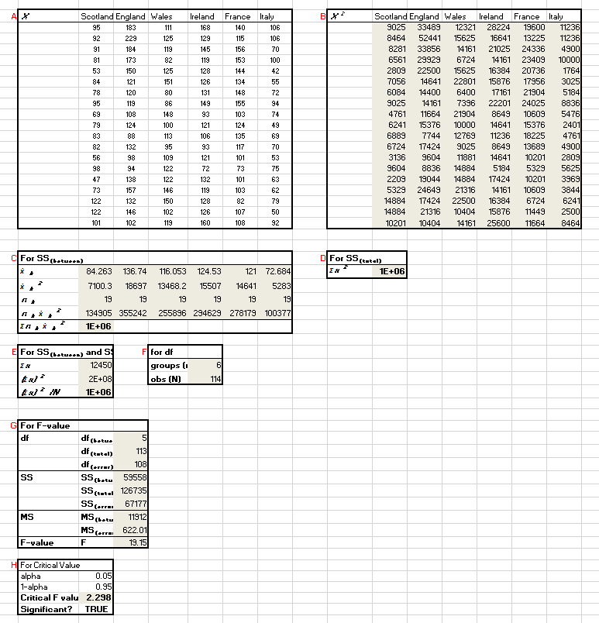
NOTICE: To investigate the effectiveness of various national public awareness campaigns on increasing recycling rates, we collected data from six different countries: Scotland, England, Wales, Ireland, France, and Italy. Each country implemented a unique public awareness campaign aimed at encouraging recycling among its citizens. The study measured the amount of waste recycled (in metric tons) after the implementation of these campaigns. The reason we are conducting a one-way between-subjects ANOVA on these data is that there is one independent variable with more than two levels (hence a one-way ANOVA and not a t test) and we have different groups per condition, rather than different treatment conditions using the same subjects (hence between-subjects and not within-subjects).
We’re going to take a moment to look through each of the labelled boxes to make sure we know which part of the equation each will be used for. As you are looking through the data, click on the numerical values in the shaded cells. If you click on the cell values in the formula bar, you’ll see the corresponding cells in the worksheet highlighted e.g.
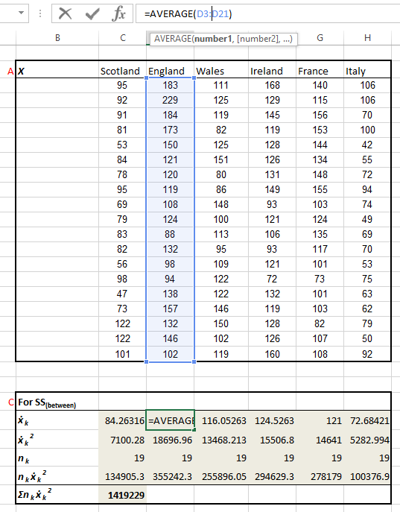
Box A. These are the raw data (X).
Box B. These are the squared values of X (X²). These are summed to compute the $\sum{x^{2}}$ portion of the SS_{total} equation in Box D.
Box C. This is used to calculate the $\sum{n_{k}{\overline{x}}_{k}^{2}}$ portion of the SS_{between} equation. The first row shows the group means (${\overline{x}}_{k}$) which are squared in the next row (${\overline{x}}_{k}^{2}$). The number of participants/observations in the group (n_{k}) is on the third row. The squared group means are multiplied by the number of participants/observations in the group ($n_{k}{\overline{x}}_{k}^{2}$) in row four, and finally summed in row five ($\sum{n_{k}{\overline{x}}_{k}^{2}}$).
Box E. This is used to calculate the $\frac{{(\sum{x)}}^{2}}{N}$ portion common to both SS_{between} and SS_{total} equations. First, all the observations are summed ($\sum{x}$). On the next row, these values are squared (${(\sum{x)}}^{2}$), before this squared total is divided by the total number of observations ($\frac{{(\sum{x)}}^{2}}{N}$).
Box F. This lists the number of groups ($n_{c}$) and the number of observation ($N$), which are used in degrees of freedom calculations.
Box G. This uses the between-subjects formulae listed above to work through calculating the degrees of freedom, the sums of squares, the mean squares and eventually the F statistic.
formula bar
- Navigate to the ‘Between 2-Programs’ worksheet. These are data from a hypothetical experiment based on Ardoin et al. (2020) comparing two environmental education programs’ (EcoLearn and GreenMind) effects on environmental behavioural intention scores, with a control condition of participants who received no environmental education.
NOTICE: The grey boxes are empty. These are what we need to fill in to see whether there is any difference in the group scores using our ANOVA.
- Box B. Here we simply want to square (raise to the power of 2) our original values of X to give us X² values. Complete Box B.
HINT1: You’ll need to start off by typing =POWER( before selecting the target cell, and the power to which you would like that cell raised.
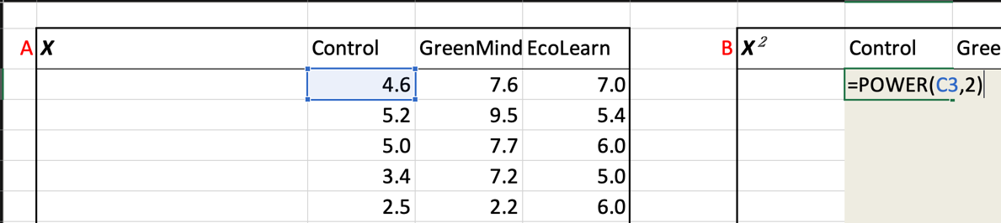
HINT2: You don’t need to type the formula in multiple times. Once you have the right formula in place, you can drag the little black box in the bottom-right corner of the selected cell across and then down to fill in the values for all the other cells.
a) 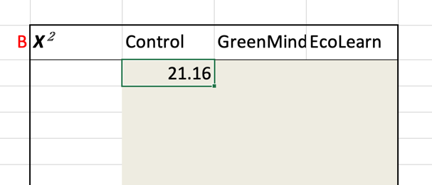Select the little black box.
b) 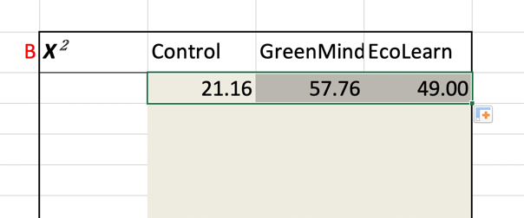Drag it across to fill the cells with an equivalent formula.
- Box C. The ${\overline{x}}_{k}$ row is particularly important because it gives us the group means. We’ll be able to see if there are any trends towards difference that might end up making our ANOVA result significant. Use the =AVERAGE() function to fill in the group mean for the Control Group, and then fill across to the other two experimental groups.
- Box C. The ${\overline{x}}_{k}^{2}$ row next. Fill this in using the =POWER() function.
- Box C. On the third row, we must enter n_{k} , the number of observations/participants per group. It would be really easy just to count the number per group and put this in manually, but use the =COUNT() function. This way, your results will update if you need to add any more data to your ANOVA.
HINT: You use the =COUNT() function in exactly the same way that you use the =AVERAGE()function, so you need to select all the data in each group for Excel to count the observations.
- Box C. To find $n_{k}{\overline{x}}_{k}^{2}$, multiply each group’s ${\overline{x}}_{k}^{2}$ by n_{k}.
- Box C. Now complete $\sum{n_{k}{\overline{x}}_{k}^{2}}$ by summing all the $n_{k}{\overline{x}}_{k}^{2}$ values. If you don’t get 1534.683, something has gone wrong – check your working and speak to a demonstrator if you can’t work out what has gone wrong.
- Box D is easy. Sum all the X² values from Box B.
- Box E. $\sum{x}$ is more of the same, this time summing all X values from Box A.
- Box E. For ${(\sum{x)}}^{2}$, square the output of row 1.
- Box E. For $\frac{{(\sum{x)}}^{2}}{N}$, divide by the total number of observations. To get the denominator (the bottom number within the fraction; in this case N) you could work out and then reference the obs (N) cell is Box F, or you could try using the =COUNT() function to count all the values in Box A. The final result of your calculation should have a value of 1521.074.
- Box F. You can count n_{c}, the number of groups, by using the =COUNT() function on the first row of your data.
NOTICE: What happens when you try to count the group headings (Control, GreenMind, etc)? The =COUNT() function only works for numerical data so don’t try to use it for nominal data.
- Box F. Calculating N (the total number of observations) should be straightforward using the =COUNT() function.
- You should now have something that looks like this:
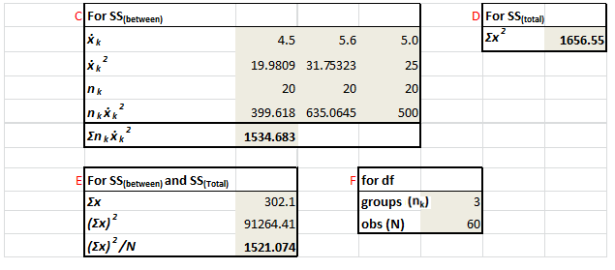
- Box G. Use the formulae to complete all the cells in this box. You should end up with a value of 3.183
- Box H. Finally, we need to compare our F value to the critical value. We can even calculate this in Excel. The =F.INV() function requires three input parameters, a probability parameter and the two degrees of freedom. The probability parameter is the proportion above which we call F values significant. If we are using an alpha level of .05, then this proportion is 1-0.05 = .95. Check that this is how cell C50 is computing its value.
- Use the =F.INV() function to calculate the critical F value.
HINT: Look at the equivalent formula on the ‘Between1-6 nations’ worksheet for a hint on how to use the F.INV() function.
NOTICE: The Significant value changes from FALSE to TRUE depending on whether our computed F value exceeds the critical value.
- Save the spreadsheet.
You now know how to calculate one-way between-subjects ANOVA in Excel. As usual it is more labour intensive than doing it using JASP, which will we do now.
1b) JASP
Although the ANOVA interface is easy to use, JASP is picky about how it likes its between-subjects data. Remember from the t test practical, that between-subjects data in JASP require a coding variable? In order to conduct our JASP ANOVA on the cognitive enhancers data, we need to first set up the data file with one coding variable column and one data column. Once we have done this, we can proceed with the ANOVA.
- Because JASP doesn’t have a native data editor, we need to enter and save the data we wish to analyse using another piece of software. Open Excel.
- Create two column headings: Condition in cell A1 and Score in cell B1.
- For the first 20 rows in the Condition column (cells A2 to A21), fill in values of 1. In the corresponding cells in the Score column, paste the data from the Control column of the ‘Between 2-Programs’ worksheet. NOTICE: JASP requires categorical data to be entered numerically (values 1, 2, 3). Because this numerical naming doesn’t necessarily make the most sense to us, JASP gives us the option to translate these numerical values into condition labels (control, GreenMind, EcoLearn), which we will learn how to do below.
- For the next 20 rows in the Condition column (cells A22 to A41), fill in values of 2. In the corresponding cells in the Score column, paste the data from the ‘GreenMind column of the ‘Between 2-Programs’ worksheet. Finish the data sheet off with 20 values of 3 and the data from the EcoLearn column.
- Save your data as a .csv file with the title: Data_prac3_1b.csv.
- Close Excel and open the .csv file you have just created in JASP.
- Double-click the Condition heading and assign the labels Control, GreenMind and EcoLearn to the values 1, 2 and 3.
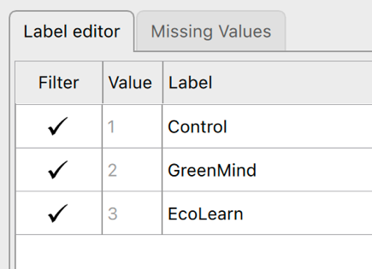
NOTICE: The data in the spreadsheet updates with the labels in real-time. Although it isn’t essential, it is good practice to label your categorical data. This gives you confidence that you are comparing the conditions you think you are. This is particularly important when you work on large datasets over multiple sittings.
- Select a between-subjects ANOVA via ANOVA > ANOVA:
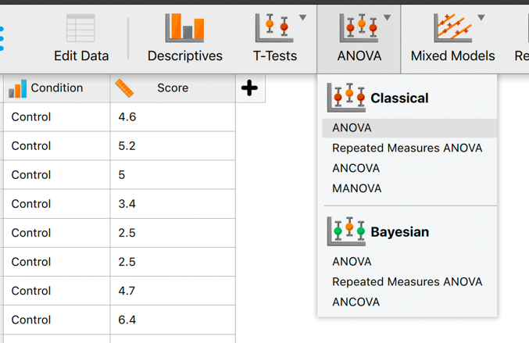
- Our dependent variable is Score, so transfer this over into Dependent Variable.
- Transfer Condition to Fixed Factors.
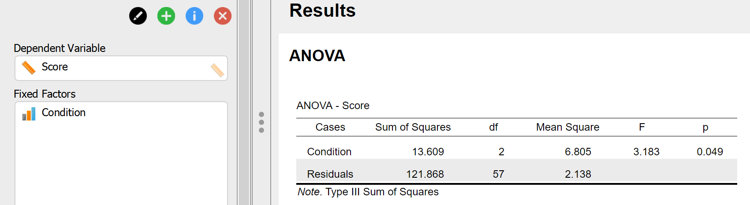
NOTICE: JASP immediately gives us the ANOVA we were asking for—we have a significant difference in our data (the p value is less than .05)—but it doesn’t give us any of the information we need to understand whether or not we have satisfied the assumptions we have made about the data, any descriptives, or any follow-up tests. To get these, we need to ask for them in the ANOVA selection.
- Specify that you want Descriptive Statistics and Estimates of effect size (select ‘partial η²’ [pronounced partial eta squared] and de-select ‘η²’).
- To test our assumption of homogeneity of variance, and give ourselves the option to correct for violated assumptions, click on the Assumption Checks accordion menu and select Homogeneity tests and add the Welch Homogeneity correction.
- If we had a hypothesis about which condition would lead to the best scores, we could contrast these afterwards using a limited number of t tests. However, because we do not have a hypothesis about this, we can select to run post hoc tests. Click on the Post Hoc accordion menu, transfer Condition over to the right, select Standard Type tests, and ask for only the Bonferroni and Tukey Corrections.
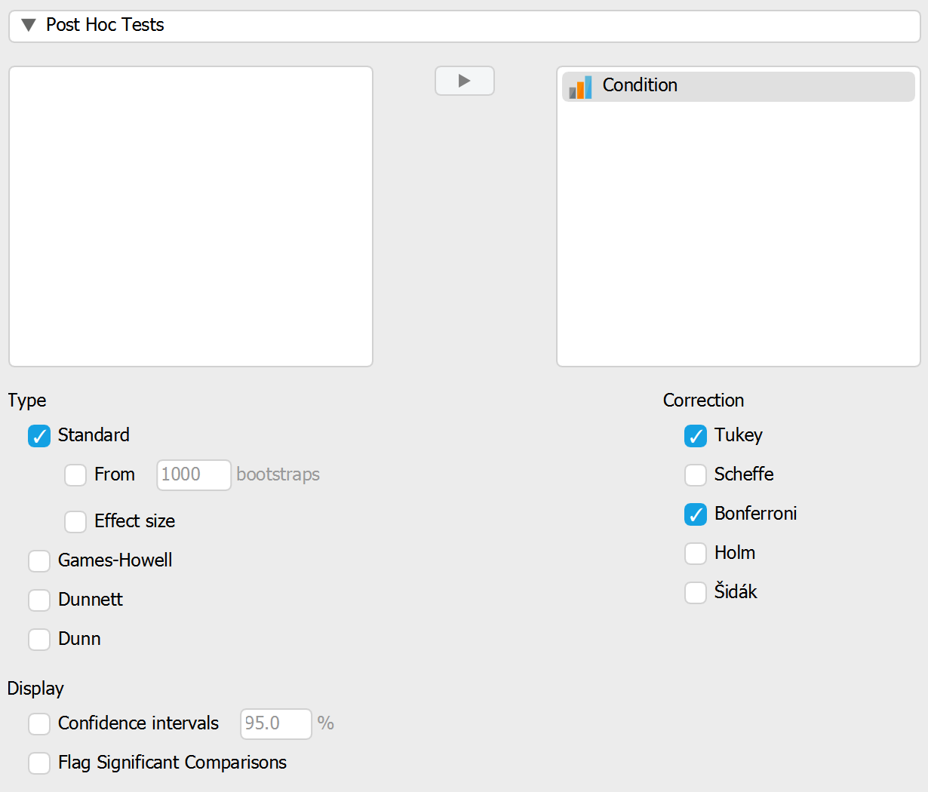
- In case you find graphs of your descriptives easier to interpret than tables, click on the Descriptives Plots accordion menu, and transfer Condition to the Horizontal Axis, and select to Display error bars (keeping the 95% Confidence interval default).
- Your output should now consist of four tables and one graph.
- Although they come after the ANOVA table, it makes most sense to start with the Descriptives and Descriptives plots.
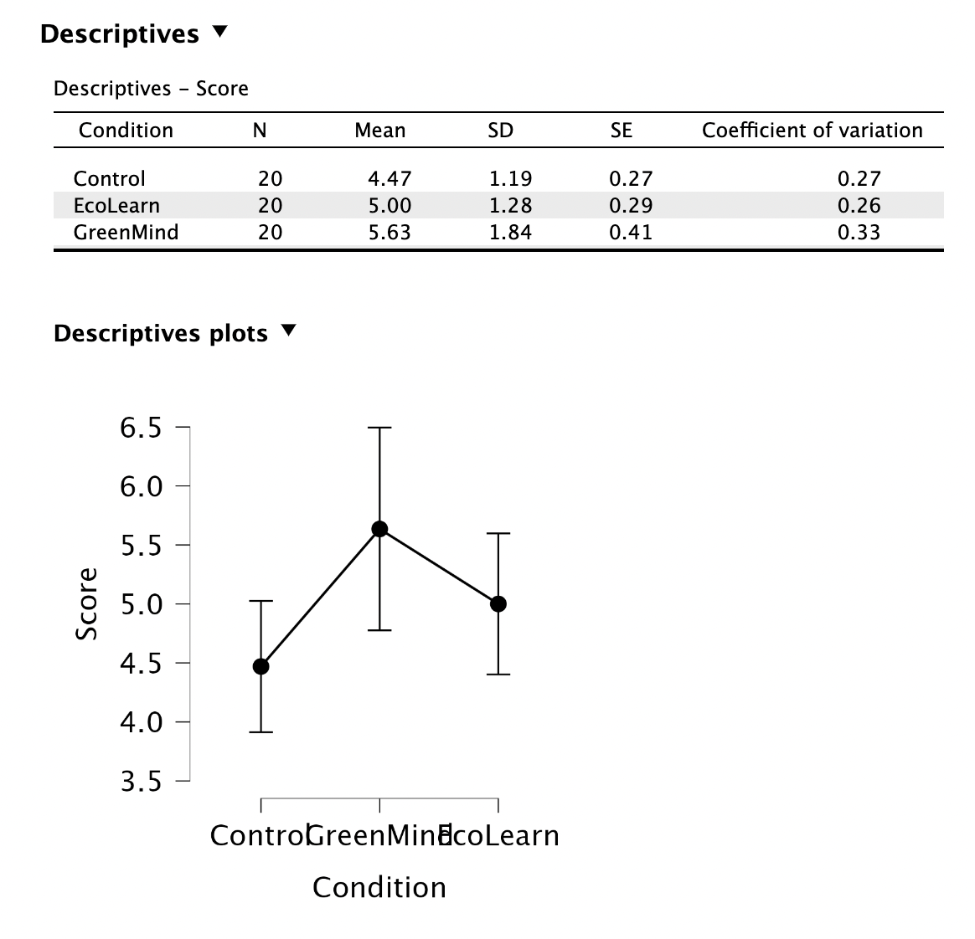
NOTICE: From the means it looks like the environmental education programs may improve environmental behavioural intention scores, but we need to reserve judgement until we interpret our ANOVA results. However, the standard deviations don’t look constant across all conditions. Remember that one of the assumptions for conducting an ANOVA is that the data have homogeneity of variance – if the standard deviations look markedly different then that is often a sign that homogeneity of variance should not be assumed.
- The next box down shows us the results of the Levene’s test of homogeneity of variance. This is testing the null hypothesis that our data possess homogeneity of variance. That means, in order to proceed with an uncorrected ANOVA and not Welch’s one-way test (which we requested just in case), we want the Levene’s test to be non-significant (i.e with a p value greater than .05).
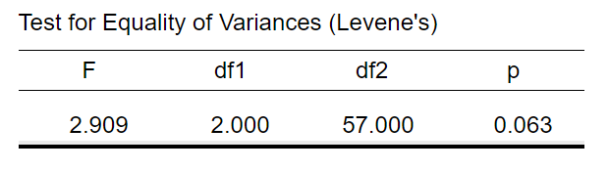
NOTICE: The test returns a non-significant result, but only just. For now, it is OK to proceed with the uncorrected ANOVA (i.e. the Homeogeneity Correction: None rows of the ANOVA table). If the p value had been significant, we would shift to examining the Welch’s one-way test rows in the ANOVA output table. Now that you have no need for it, you can de-select the Welch one-way test if you want.
- The next output is the most important table of the analysis – ANOVA results.
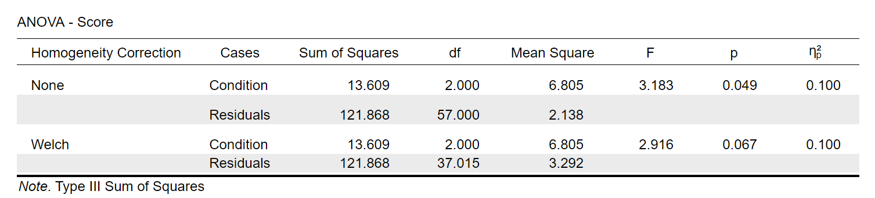
NOTICE1: Because we satisfied the homogeneity of variance assumption, we can focus on the rows without homogeneity correction and not the rows for Welch’s one-way test.
NOTICE 2: Compare this output to your Excel output to see what the important values in the table are.
From the comparison, you should see that the following highlighted cells are the important ones for reporting your ANOVA.
You are after the df(between or condition) the df (error or residuals), the F value and its significance, which are reported as follows:
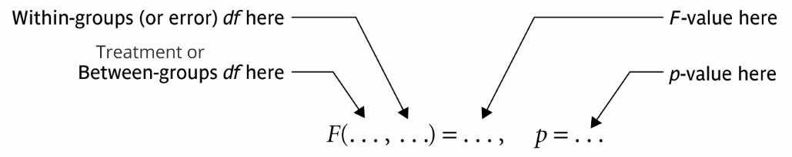
NOTICE: There are lots of ways of referring to the between and error contributors to an ANOVA calculation. You can read more about why the various names all mean the same thing in the textbook.
- Fill in the gaps:
A sample of 60 students were allocated to one of three groups before completing an environmental behavioural intention test. Two of the groups participated in environmental education programs (GreenMind or EcoLearn), the other was a [enter text] group. There was a [click] difference in test scores according to group allocation, F([enter value], [enter value]) = [enter value], p = [enter value].
- The final output of relevance to us the results of the post-hoc tests comparisons.
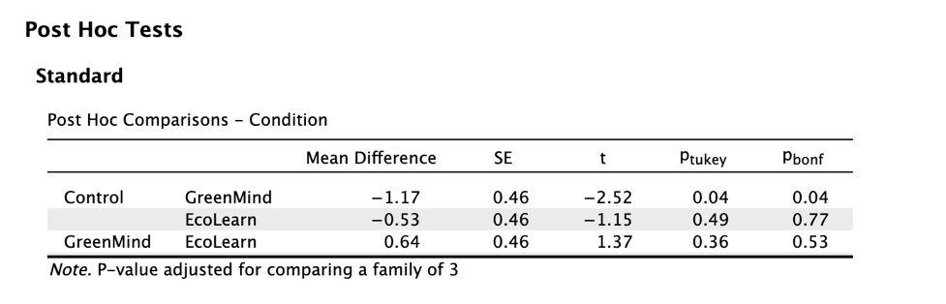
NOTICE: We have two outputs, Tukey and Bonferroni. Observe from the two p columns that, according to both tests, only one of the pairwise comparisons reaches significance: GreenMind vs. Control. Also notice that the Tukey test assigns it a greater level of significance (.038) than the Bonferroni test (.044). This is because the Bonferroni test is more conservative than the Tukey test. That is, the Bonferroni test systematically produces larger p values than the Tukey test. Imagine you are running 20 comparisons: the Tukey test might find 7 of them significant (7 p values smaller than .05), but the Bonferroni test would likely find fewer significant, e.g. 4 (4 p values smaller than .05). We call this tendency against finding significant results, which the Bonferroni test possesses, being “statistically conservative”. Conservative tests minimise Type I error (false positives), but they also increase the chances of Type II errors (missing true significant differences). Generally speaking, when you have a large number of conditions leading to a large number of pairwise comparisons, the Bonferroni test will lead to too much Type II error. In these situations, it is best to go with a more liberal test like Tukey.
- In this situation, let’s go with the Bonferroni test. Fill in the gaps:
The only significant difference according to Bonferroni-corrected post hoc pairwise contrasts was between the [GreenMind/EcoLearn/Control] condition (M = [enter value], SD = [enter value]) and the [GreenMind/EcoLearn/Control] condition (M = [enter value], SD = [enter value]), p = [enter value]. There was no difference between the [GreenMind/EcoLearn/Control] condition (M = [enter value], SD = [enter value]) and the [GreenMind/EcoLearn/Control] or [GreenMind/EcoLearn/Control] conditions, ps = [enter value] and [enter value] respectively.
HINT: When you report standard deviations, be careful to use the SD values and not the SE (standard error) values, which are presented at various other points in the JASP output.
- Save your data file as Data_Prac3_1b.jasp.
SECTION 2. Conducting within-subjects ANOVA
The formulae for within-subjects ANOVA are:
Degrees of Freedom ${df}_{treatments}=n_{c}-1$
${df}_{between subj}=n_{p}-1$
${df}_{total}=N-1$
${df}_{error}={df}_{total}-{df}_{between subj}-{df}_{treatments}$
Sums of Squares ${SS}_{treatments}=n_{p}\sum{{\overline{x}}_{c}^{2}-\frac{{(\sum{x)}}^{2}}{N}}$
${SS}_{between subj}=n_{c}\sum{{\overline{x}}_{p}^{2}-\frac{{(\sum{x)}}^{2}}{N}}$
${SS}_{total}=\sum{x^{2}-\frac{{(\sum{x)}}^{2}}{N}}$
${SS}_{error}={SS}_{total}-{SS}_{between subj}-{SS}_{treatments}$
Mean Squares ${MS}_{treatments}=\frac{{SS}_{treatments}}{{df}_{treatments}}$
${MS}_{error}=\frac{{SS}_{error}}{{df}_{error}}$
Test Statistic $F=\frac{{MS}_{treatments}}{{MS}_{error}}$
2a) EXCEL
This section shows you how to use Excel to conduct a within-subjects ANOVA. This is very similar to a between-subjects ANOVA except that we have an additional sum of squares to account for when calculating our SS_{error}.
- Use Excel to open the ‘Practical 3 data’ file (if it isn’t already open). Now navigate to the ‘Within 1-Recycling worksheet.
NOTICE: In this study, Pegels et al. (2022) assessed the effectiveness of different behavioural interventions aimed at improving waste separation behaviour among households in Trelew, Argentina. The interventions addressed three main barriers to waste separation: lack of knowledge, additional hassle, and self-regulation challenges. Interventions included simplifying information, empathetic messages, a magnetic calendar reminder, or a combination thereof.. The reason we are conducting a one-way within-subjects ANOVA on these data is that there is one independent variable with more than two treatment conditions (hence a one-way ANOVA and not a t test) and we have different treatments carried out on the same participants, rather than different groups per condition (hence within-subjects and not between-subjects).
We’re going to take a brief moment to look through each of the labelled boxes again. Remember to click on the cell values in the formula bar so you see the corresponding cells in the worksheet highlighted.
Box A. These are the raw data (x).
Box B. These are the squared values of X (x²) which are summed to compute the $\sum{x^{2}}$ portion of the SS_{total} equation in Box E.
Box C. These are the participant means across all conditions (${\overline{x}}_{p}$) which are squared (${\overline{x}}_{p}^{2}$) and then summed ($\sum{{\overline{x}}_{p}^{2}}$). The summed value is then multiplied by the number of treatment conditions (n_{c}) to compute the $n_{c}\sum{{\overline{x}}_{p}^{2}}$ portion of SS_{between subj.}
Box D. This is used to calculate the $n_{p}\sum{{\overline{x}}_{c}^{2}}$ portion of the SS_{treatments} equation. The first row shows the treatment condition means (${\overline{x}}_{c}$) which are squared in the next row (${\overline{x}}_{c}^{2}$) and then summed ($\sum{{\overline{x}}_{c}^{2}}$) . The number of participants (n_{p}) is on the fourth row. Finally, the summed treatment condition means are multiplied by the number of participants ($n_{p}\sum{{\overline{x}}_{c}^{2}}$).
Box F. This is used to calculate the $\frac{{(\sum{x)}}^{2}}{N}$ portion common to all SS equations. First, all the observations are summed ($\sum{x}$). On the next row, these values are squared (${(\sum{x)}}^{2}$), before this squared total is divided by the total number of observations ($\frac{{(\sum{x)}}^{2}}{N}$).
Box G. This lists the number of conditions (n_{c}), the number of participants (n_{p}) and the number of observations (N), which are used in degrees of freedom calculations.
Box H. This uses the within-subjects formulae listed above to work through calculating the degrees of freedom, the sums of squares, the mean squares and eventually the F statistic.
formula bar
- Navigate to the ‘Within 2-Energy Usage’ worksheet. These are data from a hypothetical experiment examining energy efficiency scores taken from 18 households. Each household implemented an energy-saving device (e.g., low, medium, high, and very high efficiency) and their energy consumption was recorded at four different levels of implementation: Device1, Device2, Device3, and Device4. NOTICE: The grey boxes are empty. These are what we need to fill in to see whether there is any treatment difference on alertness scores using our ANOVA.
- Box B. Square each value of x to give an x² value. Remember that you only need to type the formula in for one cell. You can then drag this value across to auto-fill your rows and columns.
- Box C. Calculate the mean of each participant’s four scores for each ${\overline{x}}_{p}$.
- Box C. Square these values to complete the ${\overline{x}}_{p}^{2}$ column next.
- Box C. Sum the ${\overline{x}}_{p}^{2}$ values to give you $\sum{{\overline{x}}_{p}^{2}}$.
- Box C. Below this, enter n_{c} using the =COUNT() function.
- Box C. Multiply n_{c} by $\sum{{\overline{x}}_{p}^{2}}$ to complete the final cell, $n_{c}\sum{{\overline{x}}_{p}^{2}}$, of this box. You should get a value of 118927.6.
- Box D. Calculate the mean for each treatment condition for each ${\overline{x}}_{c}$.
- Box D. Square each ${\overline{x}}_{c}$ value to give the four values of ${\overline{x}}_{c}^{2}$.
- Box D. Now sum all ${\overline{x}}_{c}^{2}$ values to give a single value of $\sum{{\overline{x}}_{c}^{2}}$.
- Box D. Enter n_{p} using the =COUNT() function to determine the number of participants in any given treatment condition.
- Box D. Multiply n_{p} by $\sum{{\overline{x}}_{c}^{2}}$ to complete the final cell, $n_{p}\sum{{\overline{x}}_{c}^{2}}$. You should get a value of 112608.5.
- Box E. Sum all the x² values from Box B.
- Box F. Sum all x values from Box A to get $\sum{x}$.
- Box F. For ${(\sum{x)}}^{2}$, square the output of row 1.
- Box F. For $\frac{{(\sum{x)}}^{2}}{N}$, divide by the total number of observations (use the =COUNT() function to determine N). You should end up with a value of 112116.9.
- Box G. Use the =COUNT()function to complete each of these three values.
- You should now have something that looks like this:
- Box H. Use the formulae to complete all the cells in this box.
- Box I. Use the =F.INV() function to calculate the critical F value.
Computed F value = [enter value]
Critical value (at the .05 alpha level) = [enter value]
Significant ANOVA result: [click]
NOTICE: ANOVA significance is not directional – there is no option to test for one- or two-tailed significance. A significant ANOVA result only tells us that there is a difference between one of our conditions and the others. It does not tell us about the direction of that difference, or even which conditions are driving the significant ANOVA result. This is why we need to think carefully about post hoc tests we run to explore two-way comparisons after the ANOVA.
- Save the spreadsheet.
2b) JASP
The JASP data file required to run a one-way, within-subjects ANOVA is more straightforward than that required for a between-subjects ANOVA. No coding variable is required because the four treatment conditions are all measured in the same participants. Therefore, JASP is happy to have four columns of data per row.
- In a new Excel spreadsheet, create four column headings: Device1, Device2, Device3, and Device4.
- Copy the x values from the ‘Within 2-Energy Usage’ worksheet.
- Save your data as a .csv file with the title: Data_prac3_2b.csv.
- Open the .csv file in JASP and specify that you would like to conduct a repeated-measures ANOVA via ANOVA > Repeated Measures ANOVA.
NOTICE: This is different to the menu path we took to specify a one-way between-subjects ANOVA, which was ANOVA > ANOVA.
- The Repeated Measures ANOVA specification looks a little daunting, but the key boxes are the ones labelled Repeated Measures Factors and Repeated Measures Cells. In the Repeated Measures Factor box, Edit RM Factor 1 and replace it with the text stage.
- Name four levels in the Repeated Measures factor box stage1, stage2, stage3 and stage4 (more will appear as you start to define them).
- Transfer each of your Device variables into the Repeated Measures Cells, as below.
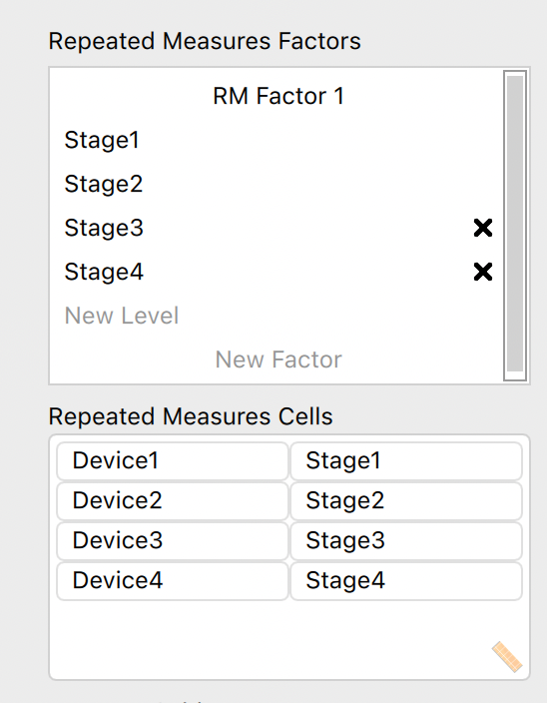
- Specify that you want Descriptive Statistics and partial η² estimates of effect size.
- The assumption check we need to carry out for within-subjects designs is Mauchly’s sphericity test. In the Assumption Checks accordion menu, click Sphericity tests and add the Greenhouse-Geisser Sphericity correction.
- Once again, we had no hypotheses about which conditions would be different to which, so we should use post-hoc tests. Click on the Post Hoc accordion menu, transfer stage over to the right, and ask for only Bonferroni Correction.
NOTICE: We have 4 levels of our independent variable, which means that Bonferroni correction would correct for 6 comparisons. That’s not too conservative, and given that we don’t have any specific predictions, we should be careful of Type I error. The conservative Bonferroni correction is therefore acceptable.
- Click on the Descriptives Plots accordion menu, and transfer stage to the Horizontal Axis, and select to Display error bars (keeping the 95% Confidence interval default).
- Your output should now consist of five tables and one graph.
- Once again, it makes most sense to start with the Descriptives and Descriptives plots.
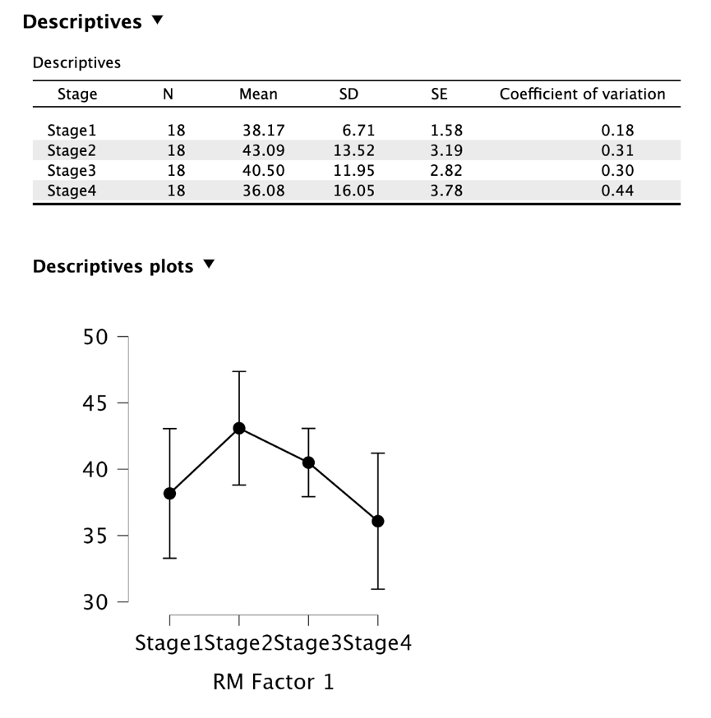
NOTICE: From the means it looks like the second stage of implementing energy-saving devices may improve energy savings, but stages three and four have more of a negative effect. Notice however that the standard deviations (and error bars in the figure) are very large. Also notice that the experimenter never took a baseline measure of energy consumption prior to the implementation of the first device. That’s bad experimental design!
- The next box down shows us the results of Mauchly’s sphericity test. This is testing the null hypothesis that our data possess sphericity of covariance. That means, in order to proceed with an uncorrected ANOVA and not the Greenhouse-Geisser-corrected ANOVA, we want Mauchly’s test to be non-significant (i.e. with a p value greater than .05).
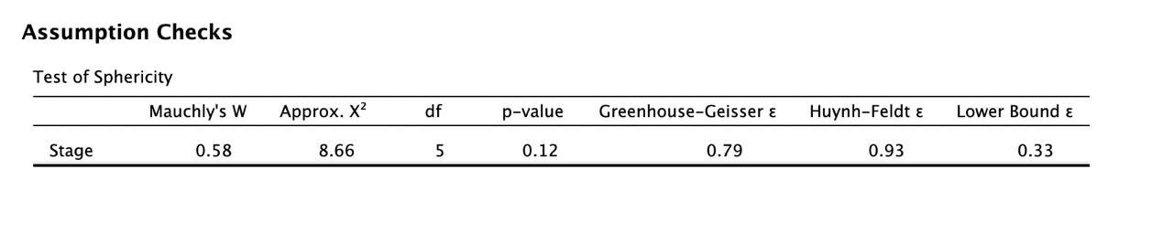
NOTICE: The test returns a non-significant result (the p value is greater than .05). It is OK to proceed with the uncorrected ANOVA (i.e. the Sphericity Correction: None rows of the ANOVA table). If the p value had been significant, we would shift to examining the Greenhouse-Geisser rows in the ANOVA output table. Now that you have no need for it, you can de-select the Greenhouse-Geisser Sphericity correction if you want.
- The Repeated Measures ANOVA tables are the most important tables in the output. Because we don’t have between-subjects factors (we’ll learn more about that in Semester 2), the Between Subjects Effects table is redundant and we can ignore it.
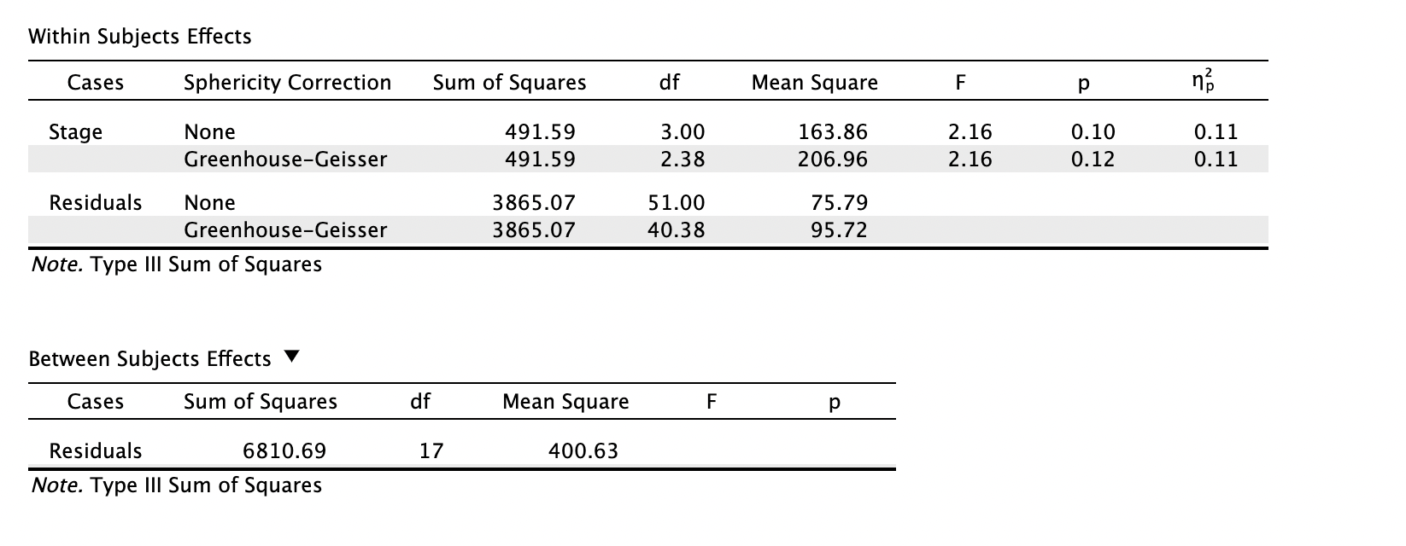
NOTICE1: Because we satisfied the sphericity assumption, we can focus on the rows without sphericity correction and not the rows to which Greenhouse-Geisser correction is applied.
NOTICE2: If the Mauchly’s test had been significant, you would instead have looked at the Greenhouse-Geisser rows for both dose and residuals. If this had been the case, then the following ANOVA statistic would have been reported: F(2.38, 40.38) = 2.16, p = .120.
NOTICE 3: Compare this output to your Excel output to see what the important values in the table are.
From the comparison, you should see that the following highlighted cells are the important ones for reporting your ANOVA.
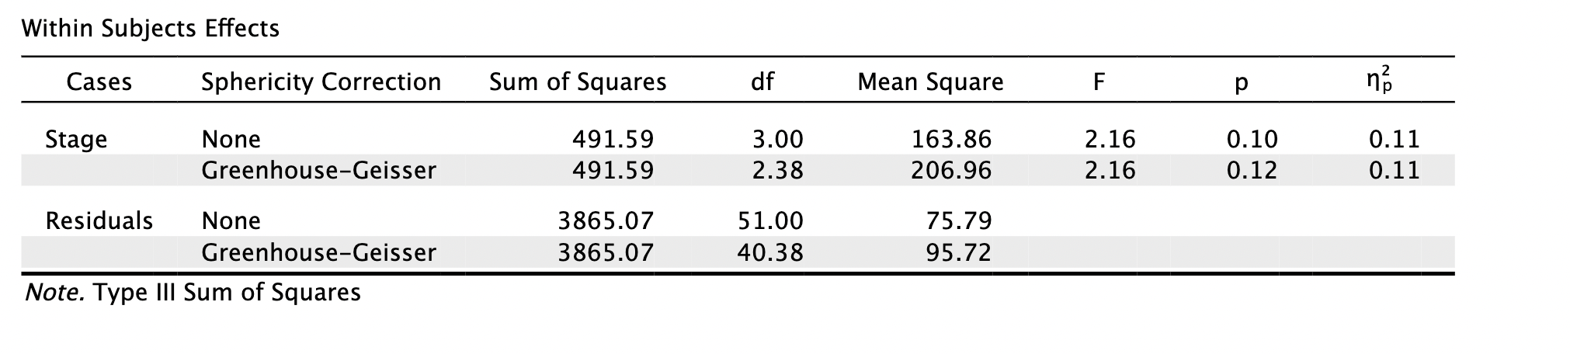
You are after the df(treatment—in this case dose) the df (error or residuals), the F value and its significance, which are reported as follows:
- Although our ANOVA did not produce a statistically significant result, for completeness we examine the pairwise comparisons (though you would not report them in a scientific report).
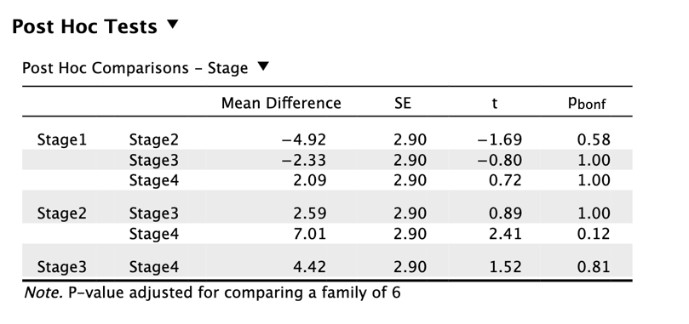
NOTICE: As we would expect, there were no significant differences in any of our comparisons.
- Fill in the gaps:
Despite trends in the means suggesting an inverted-U shape to participants’ energy saving levels following successive implementation of energy saving devices, there were no significant differences in energy savings across the four treatment conditions, F([enter value], [enter value]) = [enter value], p = [enter value].
- Save your data file as Data_Prac3_2b.jasp.
SECTION 3. Conducting non-parametric alternatives to one-way ANOVA
The following is a quick guide to running non-parametric alternatives to one-way ANOVA in JASP.
3a) Kruskal-Wallis test: a between-subjects ANOVA alternative
The non-parametric, between-subjects one-way ANOVA alternative is the Kruskal-Wallis test. It is an extension of the Mann-Whitney U test and compares the sums of groups’ ranks. If one group’s summed ranks value is much higher than the other groups’, the test returns a significant result.
- Open the between-subjects data file you previously created (Data_Prac3_1b.jasp).
NOTICE: We are using this data file to illustrate the procedure in spite of the fact that it satisfied parametric assumptions. We would typically conduct a nonparametric test if we had reasons to believe that parametric tests were unsuitable for the analyses, beyond the homogeneity and sphericity violations (which can be corrected for in the ANOVA itself by examining Welch’s one-way test and Greenhouse-Geisser-corrected ANOVA),
- JASP will open up the between-subjects analyses you previously ran. If you scroll down the ANOVA specification panel, you will see a Nonparametrics accordion menu. Click on this, then under Kruskal-Wallis test, transfer Condition to the right.
- The output, shown below all of the ANOVA output, is very straightforward.
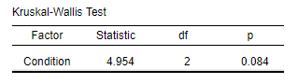
NOTICE: Our non-parametric test has returned non-significant results when our parametric ANOVA returned significant results. This is a typical pattern: non-parametric tests are generally more conservative than parametric tests.
- Fill in the gaps:
A Kruskal-Wallis test found no significant differences between the groups, χ²([enter value]) = [enter value], p = [enter value].
NOTICE: The Kruskal-Wallis test uses a $χ^{2}$ (chi-squared) statistic, just like the chi-squared test.
HINT: As with most statistical tests, the degrees of freedom are stated parenthetically prior to the result of the test statistic.
- Save the data file.

3b) Friedman test: a within-subjects ANOVA alternative
The non-parametric, within-subjects one-way ANOVA alternative is the Friedman test. It is an extension of the Wilcoxon Signed Ranks test and compares the sums of treatment conditions’ ranks. If one treatment condition’s summed ranks value is much higher than the other treatment conditions’, the test returns a significant result.
- Open the within-subjects data file you previously created (Data_Prac3_2b.jasp).
- Scroll down the Repeated Measures ANOVA specification panel, click on the Nonparametrics accordion menu, and transfer stage to RM Factor.
- The output is, once again, straightforward.
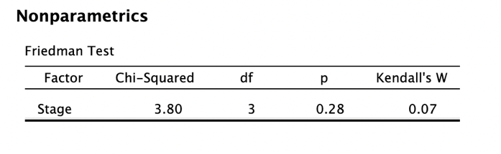

- Fill in the gaps:
A Friedman test found no significant differences between the treatment conditions, χ²([enter value]) = [enter value], p = [enter value].
NOTICE: The Friedman test also uses a $χ^{2}$ (chi-squared) statistic.
- Save the data file.

